 | How to (comfortably) wear a Backpack Vacuum

Although it seems very simple, there is both a right way and a wrong way to wear a backpack vacuum. The biggest mistake operators make is wearing the weight of the backpack too high on the back. This is caused by adjusting the shoulder straps first when the backpack is placed on instead of after the waist belt is adjusted. Once the correct method of wearing a backpack vacuum is learned, the difference in comfort is amazing. Here is a step by step guide to adjusting and wearing a backpack correctly.

- The FIRST step is to put the arms through the shoulder straps and then greatly loosen the shoulder straps. This seems awkward at first, but it allows the vacuum to sit as low as possible on the operator’s hips.  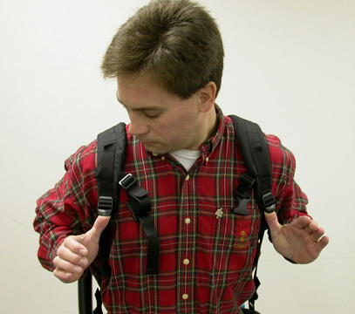 | - The second step is to fasten the belt low around the waist (at or under the belt on one’s pants). Then tighten the belt of the backpack until it is comfortably snug.  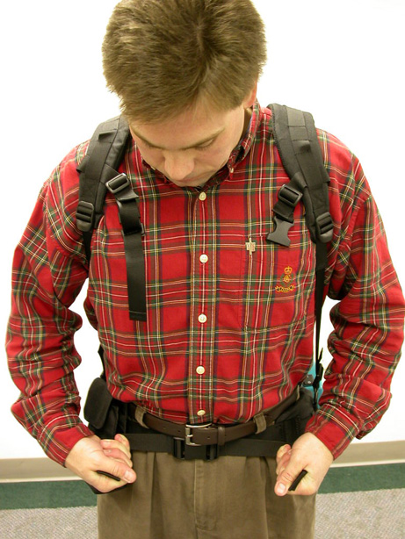
- Next, NOW its time to tighten the shoulder straps by pulling on the adjustment straps. This will pull the top of the backpack vacuum forward to snugly fit against the operator’s back.  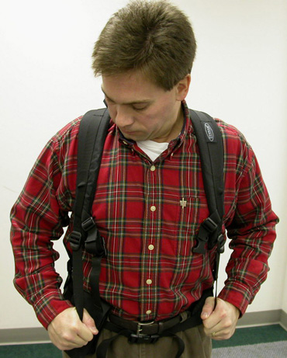 | - Finally, the shoulder straps should be fastened together with the front cross strap and clasp and comfortably tightened. This prevents the shoulder straps from slipping off the shoulders.  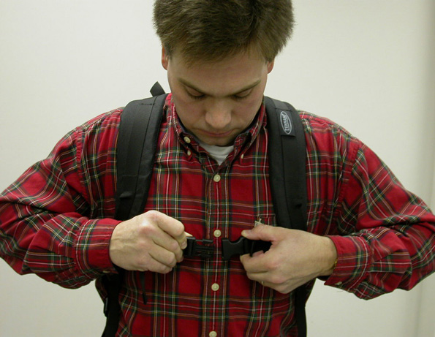

If you have any questions about the proper adjustment and comfortable use of any of the Tennant backpack vacuums, please call Mitch Urbytes at 616.786.4211 or email at mitch.urbytes@tennantco.com

