
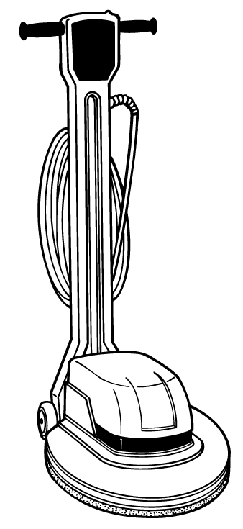

Commercial Floor Care Equipment

2160/2170 Floor Machines

Features | Specifications
Model Name:  Model Number: | 2160 - 17” Dual Speed  607643 | 2170 20” Dual Speed  607643
Pad Drive System  Brush Diameter:  Motor Amps:  Motor HP:  Motor Type:  Motor Volts:  Motor Watts:  Brush RPM | 17 in /43.18 cm  12 A  1.5 hp  Permanent magnet DC, 66 frame, dual speed, circuit breaker protected; triple planetary; precision gear box, 10:1 gear ratio  120 V  1100 watts  330 RPM (buff); 185 rpm (scrub) | 20 in /50.8 cm  12 A  1.5 hp  Permanent magnet DC, 66 frame, dual speed, circuit breaker protected; triple planetary; precision gear box, 10:1 gear ratio  120 V  1100 watts  330 rpm (buff); 185 rpm (scrub)
Chassis Construction  Handle Design: | Twist grip operation w/ safety lock; constructed of rotationally-molded polyethylene
Dimensions  Product Height:  Product Length:  Product Weight:  Product Width: | 48 in /121.92 cm  22.75 in /57.79 cm  92 lb /43.09 kg  17 in /43.18 cm | 48 in /121.92 cm  23.5 in /59.69 cm  95 lb /43.09 kg  20 in /50.8 cm
Productivity  Max. Coverage Rate Per Hour: | 2000 ft² /185.8 m² | 3000 ft² /278.7 m²
Power Cord  Length:  Power Cord Type: | 50 ft /15.24 m  14 gauge, 3-wire, SJT | 50 ft /15.24m  14 gauge, 3-wire, SJT
Solution Delivery System  Coverage Rate Per Tank:  Nominal Solution  Flow Rate: | 1000 ft² /92.9 m²  .1 gpm /.38 L/min  3 gal /11.36 L | 1500 ft² /139.35 m²  .1 gpm /.38 L/min  3 gal /11.36 L
Warranty | 10 years – Tennant warrants the rotationally-molded polyethylene housings and parts on all of its machines be free from defect in materials and workmanship, under normal use and service for ten (10) years to the original end user. 3 years – Tennant guarantees the performance of non-polyethylene parts and components to be free from defects for up to three (3) years or 2,500 hours of operation. 3 years – Labor charges are covered for three (3) full years from the date of purchase for Tennant service provider is used for repair.

