
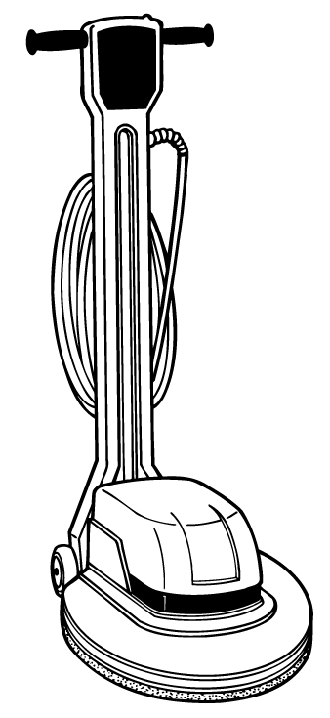

Commercial Floor Care Equipment

2010/2040 Floor Machines
Model Name:  Model Number: | 2010 17” Heavy Duty  609622 | 2040 20” Heavy Duty  609624
Pad Drive System  Brush Diameter:  Motor Amps:  Motor HP:  Motor Type:  Motor Volts  Motor Watts:  Brush RPM: | 17 in /43.18 cm  12 A  1.5 hp  AC, 66 frame, heavy duty, circuit breaker protected; triple planetary; precision gear box, 10:1 gear ratio  120 V  1100 watts  175 rpm | 20 in /50.8 cm  12 A  1.5 hp  AC, 66 frame, heavy duty, circuit breaker protected; triple planetary; precision gear box, 10:1 gear ratio  120 V  1100 watts  175 rpm
Chassis Construction  Handle Design: | Twist grip operation with safety lock; constructed of rotationally-molded polyethylene
Dimensions  Product Height:  Product Length:  Product Weight:  Product Width: | 48 in /121.92 cm  22.75 in /57.79 cm  95 lb /43.09 kg  17 in /43.18 cm | 48 in /121.92 cm  23.5 in /59.7 cm  98 lb /44.45 kg  20 in /50.8 cm
Productivity  Max. Coverage | 2000 ft² /185.8 m² | 3000 ft² /278.7 m²
Power Cord  Length:  Power Cord Type: | 50 ft /15.24 m  14 gauge, 3-wire, SJT | 50 ft /15.24 m  14 gauge, 3-wire, SJT
Solution Delivery  System  Coverage Rate Per Tank:  Nominal Solution  Flow Rate: | 1000 sq ft (92.9 sq m) /tank  .1 gpm /.38 L/min  3 gal /11.36 L | 1500 sq ft (139.35 sq m)/tank  .1 gpm /.38 L/min  3 gal /11.36 L
Warranty | 10 years – Tennant warrants the rotationally-molded polyethylene housings and parts on all of its machines to be free from defect in materials and workmanship, under normal use and service for ten (10) years to the original end user. 3 years – Tennant guarantees the performance of non-polyethylene parts and components to be free from defects for up to three (3) years or 2,500 hours of operation. 3 years – Labor charges are covered for three (3) full years from the date of purchase for Tennant service provider is used for repair.

