Hawkins, Charles

Tennant Company  [Company address]

Jetmore: sweep FCT rev_08

|  |  |  |
| --- | --- | --- |
| REV LEVEL | CHANGE | Initials-Date |
| 01 | Default | CAH – 11/01/18 |
| 02 | Removed Dust PUMP test. | CAH – 06/20/19 |
| 03 | Clarification and clean up. Added Vac Pressure tests and Input tests as well. Added table of contents | CAH – 06/25/19 |
| 04 | CLEAN UP and correction to CAN Commands. | CAH – 08/16/19 |
| 05 | CORRECTIONS from Ed Soltis, implemented by CAH | CAH – 08/23/19 |
| 06 | SIDE ACTs set to 10A, MAIN ACT set to 10A | CAH – 02/14/20 |
| 07 | TESTING corrections due to bugs or items left out.  All actuators need to be retracted then extended for specific flags to prevent false faults. So they MUST be exercised in retract then extend for OPEN load tests. Ed Soltis (1/14/2021) | CAH – 02/11/2021 |
| 08 | Added OVERVOLTAGE test for the Main brush.  Added reset to JTAG line to reboot micro without powering down board.  Changed tolerance for current measurement from  5.0% to 5.5%  Loads : Must meet power rating to satisfy V**2**/R (wattage).  Must be within 5% resistance, if not, use Ohms law.  Currents to be resolved to be within +/- 5.5% error.  Nominal Loads may be used for current checks.  Updates made after supplier review:  Voltage limits for Vacuum Filter Sensor and Vacuum HEPA Filter Sensor Voltage Check changed from +/-5% to +/-5.5%  Updated over-voltage test section as follows:   * Now using Right Brush current instead of Main Brush current to test over-voltage protection * Using 348K Resistor to *simulate* power supply at 45V and 50V * Removed unnecessary READ commands for the RT brush after turning off motor during RT Brush simulated 50V test. | CAH – 01/31/2022  CAH – 07/20/2022  CAH – 12/13/2022  WDZ – 05/07/2024 |
|  |  |  |
|  |  |  |
|  |  |  |
|  |  |  |

Contents

**Required Equipment and Loads** 6

**Controlled Function Load Table:** 6

**Control Board Connector Layout** 7

**Powering the Board** 8

**Programing Connections** 10

**Serial Flash Test:** 11

**LOAD CONNECTION FIGURES** 11

**Main Brush** 11

**Right (RT) Brush** 12

**Left (LT) Brush** 12

**Hopper Roll Actuator (ACT)** 13

**MAIN Brush (ACT)** 13

**LT Brush (ACT)** 14

**RT Brush (ACT)** 14

~~Mist Pump (REMOVED)~~ 15

**Horn** 15

**Vacuum HEPA Filter Sensor** 16

**Vacuum Filter Sensor** 16

**~~Dust Pump Water Level Switch~~** 17

**~~Seat Switch (REMOVED)~~** 17

**Hopper Rolled In Switch** 18

**Hopper Home Switch** 18

**Hopper Safe to Roll Switch** 19

**Thermal Switch** 19

**HOPPER LIFT ACTUATOR** 20

**BACKUP ALARM** 20

**SHAKER** 21

**VACUUM1** 21

**VACUUM2** 22

**Alternate 48V test (Using 36V and 39V)** 23

**Input Function Testing** 24

**Hopper Rolled IN** 24

**Hopper Home** 24

**Hopper Safe To Roll** 24

**Vacuum Filter Sensor Voltage Check****+/-5.5% of applied voltage** 24

**Vacuum HEPA Filter Sensor Voltage Check** **+/-5.5% of applied voltage** 25

**Thermal Switch** 25

**Output Function (Load Operations) Testing** 26

**MAIN BRUSH 48A Check** 26

**HOPPER RAISE 36A Check** 27

**HOPPER LOWER 36A Check** 29

**VAC 1 20A Check** 30

**VAC 2 20A Check** 31

**~~MIST PUMP 1.2A Check (REMOVED)~~** 32

**SHAKER 18A Check** 34

**MAIN BRUSH ACT EXTEND 9A Check** 35

**MAIN BRUSH ACT RETRACT 9A Check** 36

**RIGHT BRUSH ACT EXTEND 9A Check** 38

**RIGHT BRUSH ACT RETRACT 9A Check** 39

**LEFT BRUSH ACT EXTEND 9A Check** 41

**LEFT BRUSH ACT RETRACT 9A Check** 42

**HOPPER ROLL EXTEND ACT 18A Check** 43

**HOPPER ROLL RETRACT ACT 18A Check** 44

**HORN 9A Check** 45

**RT BRUSH 9A Check** 47

**LT BRUSH 9A Check** 48

**ALARM LOAD Check** 49

**SHORTED LOAD Check** 50

**MAIN BRUSH SHORTED LOAD Check** 50

**HOPPER RAISE SHORTED LOAD Check** 52

**HOPPER LOWER SHORTED LOAD Check** 53

**RT BRUSH SHORTED LOAD CHECK** 54

**LT BRUSH SHORTED LOAD CHECK** 55

**VAC 1 SHORTED LOAD Check** 56

**VAC 2 SHORTED LOAD Check** 57

**~~MIST PUMP SHORTED LOAD Check (REMOVED)~~** 59

**SHAKER SHORTED LOAD Check** 60

**HOPPER ROLL EXTEND SHORTED LOAD CHECK** 61

**HOPPER ROLL RETRACT SHORTED LOAD Check** 62

**MAIN BRUSH ACT EXTEND SHORTED LOAD CHECK** 64

**MAIN BRUSH ACT RETRACT SHORTED LOAD CHECK** 66

**RIGHT BRUSH ACT EXTEND SHORTED LOAD CHECK** 67

**RIGHT BRUSH ACT RETRACT SHORTED LOAD CHECK** 68

**LEFT BRUSH ACT EXTEND SHORTED LOAD CHECK** 69

**LEFT BRUSH ACT RETRACT SHORTED LOAD CHECK** 70

**HORN SHORTED LOAD CHECK** 72

**~~ALARM SHORTED LOAD CHECK (REMOVED)~~** 73

**OPEN LOAD CHECK** 74

**MAIN BRUSH OPEN LOAD CHECK** 74

**HOPPER ACT OPEN LOAD CHECK** 75

**RT BRUSH OPEN LOAD CHECK** 76

**LT BRUSH OPEN LOAD CHECK** 78

**VAC 1 OPEN LOAD CHECK** 79

**VAC 2 OPEN LOAD CHECK** 80

**~~MIST PUMP OPEN LOAD CHECK (REMOVED)~~** 81

**SHAKER OPEN LOAD CHECK** 82

**HOPPER ROLL OPEN LOAD CHECK** 83

**MAIN BRUSH ACT OPEN LOAD CHECK** 85

**<WRITE MAIN BRUSH RETRACT ACT to start motor>** 85

**RIGHT BRUSH ACT OPEN LOAD CHECK** 86

**LEFT BRUSH ACT EXTEND OPEN LOAD CHECK** 88

**HORN OPEN LOAD CHECK** 89

**ALARM OPEN LOAD CHECK** 90

**Output Function (OVER-VOLTAGE) Turn-Off Testing (NEW)** 91

**RIGHT BRUSH 10A Check @36V** 91

**MAIN BRUSH 12.5A Check @ 45V** 92

**MAIN BRUSH 0A Check @ 50V** 92

**MAIN BRUSH 10A Check @36V Recheck** 93

# **Required Equipment and Loads**

Power Supply : Min 40V @ 70A

Loads : Must meet power rating to satisfy V**2**/R (wattage).

Must be within 5% resistance, if not, use Ohms law.

Currents to be resolved to be within +/- 5.5% error.

Nominal Loads may be used for current checks.

# **Controlled Function Load Table:**

Main Brush : 54.9A MAX

HyPump : 40.6A MAX

Vacuum (1&2) : 25.3A MAX

Right & Left Brush, Horn : 10.1A MAX

Roll Actuator, Shaker : 20.6A MAX

Main Brush Actuator : 5.2A MAX (Switches at extreme ends of travel.)

Right & Left Actuator : 4.6A MAX

|  |  |  |  |  |
| --- | --- | --- | --- | --- |
| Power Supply needed Min 40V @ 70A | Nominal Current/LOAD | Max Current/LOAD | Over Current/LOAD | Connector  Hot / Load / board |
| Main Brush | **45A / 0.8 Ohms** | **48A / 0.75 Ohms** | 60A / 0.6 Ohms | B+ / LOAD / J12 |
| HyPump sideA | **24A / 1.5 Ohms** | **36A / 1 Ohms** | 48A / 0.75 Ohms | J10-1 / LOAD / J10-3 |
| HyPump sideB | **24A / 1.5 Ohms** | **36A / 1 Ohms** | 48A / 0.75 Ohms | J10-2 / LOAD / J10-3 |
| Vacuum1 | **18A / 2 Ohms** | **20A / 1.8 Ohms** | 30A / 1.2 Ohms | B+ / LOAD / J11-2 |
| Vacuum2 | **18A / 2 Ohms** | **20A / 1.8 Ohms** | 30A / 1.2 Ohms | B+ / LOAD / J11-3 |
| Right Brush | **6A / 6 Ohms** | **9A / 4 Ohms** | 12A / 3.0 Ohms | B+ / LOAD / J15-3,4,13,14 |
| Left Brush | **6A / 6 Ohms** | **9A / 4 Ohms** | 12A / 3.0 Ohms | B+ / LOAD / J15-5,6,15,16 |
| H Roll ACT | **4A / 9 Ohms** | **18A / 2 Ohms** | 24A / 1.5 Ohms | J15-9,10,19,29 / LOAD / J15-7,8,17,18 |
| M Brush ACT | **2A / 18 Ohms** | **9A / 4 Ohms** | 12A / 3.0 Ohms | J15-2,12 / LOAD / J15-1,11 |
| R Brush ACT | **2A / 18 Ohms** | **9A / 4 Ohms** | 12A / 3.0 Ohms | J14-5,13 / LOAD / J14-4,12 |
| L Brush ACT | **2A / 18 Ohms** | **9A / 4 Ohms** | 12A / 3.0 Ohms | J14-7,15 / LOAD / J14-6,14 |
| ~~Dust Pump~~ | **~~1A / 36 Ohms~~** | **~~1.2A / 30 Ohms~~** | ~~2A / 18 Ohms~~ | ~~B+ / LOAD / J14-1,2,3,9,10,11~~ |
| Shaker | **4A / 9 Ohms** | **18A / 2 Ohms** | 24A / 1.5 Ohms | B+ / LOAD / J11-1 |
| Horn | **4A / 9 Ohms** | **9A / 4 Ohms** | 12A / 3 Ohms | B+ / LOAD / J16-7 |
| Alarm | **0.3A / 120 Ohms** | 0.4A / 90 Ohms | 1A / 36 Ohms | B+ / LOAD / J16-2 |
| Power V**2**/R must accommodate load.  Hypump SHORT DURATION TESTING! NO HEAT SINK HERE! | | | | |

# **Control Board Connector Layout**

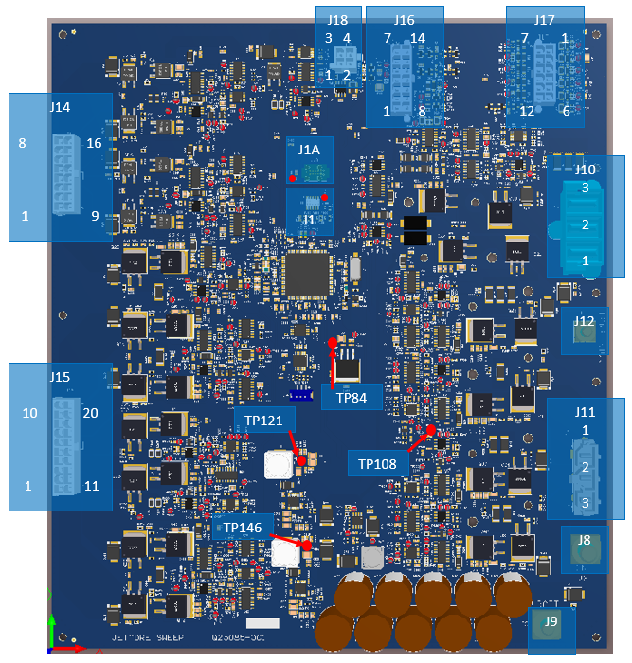

***Figure 1: Sweep Board Test Point and Connector Locations***

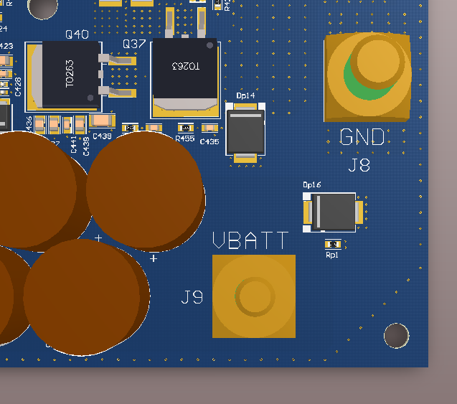

***Figure 2: Power Pin Connectors J8 and J9***

# **Powering the Board**

Turn the Power Supply ON

Set the Power Supply to 36V @ 2A.

Turn the Power Supply OFF

Referring to Figure 2

Connect the (unpowered) supply positive lead to J9

Connect the (unpowered) supply negative lead to J8

Turn the Power Supply ON

Allow 4-6 seconds for the bulk capacitance and loading of supplies to stabilize.

Check each PCB power supply voltage to insure they are within the indicated tolerance values.

|  |  |  |  |
| --- | --- | --- | --- |
| Supply | Location | Min | Max |
| 12V | TP146 | 11.7V | 12.3V |
| 12V LIMA | J16-13 | 11V | 12.2V |
| 12V LIMB | J16-14 | 11V | 12.2V |
| 5V | TP121 | 4.9V | 5.1V |
| 5V LIM | J17-12 | 4.5V | 5.1V |
| 3.3V | TP84 | 3.2505V | 3.3495V |
| 3.0V REF | C182* | 2.99 | 3.01 |
| 2.5V REF | TP108 | 2.45 | 2.55 |
| *Use C182 or Via as seen in Figure 3: Via location for 3.0V Ref | | | |

**Table 1: Supply Tolerances**

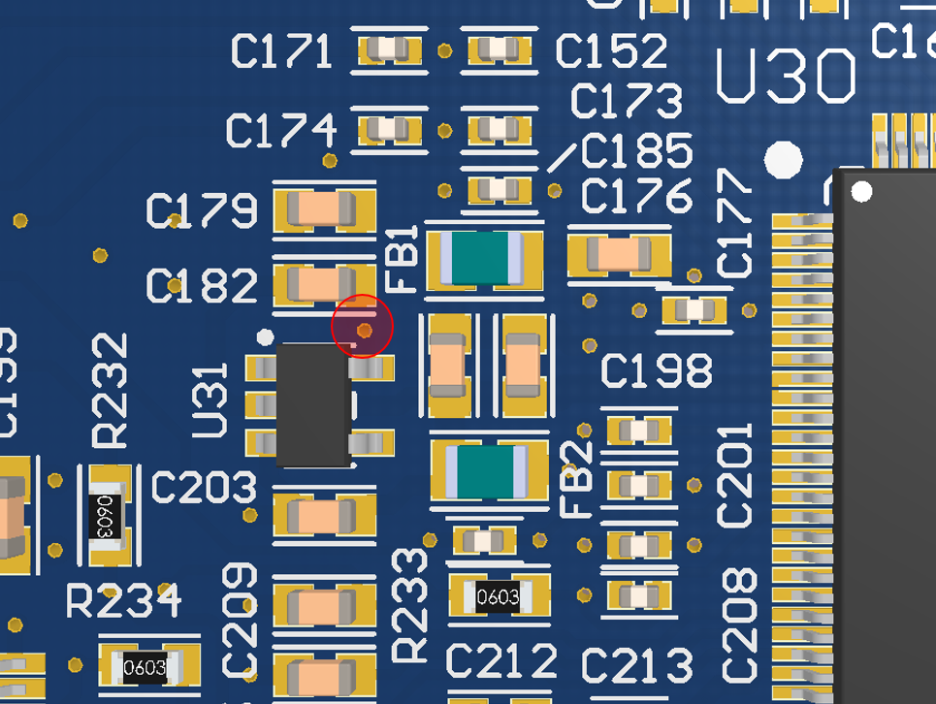

***Figure 3: Via location for 3.0V Ref***

Turn the Power Supply OFF

Wait at least Six (6) seconds for the bulk capacitance to discharge.

# **Programing Connections**

With the Power Supply turned OFF, connect the JTAG to the board at J1.

Pin1 is where the Power/Red connector is connected as shown in Figure 4.

Pin-1 Of the JTAG Programming Connector J1 & J1A

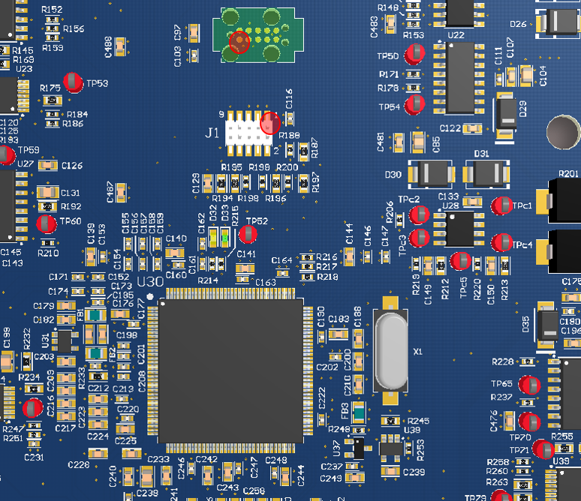

***Figure 4: Test Point and JTAG Connections***

With the Power Supply still set to 36V @ 2A.

Turn the Power Supply ON

Allow 2-3 seconds for the bulk capacitance and loading of 12V to stabilize at 36V.

After programming the board:

Turn the Power Supply OFF

Wait at least six (6) seconds for bulk capacitance to discharge.

Remove (unplug) the JTAG from the Control Board.

# **Serial Flash Test:**

**NOTE: All System functions must be run with CAN commands.**

1. Write the board serial number to the serial EEPROM by sending the following command:

Write the serial number into parameter 1999

NOTE: ASCII is fine for the characters as indicated in the following examples . . .

1. Write object 0x2000 sub-index 0x02 with data { 00, 01, CF, 07, 1E, 00, 00, 00, __, __, __, …}
2. Example serial number 123456 = {00, 01, CF, 07, 1E, 00, 00, 00, 31, 32, 33, 34, 35, 36 }
3. Read object 0x2000 sub-index 0x01 and verify array = { 00, 01, CF, 07, 1E, 00, 00, 00}}
4. Read back the board serial number from the serial EEPROM by sending the following command: Read the serial number from parameter 1999 as indicated in the following examples . . .
   1. Write object 0x2000 sub-index 0x02 with data {00, 00, CF, 07, 1E, 00, 00, 00}
   2. Read object 0x2000 sub-index 0x01 and verify array = { 00, 00, CF, 07, 1E, 00, 00, 00, __, __, __, …}

## **LOAD CONNECTION FIGURES**

## **Main Brush**

Connect the Motor/Load between Power SUPPLY + and J12

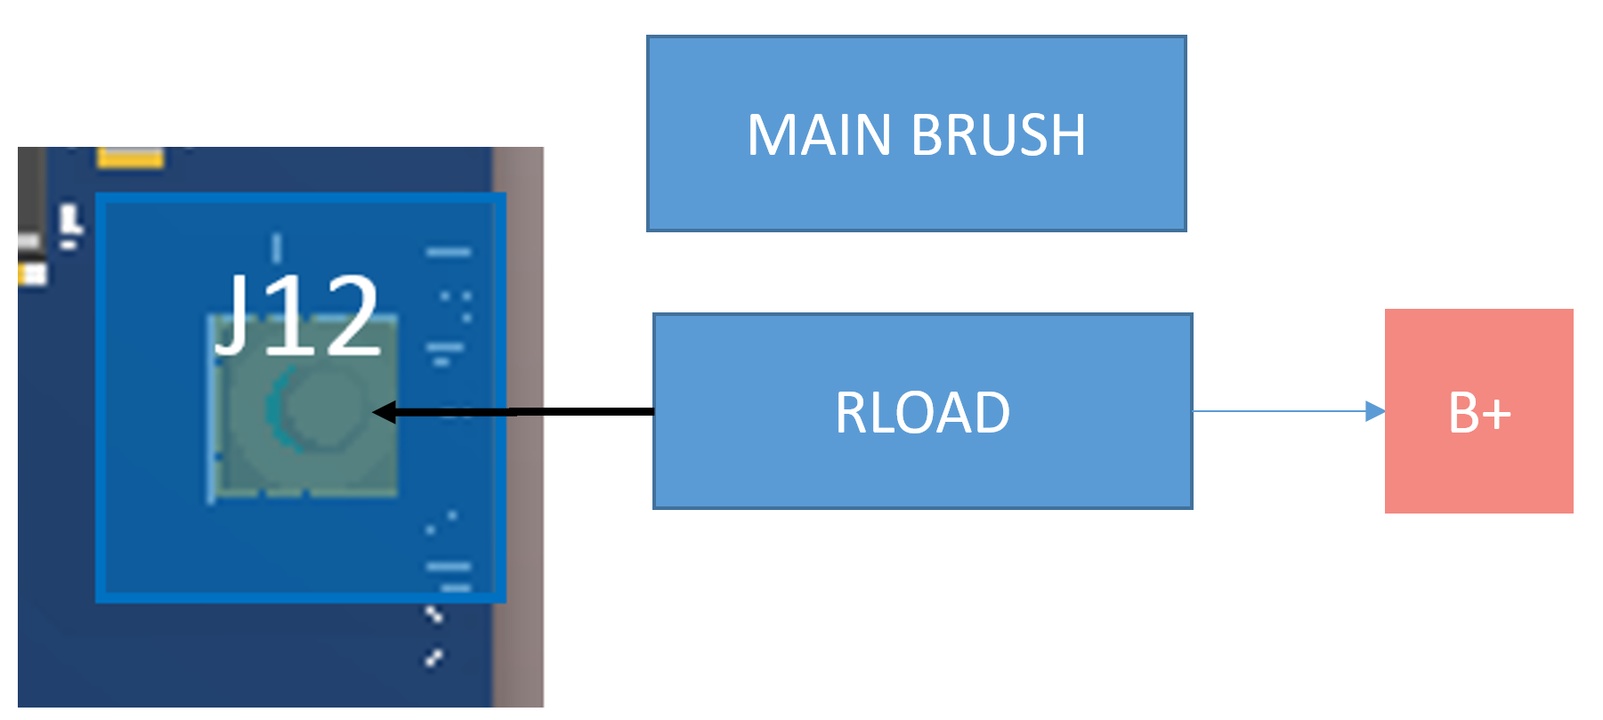

*Figure 5: MAIN SWEEP CONNECTION*

## **Right (RT) Brush**

Connect the Motor/Load between Power SUPPLY + and J15-Pins 3, 4, 13 and 14.

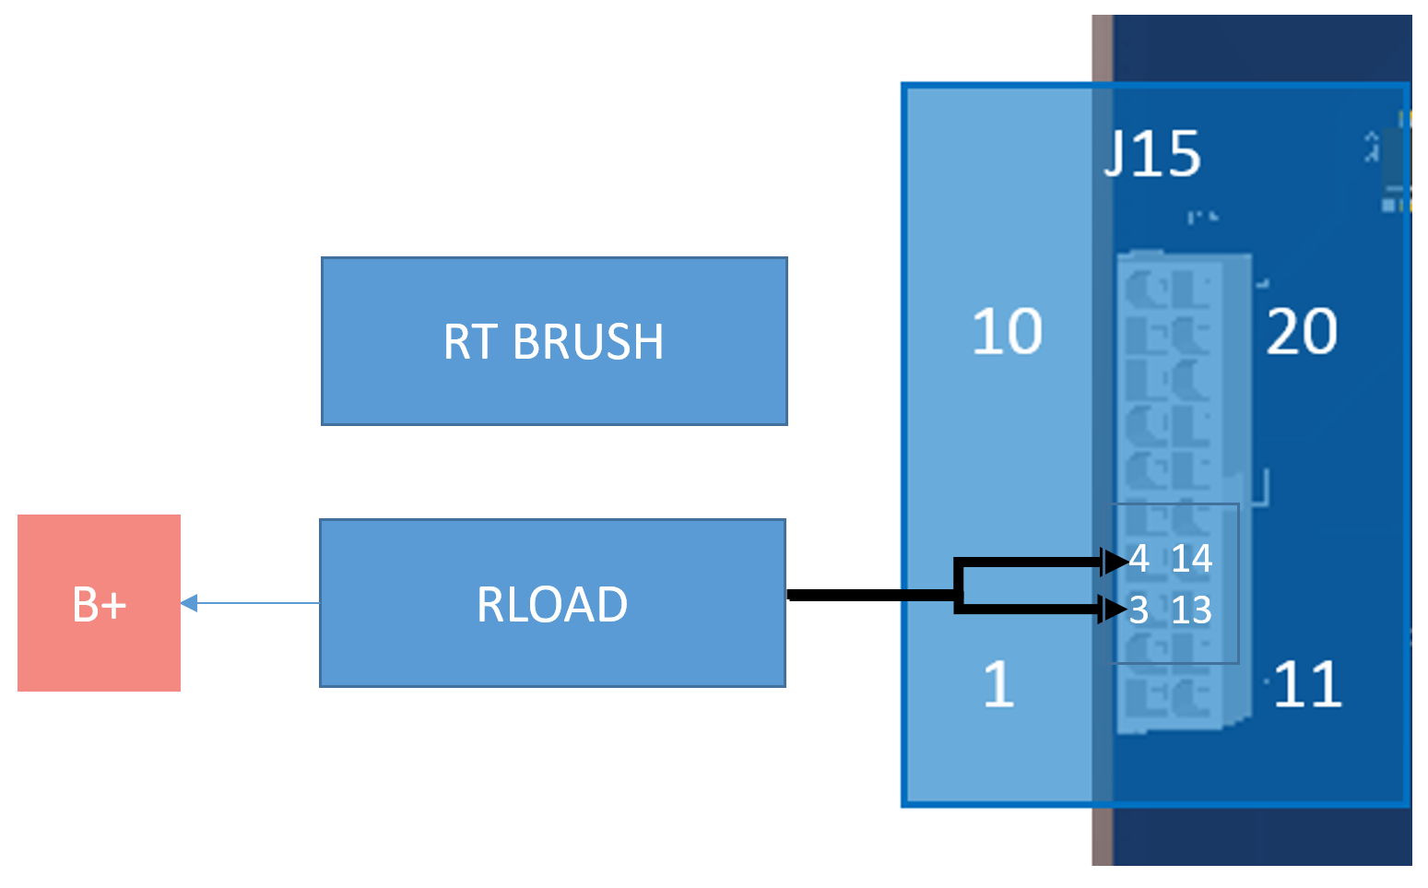

*Figure 6: RT BRUSH CONNECTION*

## **Left (LT) Brush**

Connect the Motor/Load between Power SUPPLY + and J15-Pins 5, 6, 15 and 16.

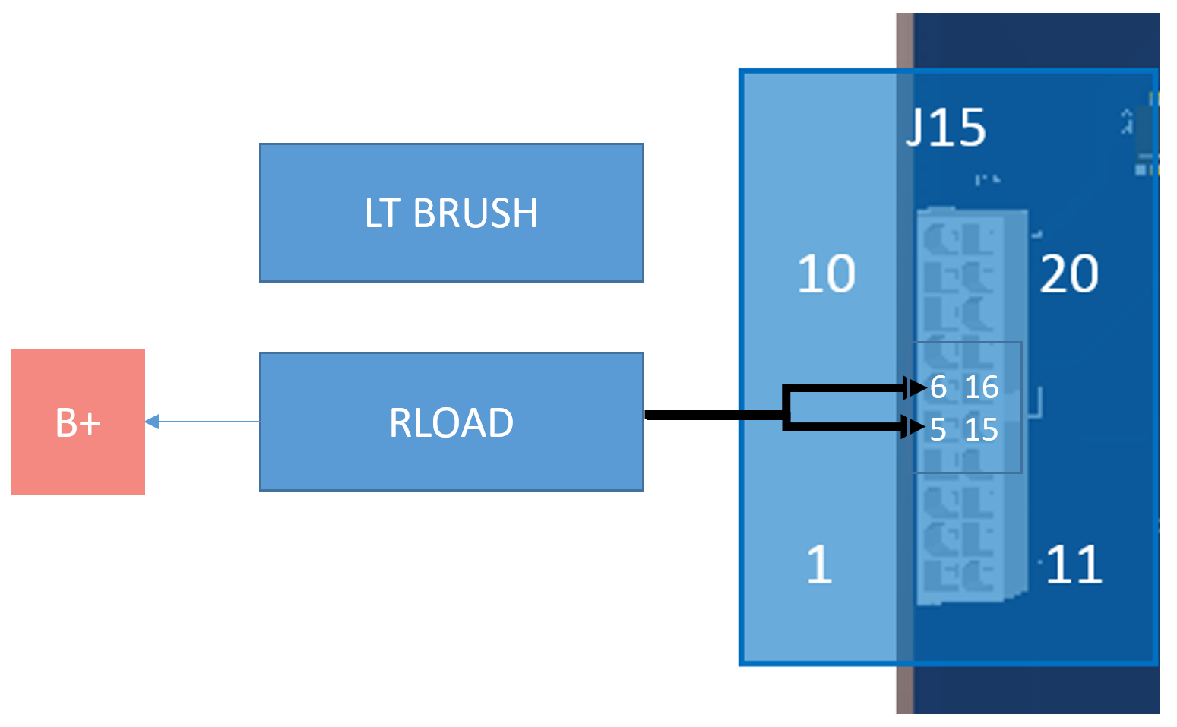

*Figure 7: LT BRUSH CONNECTION*

## **Hopper Roll Actuator (ACT)**

Connect the Motor/Load between J15-Pins9,10,19,20 and J15-Pins 7,8,17,18.

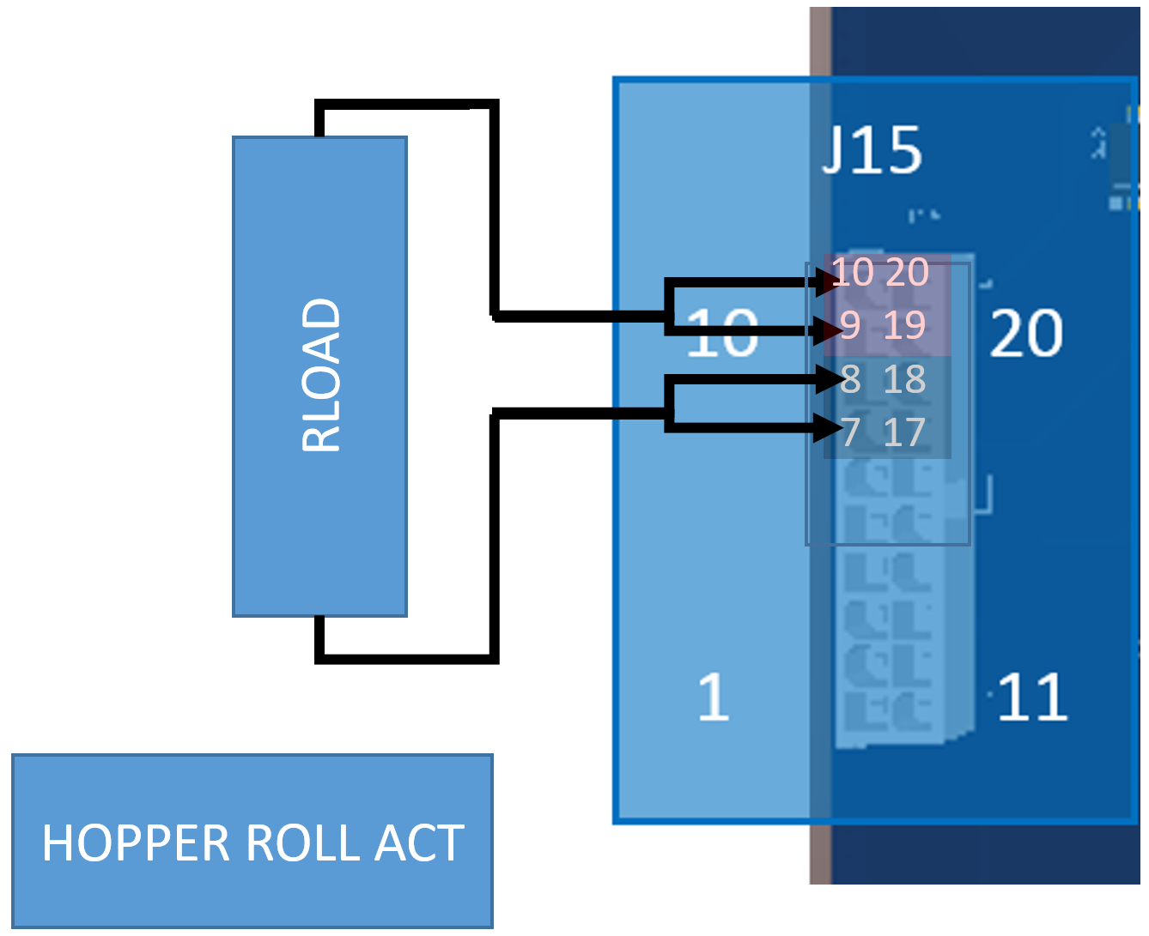

*Figure 8: HOPPER ROLL CONNECTION*

## **MAIN Brush (ACT)**

Connect the Motor/Load between J15-Pins2,12 and J14-Pins 1,11.

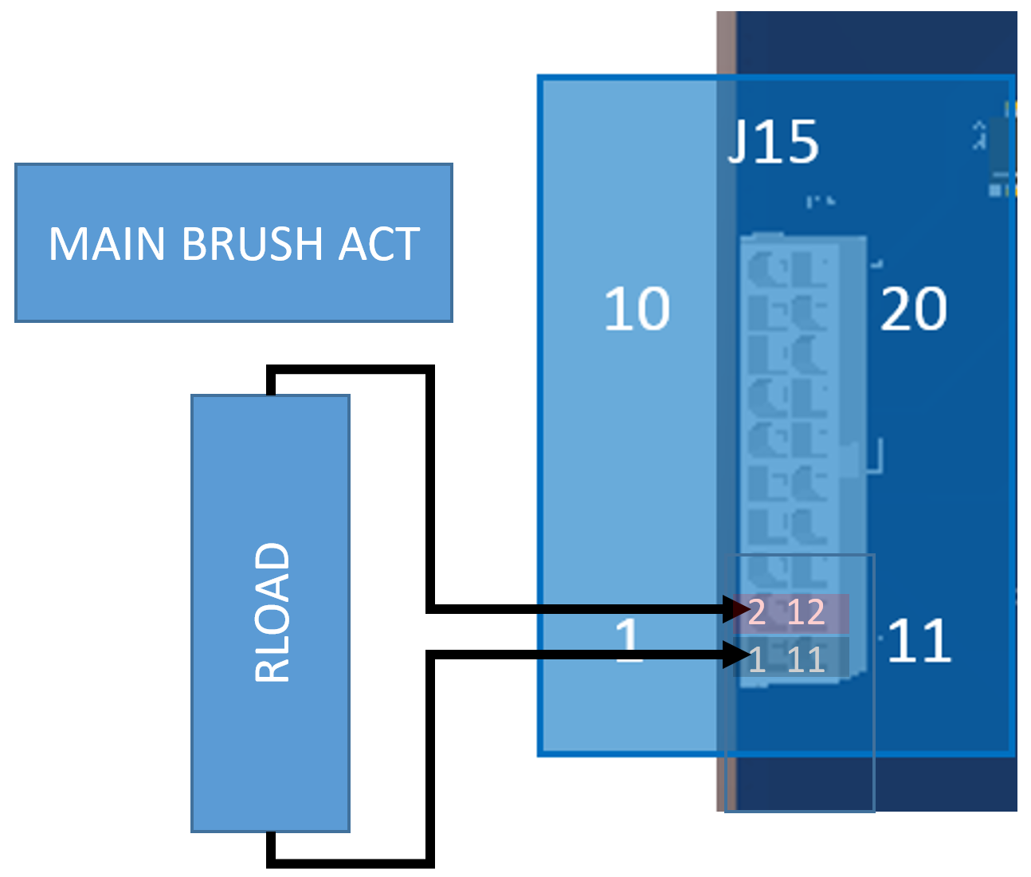

*Figure 9: MAIN BRUSH ACT CONNECTION*

## **LT Brush (ACT)**

Connect the Motor/Load between J14-Pins7,15 and J14-Pins 6,14.

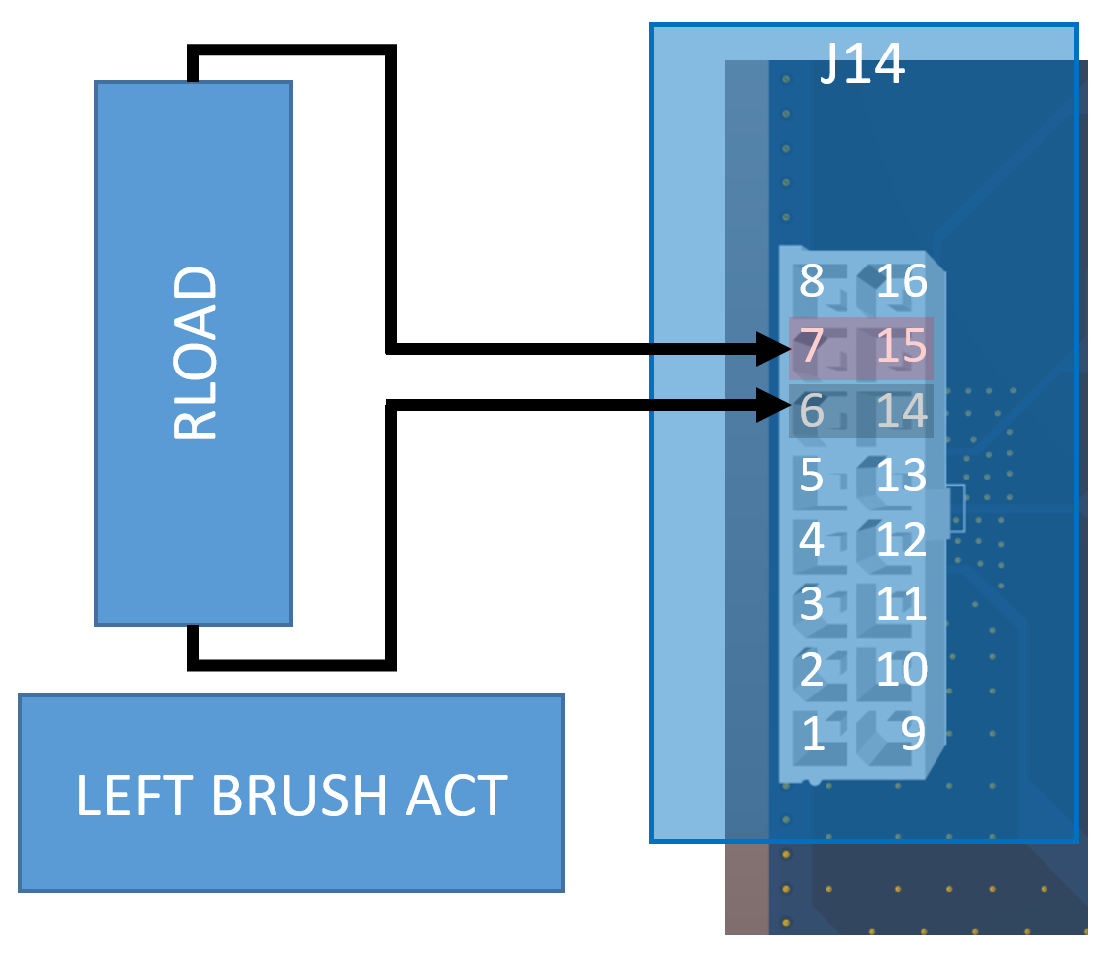

*Figure 10: LT BRUSH ACT CONNECTION*

## **RT Brush (ACT)**

Connect the Motor/Load between J14-Pins5,13 and J14-Pins 4,12.

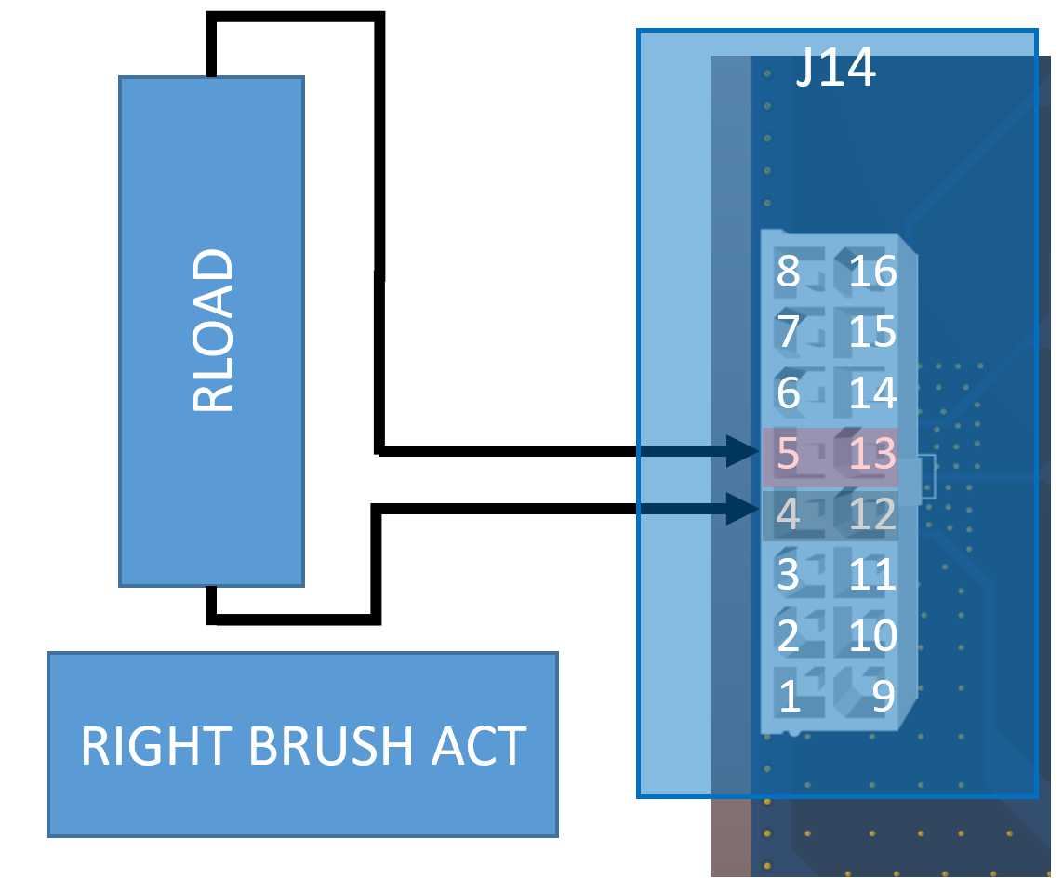

*Figure 11: RT BRUSH ACT CONNECTION*

## ~~Mist Pump (REMOVED)~~

~~Although NOT used in this Model, its connections are shown for Future use.~~

~~Connect the load between Power SUPPLY + and J14-Pins 1,2,3,9,10,11.~~

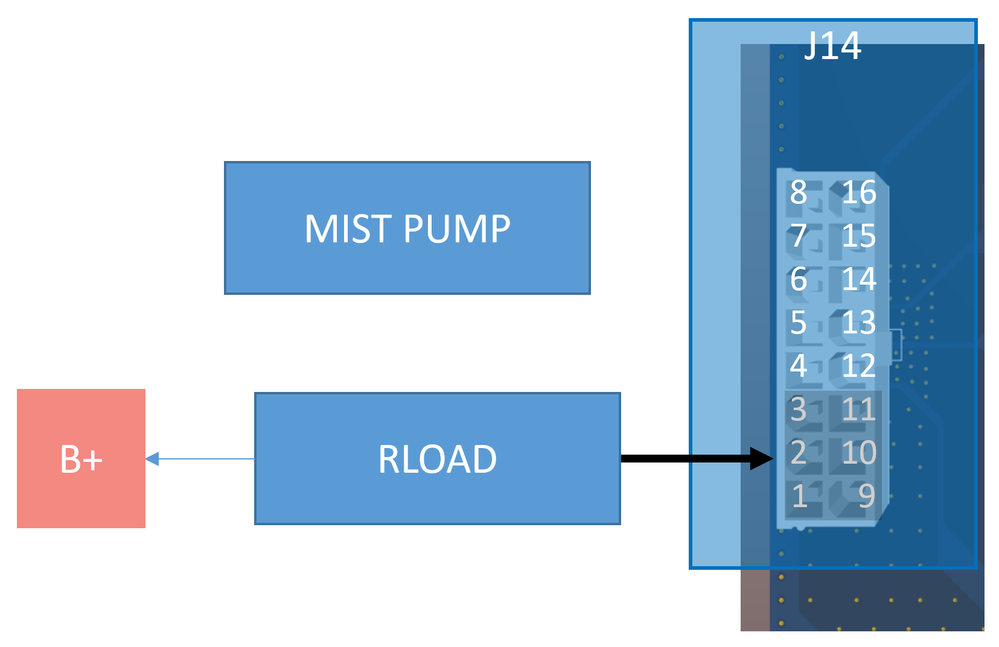

*Figure 12: MIST PUMP CONNECTION*

## **Horn**

Connect the load between Power SUPPLY + and J16-Pins 7.

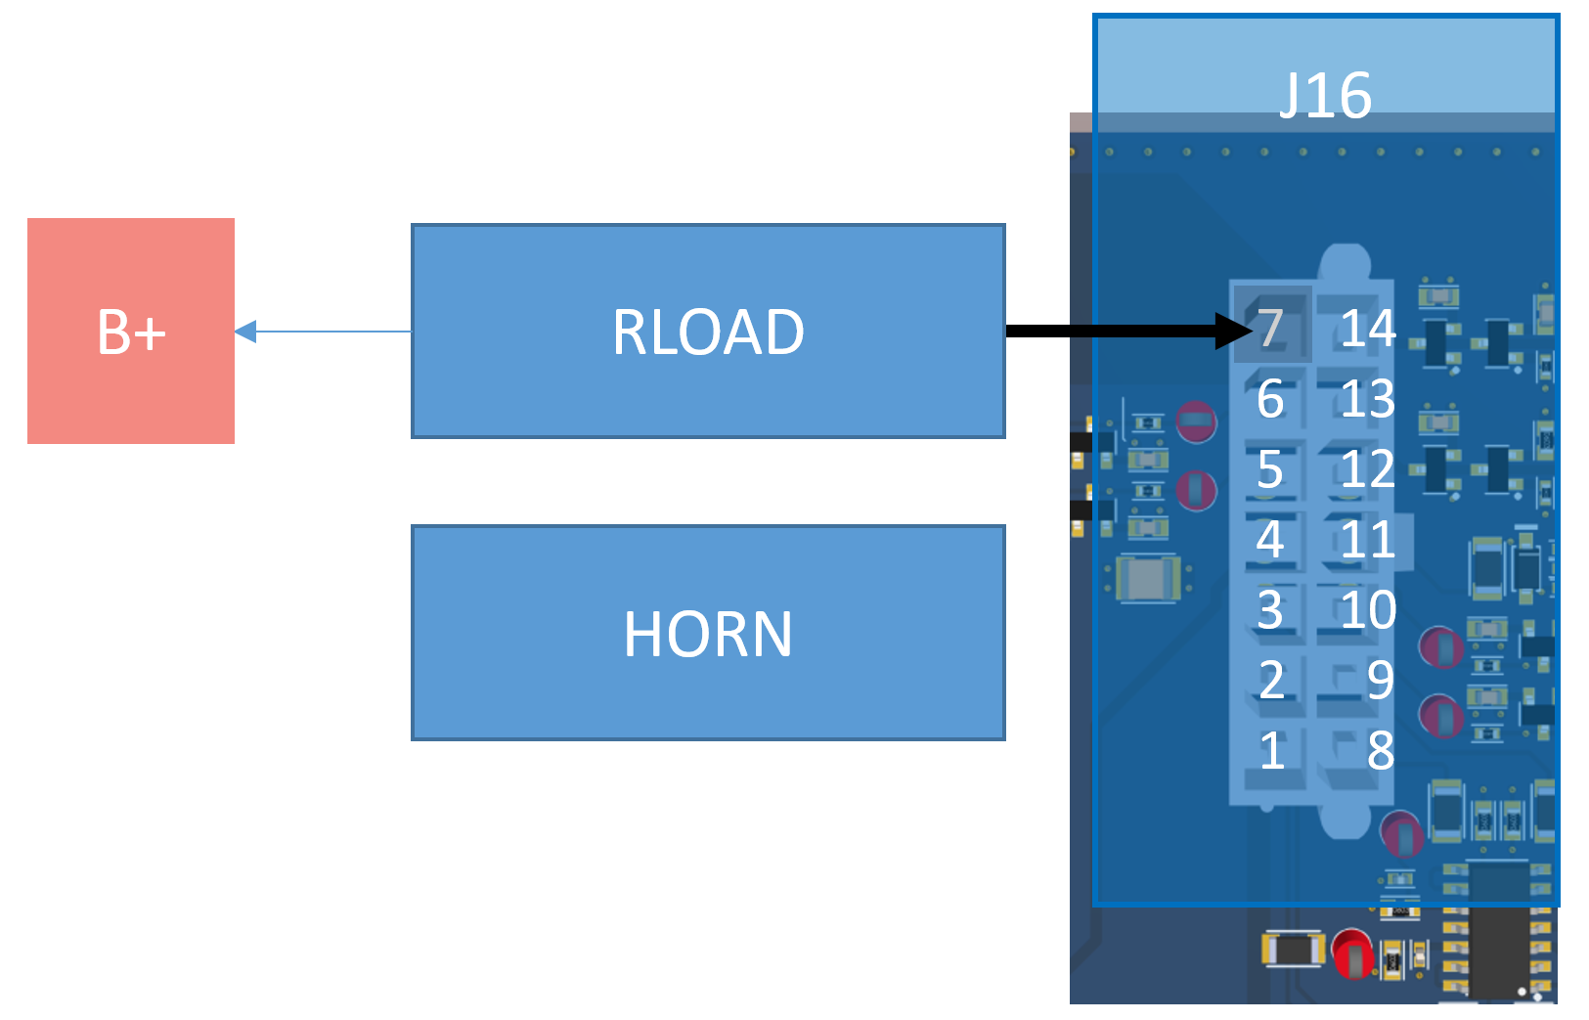

*Figure 13: HORN CONNECTION*

## **Vacuum HEPA Filter Sensor**

Connect J16-Pins 13 and 8 to simple circuit seen below. 1.66V SW OPEN. 1.25V SW CLOSED.

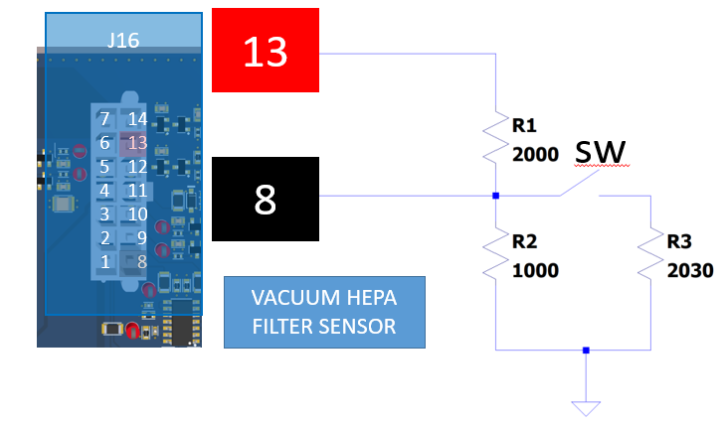

*Figure 14: VACUUM HEPA FILTER SENSOR CONNECTION*

## **Vacuum Filter Sensor**

Connect J16-Pins 14 and 9 to simple circuit seen below. 1.66V SW OPEN. 1.25V SW CLOSED.

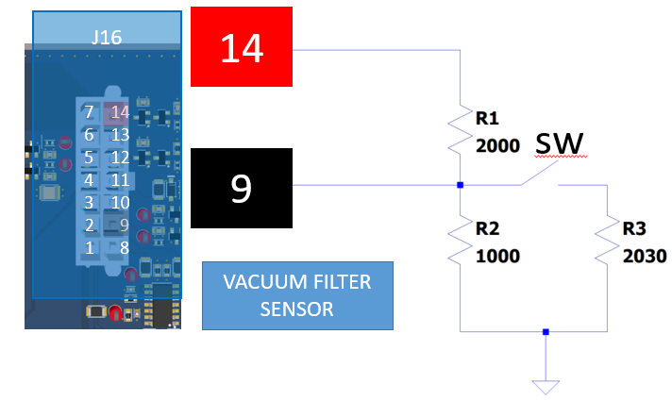

*Figure 15: VACUUM FILTER SENSOR CONNECTION*

## **~~Dust Pump Water Level Switch~~**

~~Although NOT used in this Model, its connections are shown for Future use.~~

~~Connect J16-Pins 12 and GND.~~

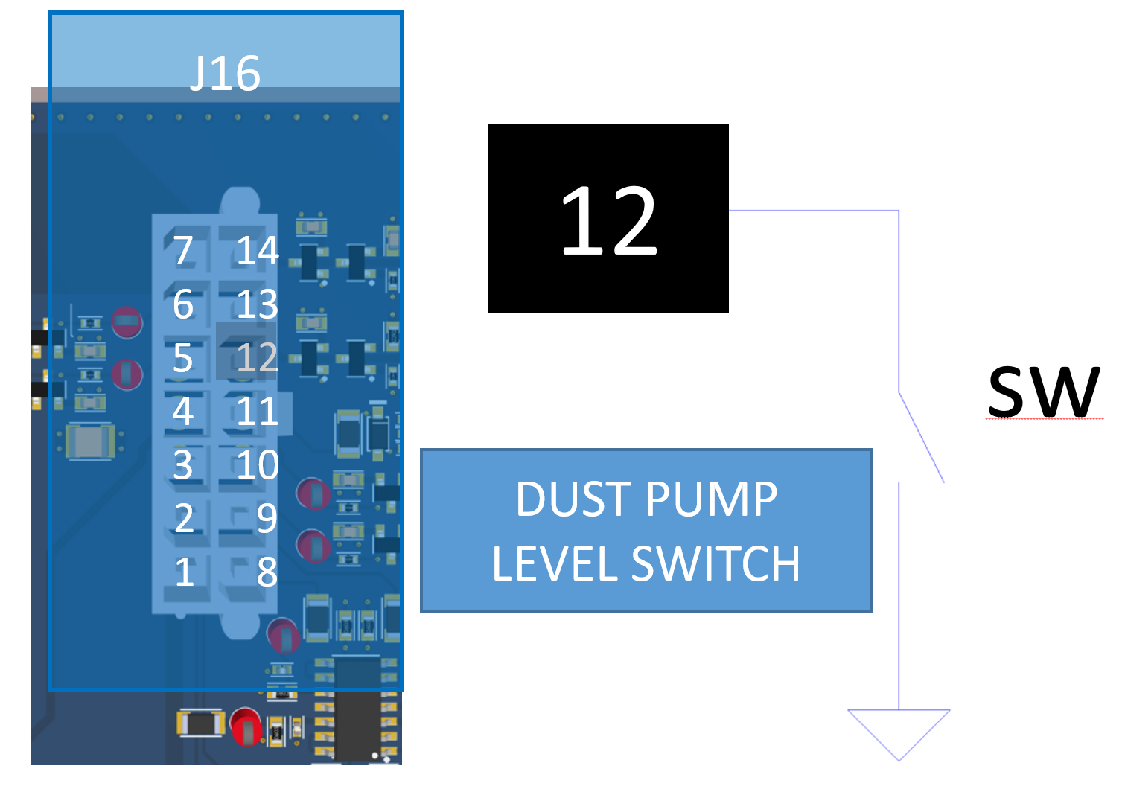

*Figure 16: DUST PUMP LEVEL SWITCH CONNECTION*

## **~~Seat Switch (REMOVED)~~**

~~Connect J17-Pins 7 and GND. NO LONGER USED~~

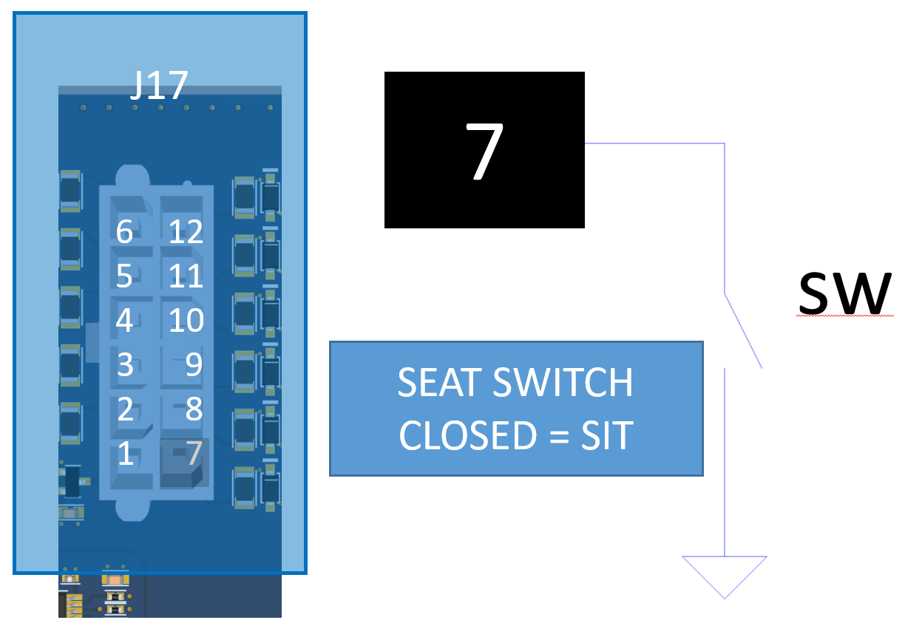

*Figure 17: SEAT SWITCH CONNECTION*

## **Hopper Rolled In Switch**

Connect J17-Pins 8 and GND.

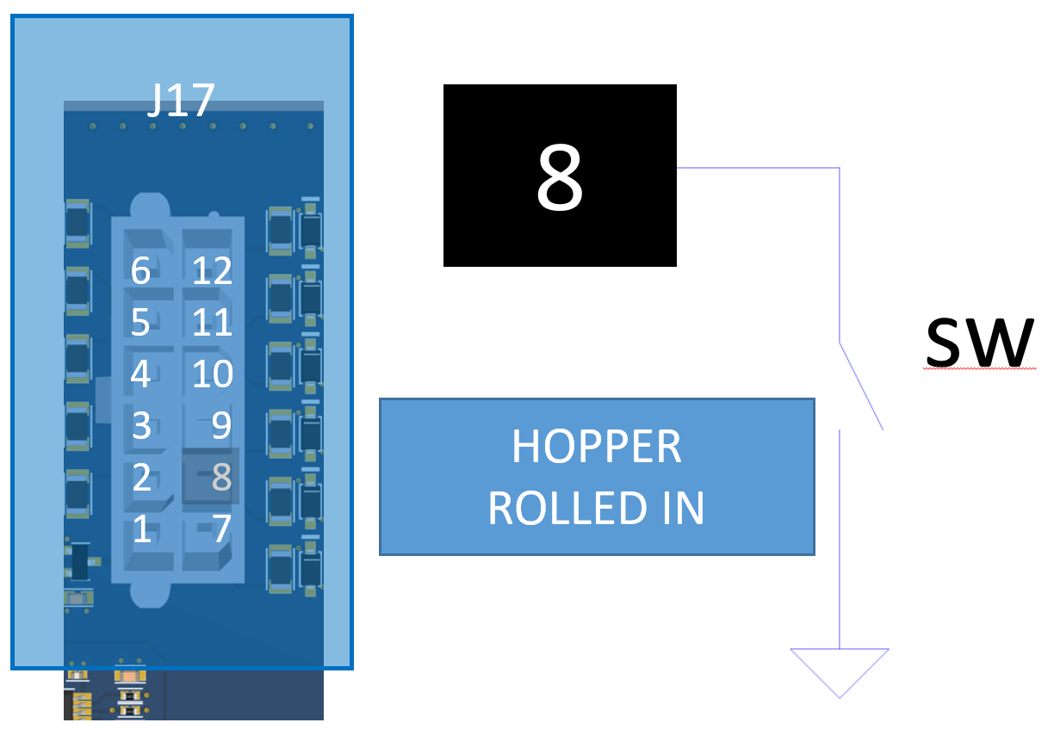

*Figure 18: HOPPER ROLLED IN SWITCH CONNECTION*

## **Hopper Home Switch**

Connect J17-Pins 9 and GND.

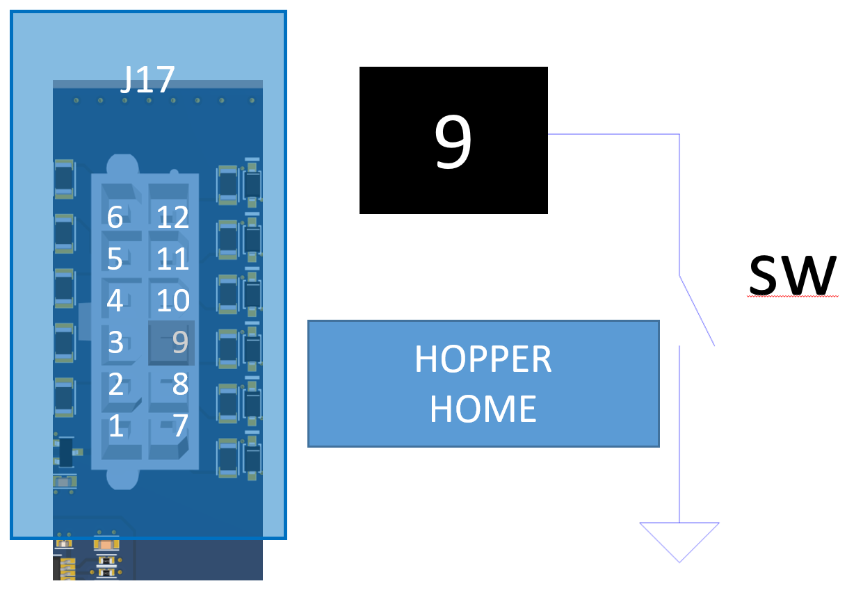

*Figure 19: HOPPER HOME SWITCH CONNECTION*

## **Hopper Safe to Roll Switch**

Connect J17-Pins 10 and GND.

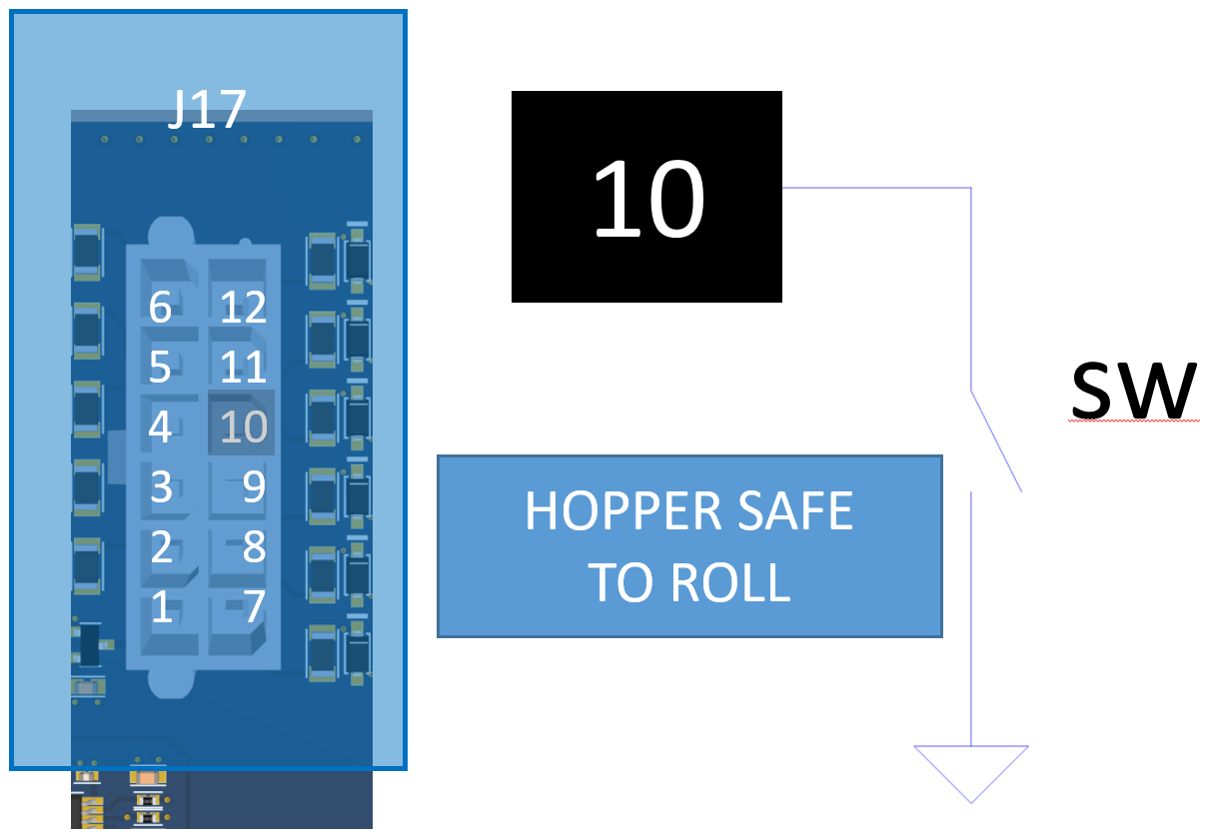

*Figure 20: HOPPER SAFE TO ROLL SWITCH CONNECTION*

## **Thermal Switch**

Connect J17-Pins 11 and GND.

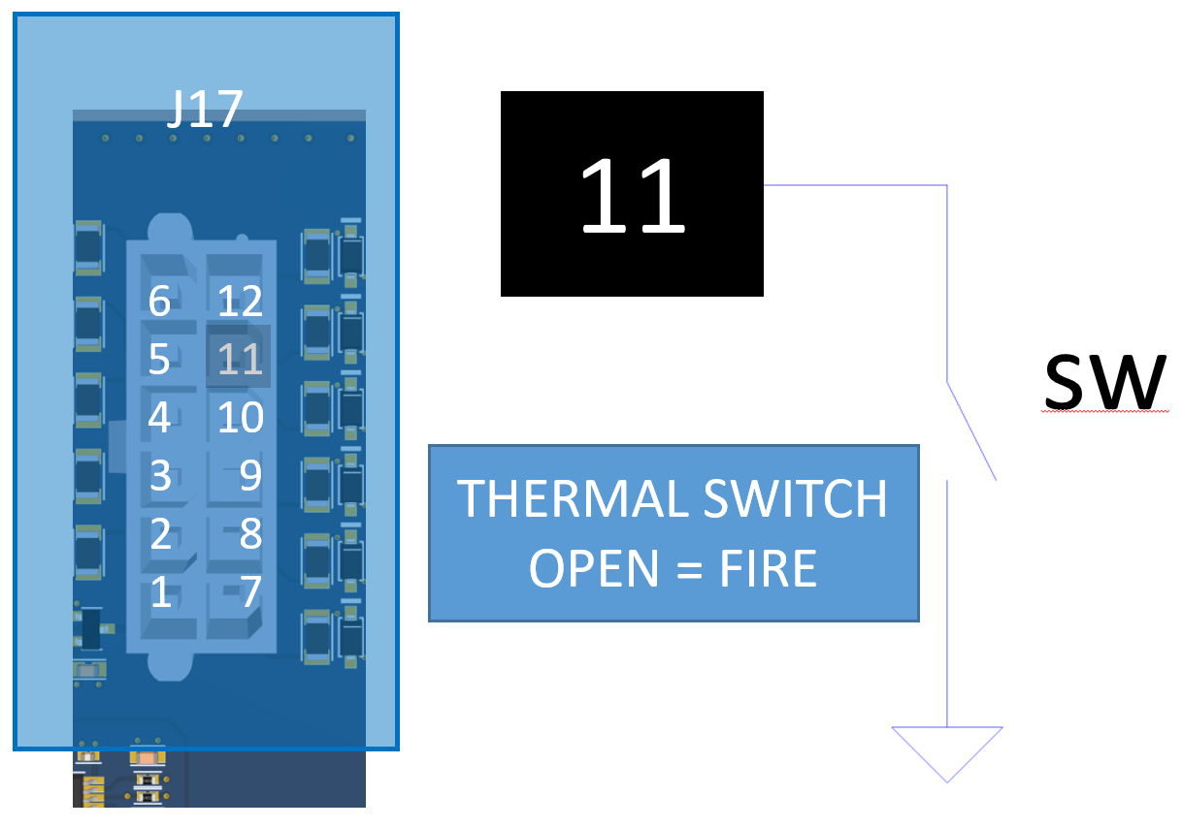

*Figure 21: THERMAL SWITCH CONNECTION*

## **HOPPER LIFT ACTUATOR**

Connect J10-Pin 1 through RLOAD to Pin 3 and Pin 2 through RLOAD to Pin 3.

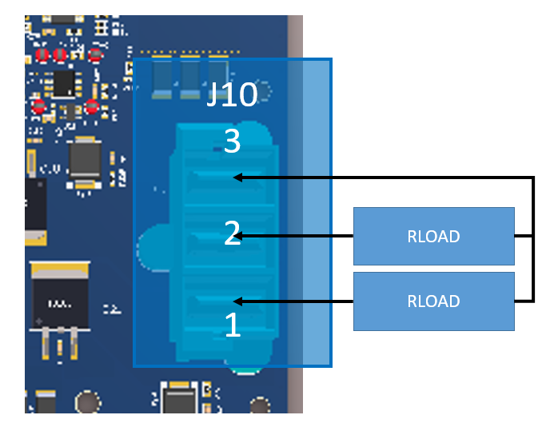

*Figure 22: HOPPER LIFT ACTUATOR CONNECTION*

## **BACKUP ALARM**

Connect the load between Power SUPPLY + and J16-Pin 2.

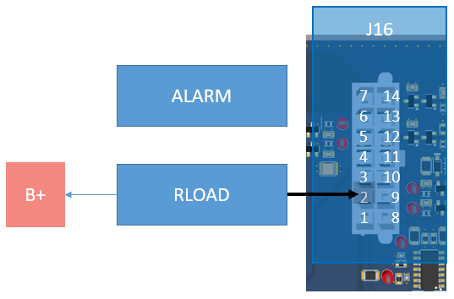

*Figure 23: BACKUP ALARM CONNECTION*

## **SHAKER**

Connect the load between Power SUPPLY + and J11-Pin 1.

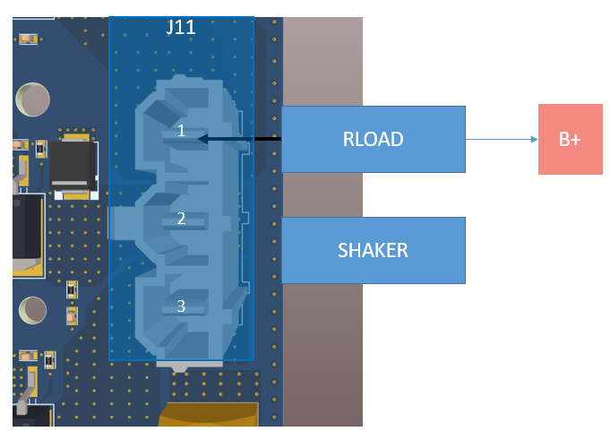

*Figure 24: SHAKER CONNECTION*

## **VACUUM1**

Connect the load between Power SUPPLY + and J11-Pin 2.

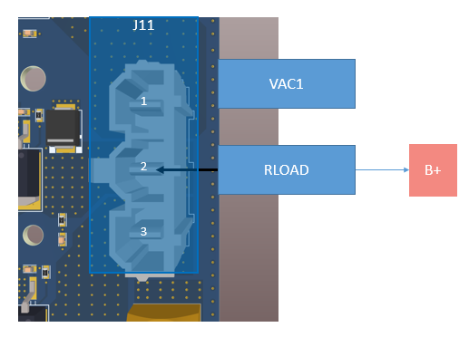

*Figure 25: VACUUM1 CONNECTION*

## **VACUUM2**

Connect the load between Power SUPPLY + and J11-Pin 3.

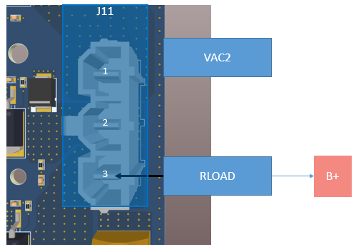

*Figure 26: VACUUM2 CONNECTION*

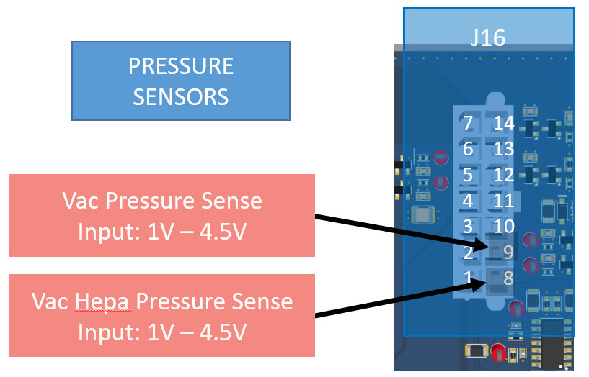

Figure 27: PRESSURE SENSORS

## **Alternate 48V test (Using 36V and 39V)**

Connect a 348K load between Power SUPPLY B+ and TP40. Using this method 36V will appear as 45V. 40V will appear as 50V)

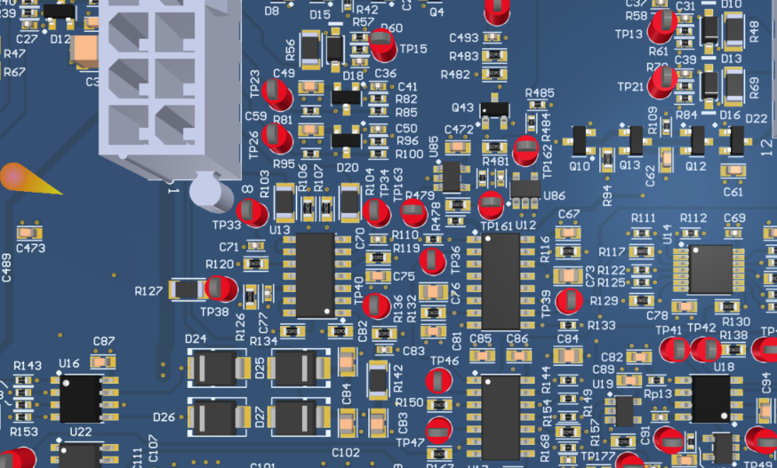

Figure 28: 48V CHECK

# **Input Function Testing**

**NOTE: ALL System functions must be run with CAN commands.**

With the Power Supply set supply to 36V 2A

## **Hopper Rolled IN**

Index 0X3601

Sub index 0x01

Data 0x01 (Status bit0 set)

## **Hopper Home**

Index 0X3601

Sub index 0x01

Data 0x02 (Status bit1 set)

## **Hopper Safe To Roll**

Index 0X3601

Sub index 0x01

Data 0x04 (Status bit2 = 1 with HOPPER SWITCH OPEN)

Data 0x04 (Status bit2 = 0 with HOPPER SWITCH CLOSED)

## **Vacuum Filter Sensor Voltage Check** **+/-5.5% of applied voltage**

Follow Figure 27: PRESSURE SENSORS to connect low voltage supply to board.

Ensure system reports +/-5.5% of applied voltage.

**<Query REPORTED VOLTAGE (LSB, MSB)> +/-5.5% of applied voltage (0.95V to 1.05V)**

Apply 1.00V 🡪 100 🡪 0x0064 🡪 (64,00)

0x3149

|  |  |  |  |  |
| --- | --- | --- | --- | --- |
| Sub Index | BYTE 0 (LSB) | BYTE 1 (MSB) | BYTE 2 | BYTE 3 |
| 0x02 | 0x64 | 0x00 | 0x00 | 0x00 |

**<Query REPORTED VOLTAGE (LSB, MSB)> +/-5.5% of applied voltage (3.8V to 4.2V)**

Apply 4.00V 🡪 400 🡪 0x0190 🡪 (90,01)

0x3149

|  |  |  |  |  |
| --- | --- | --- | --- | --- |
| Sub Index | BYTE 0 (LSB) | BYTE 1 (MSB) | BYTE 2 | BYTE 3 |
| 0x02 | 0x90 | 0x01 | 0x00 | 0x00 |

## **Vacuum HEPA Filter Sensor Voltage Check** **+/-5.5% of applied voltage**

Follow Figure 27: PRESSURE SENSORS to connect low voltage supply to board.

Ensure system reports +/-5.5% of applied voltage.

**<Query REPORTED VOLTAGE (LSB, MSB)> +/-5.5% of applied voltage (0.95V to 1.05V)**

Apply 1.00V 🡪 100 🡪 0x0064 🡪 (64,00)

0x314B

|  |  |  |  |  |
| --- | --- | --- | --- | --- |
| Sub Index | BYTE 0 (LSB) | BYTE 1 (MSB) | BYTE 2 | BYTE 3 |
| 0x02 | 0x64 | 0x00 | 0x00 | 0x00 |

**<Query REPORTED VOLTAGE (LSB, MSB)> +/-5.5% of applied voltage (3.8V to 4.2V)**

Apply 4.00V 🡪 400 🡪 0x0190 🡪 (90,01)

0x314B

|  |  |  |  |  |
| --- | --- | --- | --- | --- |
| Sub Index | BYTE 0 (LSB) | BYTE 1 (MSB) | BYTE 2 | BYTE 3 |
| 0x02 | 0x90 | 0x01 | 0x00 | 0x00 |

## **Thermal Switch**

(FAULT @ 1 – Requires Key-Cycle:Bit3 set to 1)

Index 0X3800

Sub index 0x03

Data 0x08 (Status bit3 = 1 with HOPPER SWITCH OPEN)

Data 0x00 (Status bit3 = 0 with HOPPER SWITCH CLOSED)

# **Output Function (Load Operations) Testing**

Follow steps for POWERING THE BOARD (Above)

Set supply to 36V 50A.

## **MAIN BRUSH 48A Check**

Follow Figure 5: MAIN SWEEP CONNECTION to connect Main Brush with 48A load.

Actual Current = Supply/Load. Ensure +/-5.5% of actual load.

**<WRITE MAIN BRUSH Current Limit to 50A. 5000d -> 88h, 13h (LSB, MSB)>**

0x3072

|  |  |  |  |  |
| --- | --- | --- | --- | --- |
| Sub Index | BYTE 0 (LSB) | BYTE 1 (MSB) | BYTE 2 | BYTE 3 |
| 0x04 | 0x88 | 0x13 | 0x00 | 0x00 |

**<WRITE MAIN BRUSH to 31.5V and start motor 3150d -> 4Eh, 0Ch (LSB, MSB)>**

0x3070

|  |  |  |  |  |
| --- | --- | --- | --- | --- |
| Sub Index | BYTE 0 | BYTE 1 (LSB) | BYTE 2 (MSB) | BYTE 3 |
| 0x03 | 0x01 | 0x4E | 0x0C | 0x00 |

**<READ MAIN BRUSH status:State>**

0x3071

|  |  |  |  |  |
| --- | --- | --- | --- | --- |
| Sub Index | BYTE 0 | BYTE 1 | BYTE 2 | BYTE 3 |
| 0x01 | 0x02 | 0x00 | 0x00 | 0x00 |

**< Should say *RUNNING* if using UI board or 0x02 if displaying CAN >**

**<READ MAIN BRUSH status:Status-Bits>**

0x3071

|  |  |  |  |  |
| --- | --- | --- | --- | --- |
| Sub Index | BYTE 0 | BYTE 1 | BYTE 2 | BYTE 3 |
| 0x02 | 0x01 | 0x00 | 0x00 | 0x00 |

**< Should say *RUNNING* if using UI board or 0x01 if displaying CAN >**

**<READ MAIN BRUSH Current>**

0x3071

|  |  |  |  |  |
| --- | --- | --- | --- | --- |
| Sub Index | BYTE 0 (LSB) | BYTE 1 (MSB) | BYTE 2 | BYTE 3 |
| 0x03 | 0xC0 | 0x12 | 0x00 | 0x00 |

**< Should say ~48A. 4800Ad -> C0h, 12h (LSB, MSB) >**

**<WRITE MAIN BRUSH to 0V (off) and stop motor/Load>**

0x3070

|  |  |  |  |  |
| --- | --- | --- | --- | --- |
| Sub Index | BYTE 0 | BYTE 1 (LSB) | BYTE 2 (MSB) | BYTE 3 |
| 0x03 | 0x02 | 0x00 | 0x00 | 0x00 |

**<READ MAIN BRUSH status:State>**

0x3071

|  |  |  |  |  |
| --- | --- | --- | --- | --- |
| Sub Index | BYTE 0 | BYTE 1 | BYTE 2 | BYTE 3 |
| 0x01 | 0x01 | 0x00 | 0x00 | 0x00 |

**< Should say *IDLE* if using UI board or 0x01 if displaying CAN >**

**<READ MAIN BRUSH Current>**

0x3071

|  |  |  |  |  |
| --- | --- | --- | --- | --- |
| Sub Index | BYTE 0 (LSB) | BYTE 1 (MSB) | BYTE 2 | BYTE 3 |
| 0x03 | 0x00 | 0x00 | 0x00 | 0x00 |

**< Should say ~0Ad -> 00h, 00h (LSB, MSB) >**

## **HOPPER RAISE 36A Check**

Follow *Figure 22: HOPPER LIFT ACTUATOR CONNECTION* to connect Hopper Lift with 36A load.

Actual Current = Supply/Load. Ensure +/-5.5% of actual load.

**<WRITE HOPPER RAISE Current Limit to 40A. 4000d -> A0h, 0Fh (LSB, MSB)>**

0x3604

|  |  |  |  |  |
| --- | --- | --- | --- | --- |
| Sub Index | BYTE 0 (LSB) | BYTE 1 (MSB) | BYTE 2 | BYTE 3 |
| 0x01 | 0xA0 | 0x0F | 0x00 | 0x00 |

**<WRITE HOPPER RAISE >**

0x3600

|  |  |  |  |  |
| --- | --- | --- | --- | --- |
| Sub Index | BYTE 0 | BYTE 1 | BYTE 2 | BYTE 3 |
| 0x01 | 0x01 | 0x00 | 0x00 | 0x00 |

**<READ HOPPER RAISE status:State>**



**<READ HOPPER RAISE status:State>**

0x3602

|  |  |  |  |  |
| --- | --- | --- | --- | --- |
| Sub Index | BYTE 0 | BYTE 1 | BYTE 2 | BYTE 3 |
| 0x01 | 0x02 | 0x00 | 0x00 | 0x00 |

**< Should say *Moving* if using UI board or 0x02 if displaying CAN >**

**<READ HOPPER RAISE status:Status-Bits>**

0x3602

|  |  |  |  |  |
| --- | --- | --- | --- | --- |
| Sub Index | BYTE 0 | BYTE 1 | BYTE 2 | BYTE 3 |
| 0x02 | 0x01 | 0x00 | 0x00 | 0x00 |

**< Should say * EXTENDNG* if using UI board or 0x01 if displaying CAN >**

**<READ HOPPER RAISE Current>**

0x3602

|  |  |  |  |  |
| --- | --- | --- | --- | --- |
| Sub Index | BYTE 0 (LSB) | BYTE 1 (MSB) | BYTE 2 | BYTE 3 |
| 0x04 | 0x10 | 0x0E | 0x00 | 0x00 |

**< Should say ~36A 3600Ad -> 10h, 0Eh (LSB, MSB) >**

**<WRITE HOPPER RAISE to stop motor/Load>**

0x3600

|  |  |  |  |  |
| --- | --- | --- | --- | --- |
| Sub Index | BYTE 0 | BYTE 1 (LSB) | BYTE 2 (MSB) | BYTE 3 |
| 0x01 | 0x10 | 0x00 | 0x00 | 0x00 |

**<READ HOPPER RAISE status:State>**

0x3602

|  |  |  |  |  |
| --- | --- | --- | --- | --- |
| Sub Index | BYTE 0 | BYTE 1 | BYTE 2 | BYTE 3 |
| 0x01 | 0x01 | 0x00 | 0x00 | 0x00 |

**< Should say *Stopped* if using UI board or 0x01 if displaying CAN >**

**<READ HOPPER RAISE Current>**

0x3602

|  |  |  |  |  |
| --- | --- | --- | --- | --- |
| Sub Index | BYTE 0 (LSB) | BYTE 1 (MSB) | BYTE 2 | BYTE 3 |
| 0x04 | 0x00 | 0x00 | 0x00 | 0x00 |

**< Should say ~0Ad -> 00h, 00h (LSB, MSB) >**

## **HOPPER LOWER 36A Check**

Follow *Figure 22: HOPPER LIFT ACTUATOR CONNECTION* to connect Hopper Lift with 36A load. Actual Current = Supply/Load. Ensure +/-5.5% of actual load.

**<WRITE HOPPER LIFT Current Limit to 40A. 4000d -> A0h, 0Fh (LSB, MSB)>**

0x3604

|  |  |  |  |  |
| --- | --- | --- | --- | --- |
| Sub Index | BYTE 0 (LSB) | BYTE 1 (MSB) | BYTE 2 | BYTE 3 |
| 0x01 | 0xA0 | 0x0F | 0x00 | 0x00 |

**<WRITE HOPPER LOWER >**

0x3600

|  |  |  |  |  |
| --- | --- | --- | --- | --- |
| Sub Index | BYTE 0 | BYTE 1 | BYTE 2 | BYTE 3 |
| 0x01 | 0x02 | 0x00 | 0x00 | 0x00 |



**<READ HOPPER LOWER status:State>**

0x3602

|  |  |  |  |  |
| --- | --- | --- | --- | --- |
| Sub Index | BYTE 0 | BYTE 1 | BYTE 2 | BYTE 3 |
| 0x01 | 0x02 | 0x00 | 0x00 | 0x00 |

**< Should say *MOVING* if using UI board or 0x02 if displaying CAN >**

**<READ HOPPER LOWER status:Status-Bits>**

0x3602

|  |  |  |  |  |
| --- | --- | --- | --- | --- |
| Sub Index | BYTE 0 | BYTE 1 | BYTE 2 | BYTE 3 |
| 0x02 | 0x00 | 0x00 | 0x00 | 0x00 |

**< Should say *RETRACTING* if using UI board or 0x00 if displaying CAN >**

**<READ HOPPER LOWER Current>**

0x3602

|  |  |  |  |  |
| --- | --- | --- | --- | --- |
| Sub Index | BYTE 0 (LSB) | BYTE 1 (MSB) | BYTE 2 | BYTE 3 |
| 0x04 | 0x10 | 0x0E | 0x00 | 0x00 |

**< Should say ~36A 3600Ad -> 10h, 0Eh (LSB, MSB) >**

**<WRITE HOPPER LOWER to stop motor/Load>**

0x3600

|  |  |  |  |  |
| --- | --- | --- | --- | --- |
| Sub Index | BYTE 0 | BYTE 1 | BYTE 2 | BYTE 3 |
| 0x01 | 0x10 | 0x00 | 0x00 | 0x00 |

**<READ HOPPER LOWER status:State>**

0x3602

|  |  |  |  |  |
| --- | --- | --- | --- | --- |
| Sub Index | BYTE 0 | BYTE 1 | BYTE 2 | BYTE 3 |
| 0x01 | 0x01 | 0x00 | 0x00 | 0x00 |

**< Should say *Stopped* if using UI board or 0x01 if displaying CAN >**

**<READ HOPPER LOWER Current>**

0x3602

|  |  |  |  |  |
| --- | --- | --- | --- | --- |
| Sub Index | BYTE 0 (LSB) | BYTE 1 (MSB) | BYTE 2 | BYTE 3 |
| 0x4 | 0x00 | 0x00 | 0x00 | 0x00 |

**< Should say ~0Ad -> 00h, 00h (LSB, MSB) >**

## **VAC 1 20A Check**

Follow Figure 25: VACUUM1 CONNECTION to connect Vacuum1 with 20A load.

Actual Current = Supply/Load. Ensure +/-5.5% of actual load.

**<WRITE VAC 1 Current Limit to 25A. 2500d -> C4h, 09h (LSB, MSB)>**

0x314A

|  |  |  |  |  |
| --- | --- | --- | --- | --- |
| Sub Index | BYTE 0 (LSB) | BYTE 1 (MSB) | BYTE 2 | BYTE 3 |
| 0x04 | 0xC4 | 0x09 | 0x00 | 0x00 |

**<WRITE VAC 1 to 31.5V and start motor> 3150d -> 01h, 4Eh, 0Ch, (COMMAND, VLSB, VMSB)>**

0x3148

|  |  |  |  |  |
| --- | --- | --- | --- | --- |
| Sub Index | BYTE 0 | BYTE 1 (LSB) | BYTE 2 (MSB) | BYTE 3 |
| 0x02 | 0x01 | 0x4E | 0x0C | 0x00 |

**<READ VAC 1 status:State>**

0x3149

|  |  |  |  |  |
| --- | --- | --- | --- | --- |
| Sub Index | BYTE 0 | BYTE 1 | BYTE 2 | BYTE 3 |
| 0x01 | 0x01 | 0x00 | 0x00 | 0x00 |

**< Should say *RUNNING* if using UI board or 0x01 if displaying CAN >**

**<READ VAC 1 Current>**

0x3149

|  |  |  |  |  |
| --- | --- | --- | --- | --- |
| Sub Index | BYTE 0 (LSB) | BYTE 1 (MSB) | BYTE 2 | BYTE 3 |
| 0x03 | 0xD0 | 0x07 | 0x00 | 0x00 |

**< Should say ~20Ad -> D0h, 07h (LSB, MSB) >**

**<WRITE VAC 1 to stop motor/Load>**

0x3148

|  |  |  |  |  |
| --- | --- | --- | --- | --- |
| Sub Index | BYTE 0 | BYTE 1 | BYTE 2 | BYTE 3 |
| 0x02 | 0x02 | 0x00 | 0x00 | 0x00 |

**<READ VAC 1 status:State>**

0x3149

|  |  |  |  |  |
| --- | --- | --- | --- | --- |
| Sub Index | BYTE 0 | BYTE 1 | BYTE 2 | BYTE 3 |
| 0x01 | 0x00 | 0x00 | 0x00 | 0x00 |

**< Should say *IDLE* if using UI board or 0x00 if displaying CAN >**

**<READ VAC 1 Current>**

0x3149

|  |  |  |  |  |
| --- | --- | --- | --- | --- |
| Sub Index | BYTE 0 (LSB) | BYTE 1 (MSB) | BYTE 2 | BYTE 3 |
| 0x03 | 0x00 | 0x00 | 0x00 | 0x00 |

**< Should say ~0Ad -> 00h, 00h (LSB, MSB) >**

## **VAC 2 20A Check**

Follow *Figure 26: VACUUM2 CONNECTION* to connect Vacuum2 with 20A load.

Actual Current = Supply/Load. Ensure +/-5.5% of actual load.

**<WRITE VAC 2 Current Limit to 25A. 2500d -> C4h, 09h (LSB, MSB)>**

0x314C

|  |  |  |  |  |
| --- | --- | --- | --- | --- |
| Sub Index | BYTE 0 (LSB) | BYTE 1 (MSB) | BYTE 2 | BYTE 3 |
| 0x04 | 0xC4 | 0x09 | 0x00 | 0x00 |

**<WRITE VAC 2 to 31.5V and start motor 3150d -> 01h, 4Eh, 0Ch, (COMMAND, VLSB, VMSB)>**

0x3148

|  |  |  |  |  |
| --- | --- | --- | --- | --- |
| Sub Index | BYTE 0 | BYTE 1 (LSB) | BYTE 2 (MSB) | BYTE 3 |
| 0x03 | 0x01 | 0x4E | 0x0C | 0x00 |

**<READ VAC 2 status:State>**

0x314B

|  |  |  |  |  |
| --- | --- | --- | --- | --- |
| Sub Index | BYTE 0 | BYTE 1 | BYTE 2 | BYTE 3 |
| 0x01 | 0x01 | 0x00 | 0x00 | 0x00 |

**< Should say *RUNNING* if using UI board or 0x01 if displaying CAN >**

**<READ VAC 2 Current>**

0x314B

|  |  |  |  |  |
| --- | --- | --- | --- | --- |
| Sub Index | BYTE 0 (LSB) | BYTE 1 (MSB) | BYTE 2 | BYTE 3 |
| 0x03 | 0xD0 | 0x07 | 0x00 | 0x00 |

**< Should say ~20Ad -> D0h,07 (LSB, MSB) >**

**<WRITE VAC 2 to stop motor/Load>**

0x3148

|  |  |  |  |  |
| --- | --- | --- | --- | --- |
| Sub Index | BYTE 0 | BYTE 1 | BYTE 2 | BYTE 3 |
| 0x03 | 0x02 | 0x00 | 0x00 | 0x00 |

**<READ VAC 2 status:State>**

0x314B

|  |  |  |  |  |
| --- | --- | --- | --- | --- |
| Sub Index | BYTE 0 | BYTE 1 | BYTE 2 | BYTE 3 |
| 0x01 | 0x00 | 0x00 | 0x00 | 0x00 |

**< Should say *IDLE* if using UI board or 0x00 if displaying CAN >**

**<READ VAC 2 Current>**

0x314B

|  |  |  |  |  |
| --- | --- | --- | --- | --- |
| Sub Index | BYTE 0 (LSB) | BYTE 1 (MSB) | BYTE 2 | BYTE 3 |
| 0x03 | 0x00 | 0x00 | 0x00 | 0x00 |

**< Should say ~0Ad -> 00h, 00h (LSB, MSB) >**

## **~~MIST PUMP 1.2A Check (REMOVED)~~**

**~~Although Not used in this System, the following commands are included for future use.~~**

~~Follow~~  *~~Figure 12: MIST PUMP CONNECTION~~* ~~to connect Dust Pump with 1.2A load. Actual Current = Supply/Load. Ensure +/-5.5% of actual load.~~

**~~<WRITE PUMP Current Limit to 1.5A. 150d -> 96h, 00h (LSB, MSB)>>~~**

~~0x34E2~~

|  |  |  |  |  |
| --- | --- | --- | --- | --- |
| ~~Sub Index~~ | ~~BYTE 0 (LSB)~~ | ~~BYTE 1 (MSB)~~ | ~~BYTE 2~~ | ~~BYTE 3~~ |
| ~~0x01~~ | ~~0x96~~ | ~~0x00~~ | ~~0x00~~ | ~~0x00~~ |

**~~<WRITE PUMP to 31.5V and start motor>~~**

~~0x34E0~~

|  |  |  |  |  |
| --- | --- | --- | --- | --- |
| ~~Sub Index~~ | ~~BYTE 0~~ | ~~BYTE 1 (LSB)~~ | ~~BYTE 2 (MSB)~~ | ~~BYTE 3~~ |
| ~~0x01~~ | ~~0x01~~ | ~~0x4E~~ | ~~0x0C~~ | ~~0x00~~ |

**~~<READ PUMP status:State>~~**

~~0x34E1~~

|  |  |  |  |  |
| --- | --- | --- | --- | --- |
| ~~Sub Index~~ | ~~BYTE 0~~ | ~~BYTE 1~~ | ~~BYTE 2~~ | ~~BYTE 3~~ |
| ~~0x01~~ | ~~0x02~~ | ~~0x00~~ | ~~0x00~~ | ~~0x00~~ |

**~~< Should say *Motor RUNNING* 0x02 >~~**

**~~<READ PUMP Current>~~**

~~0x34E1~~

|  |  |  |  |  |
| --- | --- | --- | --- | --- |
| ~~Sub Index~~ | ~~BYTE 0 (LSB)~~ | ~~BYTE 1 (MSB)~~ | ~~BYTE 2~~ | ~~BYTE 3~~ |
| ~~0x03~~ | ~~0x78~~ | ~~0x00~~ | ~~0x00~~ | ~~0x00~~ |

**~~< Should say ~1.2Ad -> 78h, 00h (LSB, MSB) >~~**

**~~<WRITE PUMP to stop motor/Load>~~**

~~0x34E0~~

|  |  |  |  |  |
| --- | --- | --- | --- | --- |
| ~~Sub Index~~ | ~~BYTE 0~~ | ~~BYTE 1 (LSB)~~ | ~~BYTE 2 (MSB)~~ | ~~BYTE 3~~ |
| ~~0x01~~ | ~~0x02~~ | ~~0x00~~ | ~~0x00~~ | ~~0x00~~ |

**~~<READ PUMP status:State>~~**

~~0x34E1~~

|  |  |  |  |  |
| --- | --- | --- | --- | --- |
| ~~Sub Index~~ | ~~BYTE 0~~ | ~~BYTE 1~~ | ~~BYTE 2~~ | ~~BYTE 3~~ |
| ~~0x01~~ | ~~0x01~~ | ~~0x00~~ | ~~0x00~~ | ~~0x00~~ |

**~~< Should say *IDLE* 0x01 >~~**

**~~<READ PUMP Current>~~**

~~0x34E1~~

|  |  |  |  |  |
| --- | --- | --- | --- | --- |
| ~~Sub Index~~ | ~~BYTE 0 (LSB)~~ | ~~BYTE 1 (MSB)~~ | ~~BYTE 2~~ | ~~BYTE 3~~ |
| ~~0x03~~ | ~~0x00~~ | ~~0x00~~ | ~~0x00~~ | ~~0x00~~ |

**~~< Should say ~0Ad -> 00h, 00h (LSB, MSB) >~~**

## **SHAKER 18A Check**

Follow  *Figure 24: SHAKER CONNECTION* to connect Shaker with 18A load. Actual Current = Supply/Load. Ensure +/-5.5% of actual load.

**<WRITE SHAKER Current Limit to 20A. 2000d -> D0h, 07h (LSB, MSB)>**

0x34F2

|  |  |  |  |  |
| --- | --- | --- | --- | --- |
| Sub Index | BYTE 0 (LSB) | BYTE 1 (MSB) | BYTE 2 | BYTE 3 |
| 0x04 | 0XD0 | 0x07 | 0x00 | 0x00 |

**<WRITE SHAKER to 31.5V and start motor>**

0x34F0

|  |  |  |  |  |
| --- | --- | --- | --- | --- |
| Sub Index | BYTE 0 | BYTE 1 (LSB) | BYTE 2 (MSB) | BYTE 3 |
| 0x01 | 0x01 | 0x4E | 0x0C | 0x00 |

**<READ SHAKER status:State>**

0x34F1

|  |  |  |  |  |
| --- | --- | --- | --- | --- |
| Sub Index | BYTE 0 | BYTE 1 | BYTE 2 | BYTE 3 |
| 0x01 | 0x02 | 0x00 | 0x00 | 0x00 |

**< Should say *RUNNING* if using UI board or 0x02 if displaying CAN >**

**<READ SHAKER Current>**

0x34F1

|  |  |  |  |  |
| --- | --- | --- | --- | --- |
| Sub Index | BYTE 0 (LSB) | BYTE 1 (MSB) | BYTE 2 | BYTE 3 |
| 0x03 | 0x08 | 0x07 | 0x00 | 0x00 |

**< Should say ~18Ad -> 08h, 07h (LSB, MSB) >**

**<WRITE SHAKER to stop motor/Load>**

0x34F0

|  |  |  |  |  |
| --- | --- | --- | --- | --- |
| Sub Index | BYTE 0 | BYTE 1 | BYTE 2 | BYTE 3 |
| 0x01 | 0x02 | 0x00 | 0x00 | 0x00 |

**<READ SHAKER status:State>**

0x34F1

|  |  |  |  |  |
| --- | --- | --- | --- | --- |
| Sub Index | BYTE 0 | BYTE 1 | BYTE 2 | BYTE 3 |
| 0x01 | 0x01 | 0x00 | 0x00 | 0x00 |

**< Should say *IDLE* if using UI board or 0x01 if displaying CAN >**

**<READ SHAKER Current>**

0x34F1

|  |  |  |  |  |
| --- | --- | --- | --- | --- |
| Sub Index | BYTE 0 (LSB) | BYTE 1 (MSB) | BYTE 2 | BYTE 3 |
| 0x03 | 0x00 | 0x00 | 0x00 | 0x00 |

**< Should say ~0Ad -> 00h, 00h (LSB, MSB) >**

## **MAIN BRUSH ACT EXTEND 9A Check**

Follow  *Figure 9: MAIN BRUSH ACT CONNECTION* to connect Main Brush Act with 9A load. Actual Current = Supply/Load. Ensure +/-5.5% of actual load.

**<WRITE MAIN BRUSH ACT Current Limit to 10A. 1000d -> E8h, 03h (LSB, MSB)>**

0x3092

|  |  |  |  |  |
| --- | --- | --- | --- | --- |
| Sub Index | BYTE 0 (LSB) | BYTE 1 (MSB) | BYTE 2 | BYTE 3 |
| 0x01 | 0XE8 | 0x03 | 0x00 | 0x00 |

**<WRITE MAIN BRUSH ACT to start motor>**

0x3090

|  |  |  |  |  |
| --- | --- | --- | --- | --- |
| Sub Index | BYTE 0 | BYTE 1 | BYTE 2 | BYTE 3 |
| 0x01 | 0x02 | 0x00 | 0x00 | 0x00 |

**<READ MAIN BRUSH ACT status: State>**

0x3091

|  |  |  |  |  |
| --- | --- | --- | --- | --- |
| Sub Index | BYTE 0 | BYTE 1 | BYTE 2 | BYTE 3 |
| 0x01 | 0x02 | 0x00 | 0x00 | 0x00 |

**< Should say *Actuator Moving* if using UI board or 0x02 if displaying CAN >**

**<READ MAIN BRUSH ACT status bits:State>**

0x3091

|  |  |  |  |  |
| --- | --- | --- | --- | --- |
| Sub Index | BYTE 0 | BYTE 1 | BYTE 2 | BYTE 3 |
| 0x02 | 0x01 | 0x00 | 0x00 | 0x00 |

**Extending (Bit0 = 1 for extend)01**

**<READ MAIN BRUSH ACT Current>**

0x3091

|  |  |  |  |  |
| --- | --- | --- | --- | --- |
| Sub Index | BYTE 0 (LSB) | BYTE 1 (MSB) | BYTE 2 | BYTE 3 |
| 0x04 | 0x84 | 0x03 | 0x00 | 0x00 |

**< Should say ~9Ad -> 84h, 03h (LSB, MSB) >**

**<WRITE MAIN BRUSH ACT to stop motor/Load>**

0x3090

|  |  |  |  |  |
| --- | --- | --- | --- | --- |
| Sub Index | BYTE 0 | BYTE 1 | BYTE 2 | BYTE 3 |
| 0x01 | 0x01 | 0x00 | 0x00 | 0x00 |

**<READ MAIN BRUSH ACT status:State>**

0x3091

|  |  |  |  |  |
| --- | --- | --- | --- | --- |
| Sub Index | BYTE 0 | BYTE 1 | BYTE 2 | BYTE 3 |
| 0x01 | 0x01 | 0x00 | 0x00 | 0x00 |

**< Should say *Actuator Stopped* if using UI board or 0x01 if displaying CAN >**

**<READ MAIN BRUSH ACT Current>**

0x3091

|  |  |  |  |  |
| --- | --- | --- | --- | --- |
| Sub Index | BYTE 0 (LSB) | BYTE 1 (MSB) | BYTE 2 | BYTE 3 |
| 0x04 | 0x00 | 0x00 | 0x00 | 0x00 |

**< Should say ~0Ad -> 00h, 00h (LSB, MSB) >**

## **MAIN BRUSH ACT RETRACT 9A Check**

Follow  *Figure 9: MAIN BRUSH ACT CONNECTION* to connect Main Brush Act with 9A load.

Actual Current = Supply/Load. Ensure +/-5.5% of actual load.

**<WRITE MAIN BRUSH ACT Current Limit to 10A. 1000d -> E8h, 03h (LSB, MSB)>**

0x3092

|  |  |  |  |  |
| --- | --- | --- | --- | --- |
| Sub Index | BYTE 0 (LSB) | BYTE 1 (MSB) | BYTE 2 | BYTE 3 |
| 0x01 | 0x84 | 0x03 | 0x00 | 0x00 |

**<WRITE MAIN BRUSH ACT to start motor>**

0x3090

|  |  |  |  |  |
| --- | --- | --- | --- | --- |
| Sub Index | BYTE 0 | BYTE 1 | BYTE 2 | BYTE 3 |
| 0x01 | 0x04 | 0x00 | 0x00 | 0x00 |

**<READ MAIN BRUSH ACT status:State>**

0x3091

|  |  |  |  |  |
| --- | --- | --- | --- | --- |
| Sub Index | BYTE 0 | BYTE 1 | BYTE 2 | BYTE 3 |
| 0x01 | 0x02 | 0x00 | 0x00 | 0x00 |

**< Should say *Actuator Moving* if using UI board or 0x02 if displaying CAN >**

**<READ MAIN BRUSH ACT status bits:State>**

0x3091

|  |  |  |  |  |
| --- | --- | --- | --- | --- |
| Sub Index | BYTE 0 | BYTE 1 | BYTE 2 | BYTE 3 |
| 0x02 | 0x00 | 0x00 | 0x00 | 0x00 |

**< Should say *Retracting* (Bit0 = 0 for retract) if using UI board or 0x00 if displaying CAN >**

**<READ MAIN BRUSH ACT Current>**

0x3091

|  |  |  |  |  |
| --- | --- | --- | --- | --- |
| Sub Index | BYTE 0 (LSB) | BYTE 1 (MSB) | BYTE 2 | BYTE 3 |
| 0x04 | 0XE8 | 0x03 | 0x00 | 0x00 |

**< Should say ~9Ad -> 84h, 03h (LSB, MSB) >**

**<WRITE MAIN BRUSH ACT to stop motor/Load>**

0x3090

|  |  |  |  |  |
| --- | --- | --- | --- | --- |
| Sub Index | BYTE 0 | BYTE 1 | BYTE 2 | BYTE 3 |
| 0x01 | 0x01 | 0x00 | 0x00 | 0x00 |

**<READ MAIN BRUSH ACT status:State>**

0x3091

|  |  |  |  |  |
| --- | --- | --- | --- | --- |
| Sub Index | BYTE 0 | BYTE 1 | BYTE 2 | BYTE 3 |
| 0x01 | 0x01 | 0x00 | 0x00 | 0x00 |

**< Should say *Actuator Stopped* if using UI board or 0x01 if displaying CAN >**

**<READ MAIN BRUSH ACT Current>**

0x3091

|  |  |  |  |  |
| --- | --- | --- | --- | --- |
| Sub Index | BYTE 0 (LSB) | BYTE 1 (MSB) | BYTE 2 | BYTE 3 |
| 0x04 | 0x00 | 0x00 | 0x00 | 0x00 |

**< Should say ~0Ad -> 00h, 00h (LSB, MSB) >**

## **RIGHT BRUSH ACT EXTEND 9A Check**

Follow *Figure 11: RT BRUSH ACT CONNECTION* to connect Right Brush Act with 9A load. Actual Current = Supply/Load. Ensure +/-5.5% of actual load.

**<WRITE RIGHT BRUSH ACT Current Limit to 10A. 1000d -> E8h, 03h (LSB, MSB)>**

0x3402

|  |  |  |  |  |
| --- | --- | --- | --- | --- |
| Sub Index | BYTE 0 (LSB) | BYTE 1 (MSB) | BYTE 2 | BYTE 3 |
| 0x01 | 0XE8 | 0x03 | 0x00 | 0x00 |

**<WRITE RIGHT BRUSH EXTEND ACT to start motor>**

0x3400

|  |  |  |  |  |
| --- | --- | --- | --- | --- |
| Sub Index | BYTE 1 | BYTE 1 | BYTE 2 | BYTE 3 |
| 0x01 | 0x02 | 0x00 | 0x00 | 0x00 |

**<READ RIGHT BRUSH ACT status:State>**

0x3401

|  |  |  |  |  |
| --- | --- | --- | --- | --- |
| Sub Index | BYTE 0 | BYTE 1 | BYTE 2 | BYTE 3 |
| 0x01 | 0x02 | 0x00 | 0x00 | 0x00 |

**< Should say *Actuator Moving* if using UI board or 0x02 if displaying CAN >**

**<READ RIGHT BRUSH ACT Current>**

0x3401

|  |  |  |  |  |
| --- | --- | --- | --- | --- |
| Sub Index | BYTE 0 (LSB) | BYTE 1 (MSB) | BYTE 2 | BYTE 3 |
| 0x04 | 0x84 | 0x03 | 0x00 | 0x00 |

**< Should say ~9Ad -> 84h, 03h (LSB, MSB) >**

**<WRITE RIGHT BRUSH ACT to stop motor/Load>**

0x3400

|  |  |  |  |  |
| --- | --- | --- | --- | --- |
| Sub Index | BYTE 0 | BYTE 1 | BYTE 2 | BYTE 3 |
| 0x01 | 0x01 | 0x00 | 0x00 | 0x00 |

**<READ RIGHT BRUSH ACT status:State>**

0x3401

|  |  |  |  |  |
| --- | --- | --- | --- | --- |
| Sub Index | BYTE 0 | BYTE 1 | BYTE 2 | BYTE 3 |
| 0x01 | 0x01 | 0x00 | 0x00 | 0x00 |

**< Should say *Actuator Stopped* if using UI board or 0x01 if displaying CAN >**

**<READ RIGHT BRUSH ACT Current>**

0x3401

|  |  |  |  |  |
| --- | --- | --- | --- | --- |
| Sub Index | BYTE 0 (LSB) | BYTE 1 (MSB) | BYTE 2 | BYTE 3 |
| 0x04 | 0x00 | 0x00 | 0x00 | 0x00 |

**< Should say ~0Ad -> 00h, 00h (LSB, MSB) >**

## **RIGHT BRUSH ACT RETRACT 9A Check**

Follow *Figure 11: RT BRUSH ACT CONNECTION* to connect Right Brush Act with 9A load. Actual Current = Supply/Load. Ensure +/-5.5% of actual load.

**<WRITE RIGHT BRUSH ACT Current Limit to 10A. 1000d -> E8h, 03h (LSB, MSB)>**

0x3402

|  |  |  |  |  |
| --- | --- | --- | --- | --- |
| Sub Index | BYTE 0 (LSB) | BYTE 1 (MSB) | BYTE 2 | BYTE 3 |
| 0x01 | 0XE8 | 0x03 | 0x00 | 0x00 |

**<WRITE RIGHT BRUSH RETRACT ACT to start motor>**

0x3400

|  |  |  |  |  |
| --- | --- | --- | --- | --- |
| Sub Index | BYTE 1 | BYTE 1 | BYTE 2 | BYTE 3 |
| 0x01 | 0x04 | 0x00 | 0x00 | 0x00 |

**<READ RIGHT BRUSH ACT status:State>**

0x3401

|  |  |  |  |  |
| --- | --- | --- | --- | --- |
| Sub Index | BYTE 0 | BYTE 1 | BYTE 2 | BYTE 3 |
| 0x01 | 0x02 | 0x00 | 0x00 | 0x00 |

**< Should say *Actuator State Moving* if using UI board or 0x02 if displaying CAN >**

**<READ RIGHT BRUSH ACT Current>**

0x3401

|  |  |  |  |  |
| --- | --- | --- | --- | --- |
| Sub Index | BYTE 0 (LSB) | BYTE 1 (MSB) | BYTE 2 | BYTE 3 |
| 0x04 | 0x84 | 0x03 | 0x00 | 0x00 |

**< Should say ~9Ad -> 84h, 03h (LSB, MSB) >**

**<WRITE MAIN BRUSH ACT Current Limit to 10A. 1000d -> E8h, 03h (LSB, MSB)>**

0x3092

|  |  |  |  |  |
| --- | --- | --- | --- | --- |
| Sub Index | BYTE 0 (LSB) | BYTE 1 (MSB) | BYTE 2 | BYTE 3 |
| 0x01 | 0XE8 | 0x03 | 0x00 | 0x00 |

**<WRITE RIGHT BRUSH ACT to stop motor/Load>**

0x3400

|  |  |  |  |  |
| --- | --- | --- | --- | --- |
| Sub Index | BYTE 0 | BYTE 1 | BYTE 2 | BYTE 3 |
| 0x01 | 0x01 | 0x00 | 0x00 | 0x00 |

**<READ RIGHT BRUSH ACT status:State>**

0x3401

|  |  |  |  |  |
| --- | --- | --- | --- | --- |
| Sub Index | BYTE 0 | BYTE 1 | BYTE 2 | BYTE 3 |
| 0x01 | 0x01 | 0x00 | 0x00 | 0x00 |

**< Should say *Actuator Stopped* if using UI board or 0x01 if displaying CAN >**

**<READ RIGHT BRUSH ACT Current>**

0x3401

|  |  |  |  |  |
| --- | --- | --- | --- | --- |
| Sub Index | BYTE 0 (LSB) | BYTE 1 (MSB) | BYTE 2 | BYTE 3 |
| 0x04 | 0x00 | 0x00 | 0x00 | 0x00 |

**< Should say ~0Ad -> 00h, 00h (LSB, MSB) >**

## **LEFT BRUSH ACT EXTEND 9A Check**

Follow  *Figure 10: LT BRUSH ACT CONNECTION* to connect Left Brush Act with 9A load.

Actual Current = Supply/Load. Ensure +/-5.5% of actual load.

**<WRITE LEFT BRUSH ACT Current Limit to 10A. 1000d -> E8h, 03h (LSB, MSB)>**

0x3442

|  |  |  |  |  |
| --- | --- | --- | --- | --- |
| Sub Index | BYTE 0 (LSB) | BYTE 1 (MSB) | BYTE 2 | BYTE 3 |
| 0x01 | 0XE8 | 0x03 | 0x00 | 0x00 |

**<WRITE LEFT BRUSH EXTEND ACT to start motor>**

0x3440

|  |  |  |  |  |
| --- | --- | --- | --- | --- |
| Sub Index | BYTE 0 | BYTE 1 | BYTE 2 | BYTE 3 |
| 0x01 | 0x02 | 0x00 | 0x00 | 0x00 |

**<READ LEFT BRUSH ACT status:State>**

0x3441

|  |  |  |  |  |
| --- | --- | --- | --- | --- |
| Sub Index | BYTE 0 | BYTE 1 | BYTE 2 | BYTE 3 |
| 0x01 | 0x02 | 0x00 | 0x00 | 0x00 |

**< Should say *Actuator Moving* if using UI board or 0x02 if displaying CAN >**

**<READ LEFT BRUSH ACT Current>**

0x3441

|  |  |  |  |  |
| --- | --- | --- | --- | --- |
| Sub Index | BYTE 0 (LSB) | BYTE 1 (MSB) | BYTE 2 | BYTE 3 |
| 0x04 | 0x84 | 0x03 | 0x00 | 0x00 |

**< Should say ~9Ad -> 84h, 03h (LSB, MSB) >**

**<WRITE LEFT BRUSH ACT to stop motor/Load>**

0x3440

|  |  |  |  |  |
| --- | --- | --- | --- | --- |
| Sub Index | BYTE 0 | BYTE 1 | BYTE 2 | BYTE 3 |
| 0x01 | 0x01 | 0x00 | 0x00 | 0x00 |

**<READ LEFT BRUSH ACT status:State>**

0x3441

|  |  |  |  |  |
| --- | --- | --- | --- | --- |
| Sub Index | BYTE 0 | BYTE 1 | BYTE 2 | BYTE 3 |
| 0x01 | 0x01 | 0x00 | 0x00 | 0x00 |

**< Should say *Actuator Stopped* if using UI board or 0x01 if displaying CAN >**

**<READ LEFT BRUSH ACT Current>**

0x3441

|  |  |  |  |  |
| --- | --- | --- | --- | --- |
| Sub Index | BYTE 0 (LSB) | BYTE 1 (MSB) | BYTE 2 | BYTE 3 |
| 0x04 | 0x00 | 0x00 | 0x00 | 0x00 |

**< Should say ~0Ad -> 00h, 00h (LSB, MSB) >**

## **LEFT BRUSH ACT RETRACT 9A Check**

Follow  *Figure 10: LT BRUSH ACT CONNECTION* to connect Left Brush Act with 9A load. Actual Current = Supply/Load. Ensure +/-5.5% of actual load.

**<WRITE LEFT BRUSH ACT Current Limit to 10A. 1000d -> E8h, 03h (LSB, MSB)>**

0x3442

|  |  |  |  |  |
| --- | --- | --- | --- | --- |
| Sub Index | BYTE 0 (LSB) | BYTE 1 (MSB) | BYTE 2 | BYTE 3 |
| 0x01 | 0XE8 | 0x03 | 0x00 | 0x00 |

**<WRITE LEFT BRUSH RETRACT ACT to start motor>**

0x3440

|  |  |  |  |  |
| --- | --- | --- | --- | --- |
| Sub Index | BYTE 0 | BYTE 1 | BYTE 2 | BYTE 3 |
| 0x01 | 0x04 | 0x00 | 0x00 | 0x00 |

**<READ LEFT BRUSH ACT status:State>**

0x3441

|  |  |  |  |  |
| --- | --- | --- | --- | --- |
| Sub Index | BYTE 0 | BYTE 1 (LSB) | BYTE 2 (MSB) | BYTE 3 |
| 0x01 | 0x02 | 0x00 | 0x00 | 0x00 |

**< Should say *Actuator Moving* if using UI board or 0x02 if displaying CAN >**

**<READ LEFT BRUSH ACT Current>**

0x3441

|  |  |  |  |  |
| --- | --- | --- | --- | --- |
| Sub Index | BYTE 0 (LSB) | BYTE 1 (MSB) | BYTE 2 | BYTE 3 |
| 0x04 | 0x84 | 0x03 | 0x00 | 0x00 |

**< Should say ~9Ad -> 84h, 03h (LSB, MSB) >**

**<WRITE LEFT BRUSH ACT to stop motor/Load>**

0x3440

|  |  |  |  |  |
| --- | --- | --- | --- | --- |
| Sub Index | BYTE 0 | BYTE 1 | BYTE 2 | BYTE 3 |
| 0x01 | 0x01 | 0x00 | 0x00 | 0x00 |

**<READ LEFT BRUSH ACT status:State>**

0x3441

|  |  |  |  |  |
| --- | --- | --- | --- | --- |
| Sub Index | BYTE 0 | BYTE 1 | BYTE 2 | BYTE 3 |
| 0x01 | 0x01 | 0x00 | 0x00 | 0x00 |

**< Should say *Actuator Stopped* if using UI board or 0x01 if displaying CAN>**

**<READ LEFT BRUSH ACT Current>**

0x3441

|  |  |  |  |  |
| --- | --- | --- | --- | --- |
| Sub Index | BYTE 0 (LSB) | BYTE 1 (MSB) | BYTE 2 | BYTE 3 |
| 0x04 | 0x00 | 0x00 | 0x00 | 0x00 |

**< Should say ~0Ad -> 00h, 00h (LSB, MSB) >**

## **HOPPER ROLL EXTEND ACT 18A Check**

Follow  *Figure 8: HOPPER ROLL CONNECTION* to connect Hopper Roll Act with 18A load.

Actual Current = Supply/Load. Ensure +/-5.5% of actual load.

**<WRITE ROLL ACT Current Limit to 20A. 2000d -> D0h, 07h (LSB, MSB)>**

0x3605

|  |  |  |  |  |
| --- | --- | --- | --- | --- |
| Sub Index | BYTE 0 (LSB) | BYTE 1 (MSB) | BYTE 2 | BYTE 3 |
| 0x01 | 0xD0 | 0x07 | 0x00 | 0x00 |

**<WRITE ROLL EXTEND ACT to start motor>**

0x3600

|  |  |  |  |  |
| --- | --- | --- | --- | --- |
| Sub Index | BYTE 0 | BYTE 1 | BYTE 2 | BYTE 3 |
| 0x01 | 0x04 | 0x00 | 0x00 | 0x00 |

**<READ ROLL ACT status:State>**

0x3603

|  |  |  |  |  |
| --- | --- | --- | --- | --- |
| Sub Index | BYTE 0 | BYTE 1 | BYTE 2 | BYTE 3 |
| 0x01 | 0x02 | 0x00 | 0x00 | 0x00 |

**< Should say *Moving* if using UI board or 0x02 if displaying CAN >**

**<READ ROLL ACT Current>**

0x3603

|  |  |  |  |  |
| --- | --- | --- | --- | --- |
| Sub Index | BYTE 0 (LSB) | BYTE 1 (MSB) | BYTE 2 | BYTE 3 |
| 0x04 | 0x08 | 0x07 | 0x00 | 0x00 |

**< Should say ~18Ad -> 08h, 07h (LSB, MSB) >**

**<WRITE ROLL ACT to stop motor/Load>**

0x3600

|  |  |  |  |  |
| --- | --- | --- | --- | --- |
| Sub Index | BYTE 0 | BYTE 1 | BYTE 2 | BYTE 3 |
| 0x01 | 0x20 | 0x00 | 0x00 | 0x00 |

**<READ ROLL ACT status:State>**

0x3603

|  |  |  |  |  |
| --- | --- | --- | --- | --- |
| Sub Index | BYTE 0 | BYTE 1 | BYTE 2 | BYTE 3 |
| 0x01 | 0x01 | 0x00 | 0x00 | 0x00 |

**< Should say *Stopped* if using UI board or 0x01 if displaying CAN >**

**<READ ROLL ACT Current>**

0x3603

|  |  |  |  |  |
| --- | --- | --- | --- | --- |
| Sub Index | BYTE 0 (LSB) | BYTE 1 (MSB) | BYTE 2 | BYTE 3 |
| 0x04 | 0x00 | 0x00 | 0x00 | 0x00 |

**< Should say ~0Ad -> 00h, 00h (LSB, MSB) >**

## **HOPPER ROLL RETRACT ACT 18A Check**

Follow  *Figure 8: HOPPER ROLL CONNECTION* to connect Hopper Roll Act with 18A load.

Actual Current = Supply/Load. Ensure +/-5.5% of actual load.

**<WRITE ROLL ACT Current Limit to 20A. 2000d -> D0h, 07h (LSB, MSB)>**

0x3605

|  |  |  |  |  |
| --- | --- | --- | --- | --- |
| Sub Index | BYTE 0 (LSB) | BYTE 1 (MSB) | BYTE 2 | BYTE 3 |
| 0x01 | 0xD0 | 0x07 | 0x00 | 0x00 |

**<WRITE ROLL RETRACT ACT to start motor>**

0x3600

|  |  |  |  |  |
| --- | --- | --- | --- | --- |
| Sub Index | BYTE 0 | BYTE 1 | BYTE 2 | BYTE 3 |
| 0x01 | 0x08 | 0x00 | 0x00 | 0x00 |

**<READ ROLL ACT status:State>**

0x3603

|  |  |  |  |  |
| --- | --- | --- | --- | --- |
| Sub Index | BYTE 0 | BYTE 1 | BYTE 2 | BYTE 3 |
| 0x01 | 0x02 | 0x00 | 0x00 | 0x00 |

**< Should say *Moving* if using UI board or 0x02 if displaying CAN >**

**<READ ROLL ACT Current>**

0x3603

|  |  |  |  |  |
| --- | --- | --- | --- | --- |
| Sub Index | BYTE 0 (LSB) | BYTE 1 (MSB) | BYTE 2 | BYTE 3 |
| 0x04 | 0x08 | 0x07 | 0x00 | 0x00 |

**< Should say ~18Ad -> 08h, 07h (LSB, MSB) >**

**<WRITE ROLL ACT to stop motor/Load>**

0x3600

|  |  |  |  |  |
| --- | --- | --- | --- | --- |
| Sub Index | BYTE 0 | BYTE 1 | BYTE 2 | BYTE 3 |
| 0x01 | 0x20 | 0x00 | 0x00 | 0x00 |

**<READ ROLL ACT status:State>**

0x3603

|  |  |  |  |  |
| --- | --- | --- | --- | --- |
| Sub Index | BYTE 0 | BYTE 1 | BYTE 2 | BYTE 3 |
| 0x01 | 0x01 | 0x00 | 0x00 | 0x00 |

**< Should say *Stopped* if using UI board or 0x01 if displaying CAN >**

**<READ ROLL ACT Current>**

0x3603

|  |  |  |  |  |
| --- | --- | --- | --- | --- |
| Sub Index | BYTE 0 (LSB) | BYTE 1 (MSB) | BYTE 2 | BYTE 3 |
| 0x04 | 0x00 | 0x00 | 0x00 | 0x00 |

**< Should say ~0Ad -> 00h, 00h (LSB, MSB )>**

**HORN 9A Check**Follow  *Figure 13: HORN CONNECTION* to connect Horn with 9A load.

Actual Current = Supply/Load. Ensure +/-5.5% of actual load.

**<WRITE HORN Current Limit to 10A. 1000d -> E8h, 03h (LSB, MSB)>**

0x3022

|  |  |  |  |  |
| --- | --- | --- | --- | --- |
| Sub Index | BYTE 0 (LSB) | BYTE 1 (MSB) | BYTE 2 | BYTE 3 |
| 0x04 | 0xE8 | 0x03 | 0x00 | 0x00 |

**<WRITE HORN to ENABLE and start motor>**

0x3020

|  |  |  |  |  |
| --- | --- | --- | --- | --- |
| Sub Index | BYTE 0 | BYTE 1 | BYTE 2 | BYTE 3 |
| 0x01 | 0x01 | 0x00 | 0x00 | 0x00 |

**<READ HORN status:State>**

0x3021

|  |  |  |  |  |
| --- | --- | --- | --- | --- |
| Sub Index | BYTE 0 | BYTE 1 (LSB) | BYTE 2 (MSB) | BYTE 3 |
| 0x02 | 0x00 | 0x00 | 0x00 | 0x00 |

**< Should say *NO FAULT* if using UI board or 0x00 if displaying CAN >**

**<READ HORN Current>**

0x3021

|  |  |  |  |  |
| --- | --- | --- | --- | --- |
| Sub Index | BYTE 0 (LSB) | BYTE 1 (MSB) | BYTE 2 | BYTE 3 |
| 0x03 | 0x84 | 0x03 | 0x00 | 0x00 |

**< Should say ~9Ad -> 84h, 03h (LSB, MSB) >**

**<WRITE Horn to stop motor/Load>**

0x3020

|  |  |  |  |  |
| --- | --- | --- | --- | --- |
| Sub Index | BYTE 0 | BYTE 1 (LSB) | BYTE 2 (MSB) | BYTE 3 |
| 0x01 | 0x02 | 0x00 | 0x00 | 0x00 |

**<READ HORN status:State>**

0x3021

|  |  |  |  |  |
| --- | --- | --- | --- | --- |
| Sub Index | BYTE 0 | BYTE 1 (LSB) | BYTE 2 (MSB) | BYTE 3 |
| 0x02 | 0x00 | 0x00 | 0x00 | 0x00 |

**< Should say *NO FAULT* if using UI board or 0x00 if displaying CAN >**

**<READ HORN Current>**

0x3021

|  |  |  |  |  |
| --- | --- | --- | --- | --- |
| Sub Index | BYTE 0 (LSB) | BYTE 1 (MSB) | BYTE 2 | BYTE 3 |
| 0x03 | 0x00 | 0x00 | 0x00 | 0x00 |

**< Should say ~0Ad -> 00h, 00h (LSB, MSB) >**

**RT BRUSH 9A Check**Follow *Figure 6: RT BRUSH CONNECTION* to connect Right Brush with 9A load. Actual Current = Supply/Load. Ensure +/-5.5% of actual load.

**<WRITE RT Brush Current Limit to 10A. 1000d -> E8h, 03h (LSB, MSB)>**

0x3382

|  |  |  |  |  |
| --- | --- | --- | --- | --- |
| Sub Index | BYTE 0 (LSB) | BYTE 1 (MSB) | BYTE 2 | BYTE 3 |
| 0x04 | 0xE8 | 0x03 | 0x00 | 0x00 |

**<WRITE RT Brush to start motor>3150d -> 4Eh, 0Ch (LSB, MSB)>**

0x3380

|  |  |  |  |  |
| --- | --- | --- | --- | --- |
| Sub Index | BYTE 0 | BYTE 1 (LSB) | BYTE 2 (MSB) | BYTE 3 |
| 0x01 | 0x01 | 0x4E | 0x0C | 0x00 |

**<READ RT Brush status:State>**

0x3381

|  |  |  |  |  |
| --- | --- | --- | --- | --- |
| Sub Index | BYTE 0 | BYTE 1 | BYTE 2 | BYTE 3 |
| 0x01 | 0x02 | 0x00 | 0x00 | 0x00 |

**< Should say *MOTOR RUNNING* if using UI board or 0x02 if displaying CAN >**

**<READ RT Brush Current>**

0x3381

|  |  |  |  |  |
| --- | --- | --- | --- | --- |
| Sub Index | BYTE 0 (LSB) | BYTE 1 (MSB) | BYTE 2 | BYTE 3 |
| 0x03 | 0x84 | 0x03 | 0x00 | 0x00 |

**< Should say ~9Ad -> 84h, 03h (LSB, MSB) >**

**<WRITE RT Brush to stop motor/Load>**

0x3380

|  |  |  |  |  |
| --- | --- | --- | --- | --- |
| Sub Index | BYTE 0 | BYTE 1 | BYTE 2 | BYTE 3 |
| 0x01 | 0x02 | 0x00 | 0x00 | 0x00 |

**<READ RT Brush status:State>**

0x3381

|  |  |  |  |  |
| --- | --- | --- | --- | --- |
| Sub Index | BYTE 0 | BYTE 1 (LSB) | BYTE 2 (MSB) | BYTE 3 |
| 0x01 | 0x01 | 0x00 | 0x00 | 0x00 |

**< Should say *MOTOR IDLE* if using UI board or 0x01 if displaying CAN >**

**<READ RT Brush Current>**

0x3381

|  |  |  |  |  |
| --- | --- | --- | --- | --- |
| Sub Index | BYTE 0 (LSB) | BYTE 1 (MSB) | BYTE 2 | BYTE 3 |
| 0x03 | 0x00 | 0x00 | 0x00 | 0x00 |

**< Should say ~0Ad -> 00h, 00h (LSB, MSB) >**

**LT BRUSH 9A Check**Follow *Figure 7: LT BRUSH CONNECTION* to connect Left Brush with 9A load.

Actual Current = Supply/Load. Ensure +/-5.5% of actual load.

**<WRITE LT Brush Current Limit to 10A. 1000d -> E8h, 03h (LSB, MSB)>**

0x3422

|  |  |  |  |  |
| --- | --- | --- | --- | --- |
| Sub Index | BYTE 0 (LSB) | BYTE 1 (MSB) | BYTE 2 | BYTE 3 |
| 0x04 | 0xE8 | 0x03 | 0x00 | 0x00 |

**<WRITE LT Brush to start motor>3150d -> 4Eh, 0Ch (LSB, MSB)>**

0x3420

|  |  |  |  |  |
| --- | --- | --- | --- | --- |
| Sub Index | BYTE 0 | BYTE 1 (LSB) | BYTE 2 (MSB) | BYTE 3 |
| 0x01 | 0x01 | 0x4E | 0x0C | 0x00 |

**<READ LT Brush status:State>**

0x3421

|  |  |  |  |  |
| --- | --- | --- | --- | --- |
| Sub Index | BYTE 0 | BYTE 1 | BYTE 2 | BYTE 3 |
| 0x01 | 0x02 | 0x00 | 0x00 | 0x00 |

**< Should say *MOTOR RUNNING* if using UI board or 0x02 if displaying CAN >**

**<READ LT Brush Current>**

0x3421

|  |  |  |  |  |
| --- | --- | --- | --- | --- |
| Sub Index | BYTE 0 (LSB) | BYTE 1 (MSB) | BYTE 2 | BYTE 3 |
| 0x03 | 0x84 | 0x03 | 0x00 | 0x00 |

**< Should say ~9Ad -> 84h, 03h (LSB, MSB) >**

**<WRITE LT Brush to stop motor/Load>**

0x3420

|  |  |  |  |  |
| --- | --- | --- | --- | --- |
| Sub Index | BYTE 0 | BYTE 1 (LSB) | BYTE 2 (MSB) | BYTE 3 |
| 0x01 | 0x02 | 0x00 | 0x00 | 0x00 |

**<READ LT BRUSH status:State>**

0x3421

|  |  |  |  |  |
| --- | --- | --- | --- | --- |
| Sub Index | BYTE 0 | BYTE 1 | BYTE 2 | BYTE 3 |
| 0x01 | 0x01 | 0x00 | 0x00 | 0x00 |

**< Should say *IDLE* if using UI board or 0x01 if displaying CAN >**

**<READ LT BRUSH Current>**

0x3421

|  |  |  |  |  |
| --- | --- | --- | --- | --- |
| Sub Index | BYTE 0 (LSB) | BYTE 1 (MSB) | BYTE 2 | BYTE 3 |
| 0x03 | 0x00 | 0x00 | 0x00 | 0x00 |

**< Should say ~0Ad -> 00h, 00h (LSB, MSB) >**

## **ALARM LOAD Check**

Follow steps for POWERING THE BOARD (Above)

Set supply to 36V 5A.

Follow Figure 23: BACKUP ALARM CONNECTION to connect ALARM with 0.5A load.

**Ensure J16 pin 2 has battery voltage with respect to ground.**

**<WRITE to ALARM to turn on with 50% duty cycle 500d -> F4h, 01h (LSB, MSB)>**

0x3040

|  |  |  |  |  |
| --- | --- | --- | --- | --- |
| Sub Index | BYTE 0 | BYTE 1 (LSB) | BYTE 2 (MSB) | BYTE 3 |
| 0x01 | 0x01 | 0xF4 | 0x01 | 0x00 |

**<READ ALARM status: State>**

0x3041

|  |  |  |  |  |
| --- | --- | --- | --- | --- |
| Sub Index | BYTE 0 | BYTE 1 | BYTE 2 | BYTE 3 |
| 0x02 | 0x00 | 0x00 | 0x00 | 0x00 |

**Ensure J16 pin 2 has < 20V with respect to ground (due to 36V at 50% is 18V and average voltage with multimeter)**

**< Should say *NO FAULT* if using UI board or 0x00 if displaying CAN >**

**<WRITE to ALARM to turn off>**

0x3040

|  |  |  |  |  |
| --- | --- | --- | --- | --- |
| Sub Index | BYTE 0 | BYTE 1 | BYTE 2 | BYTE 3 |
| 0x01 | 0x02 | 0x00 | 0x00 | 0x00 |

**<READ ALARM status: State>**

0x3041

|  |  |  |  |  |
| --- | --- | --- | --- | --- |
| Sub Index | BYTE 0 | BYTE 1 | BYTE 2 | BYTE 3 |
| 0x02 | 0x00 | 0x00 | 0x00 | 0x00 |

**Ensure J16 pin 2 has battery voltage with respect to ground.**

**< Should say *NO FAULT* if using UI board or 0x00 if displaying CAN >**

**POWER DOWN**

# **SHORTED LOAD Check**

* Change MAIN BRUSH LOAD to 60A. See Figure 5: MAIN SWEEP CONNECTION
* Change HOPPER LIFT LOAD to 45A. See Figure 22: HOPPER LIFT ACTUATOR CONNECTION
* Change VACUUM 1 LOAD to 30A. See Figure 25: VACUUM1 CONNECTION
* Change VACUUM 2 LOAD to 30A. See Figure 26: VACUUM2 CONNECTION
* Change SHAKER LOAD to 25A. See Figure 24: SHAKER CONNECTION
* Change HOPPER ROLL LOAD to 25A. See Figure 8: HOPPER ROLL CONNECTION
* Change RT BRUSH LOAD to 12A. See Figure 6: RT BRUSH CONNECTION
* Change LT BRUSH LOAD to 12A. See Figure 7: LT BRUSH CONNECTION
* Change HORN LOAD to 12A. See *Figure 13: HORN CONNECTION*
* Change MAIN ACT LOAD to 6A. See *Figure 9: MAIN BRUSH ACT CONNECTION*
* Change RT ACT LOAD to 12A. See *Figure 11: RT BRUSH ACT CONNECTION*
* Change LT ACT LOAD to 12A. See *Figure 10: LT BRUSH ACT CONNECTION*
* Change BACKUP ALARM to 1A. See Figure 23: BACKUP ALARM CONNECTION

Follow steps for POWERING THE BOARD (Above)

Set supply to 36V 70A.

## **MAIN BRUSH SHORTED LOAD Check**

**<WRITE MAIN BRUSH Current Limit to 50A. 5000d -> 88h, 13h (LSB, MSB)>**

0x3072

|  |  |  |  |  |
| --- | --- | --- | --- | --- |
| Sub Index | BYTE 0 (LSB) | BYTE 1 (MSB) | BYTE 2 | BYTE 3 |
| 0x04 | 0x88 | 0x13 | 0x00 | 0x00 |

**<WRITE MAIN BRUSH to 31.5V and start motor>**

0x3070

|  |  |  |  |  |
| --- | --- | --- | --- | --- |
| Sub Index | BYTE 0 | BYTE 1 (LSB) | BYTE 2 (MSB) | BYTE 3 |
| 0x03 | 0x01 | 0x4E | 0x0C | 0x00 |

**<READ MAIN BRUSH status: State>**

0x3071

|  |  |  |  |  |
| --- | --- | --- | --- | --- |
| Sub Index | BYTE 0 | BYTE 1 | BYTE 2 | BYTE 3 |
| 0x01 | 0x04 | 0x00 | 0x00 | 0x00 |

**< Should say *SHUTDOWN* if using UI board or 0x04 if displaying CAN >**

**<READ MAIN BRUSH status:Status-Bits>**

0x3071

|  |  |  |  |  |
| --- | --- | --- | --- | --- |
| Sub Index | BYTE 0 | BYTE 1 | BYTE 2 | BYTE 3 |
| 0x02 | 0x40 | 0x00 | 0x00 | 0x00 |

**< Should say *SHORTED LOAD* if using UI board or 0x40 if displaying CAN >**

**<READ MAIN BRUSH Current>**

0x3071

|  |  |  |  |  |
| --- | --- | --- | --- | --- |
| Sub Index | BYTE 0 (LSB) | BYTE 1 (MSB) | BYTE 2 | BYTE 3 |
| 0x03 | 0x00 | 0x00 | 0x00 | 0x00 |

**< Should say ~0Ad -> 00h, 00h (LSB, MSB) >**

**NOTE: HARDWARE will clip pulses and not allow current to flow long enough to be read. 0Ad is expected to be read here. HARDWARE may give some small value other than 00h, 00h. This is due to A/D and hardware tolerances.**

**<WRITE MAIN BRUSH to stop motor/Load>**

0x3070

|  |  |  |  |  |
| --- | --- | --- | --- | --- |
| Sub Index | BYTE 0 | BYTE 1 | BYTE 2 | BYTE 3 |
| 0x03 | 0x02 | 0x00 | 0x00 | 0x00 |

**REMOVE POWER TO RESET SYSTEM FAULT**

## **HOPPER RAISE SHORTED LOAD Check**

Follow steps for POWERING THE BOARD (Above)

Set supply to 36V 50A.

**<WRITE HOPPER RAISE Current Limit to 40A. 4000d -> A0h, 0Fh (LSB, MSB)>**

0x3604

|  |  |  |  |  |
| --- | --- | --- | --- | --- |
| Sub Index | BYTE 0 (LSB) | BYTE 1 (MSB) | BYTE 2 | BYTE 3 |
| 0x01 | 0xA0 | 0x0F | 0x00 | 0x00 |

**<WRITE HOPPER RAISE >**

0x3600

|  |  |  |  |  |
| --- | --- | --- | --- | --- |
| Sub Index | BYTE 0 | BYTE 1 | BYTE 2 | BYTE 3 |
| 0x01 | 0x01 | 0x00 | 0x00 | 0x00 |

**<READ HOPPER RAISE status:State>**

0x3602

|  |  |  |  |  |
| --- | --- | --- | --- | --- |
| Sub Index | BYTE 0 | BYTE 1 | BYTE 2 | BYTE 3 |
| 0x01 | 0x01 | 0x00 | 0x00 | 0x00 |

**< Should say *STOPPED* if using UI board or 0x01 if displaying CAN >**

**<READ HOPPER RAISE status:Status-Bits>**

0x3602

|  |  |  |  |  |
| --- | --- | --- | --- | --- |
| Sub Index | BYTE 0 | BYTE 1 | BYTE 2 | BYTE 3 |
| 0x02 | 0x41 | 0x00 | 0x00 | 0x00 |

**< Should say *SHORTED* (Or STALLED) if using UI board or 0x41 (0x11 for stalled) if displaying CAN >**

**<READ HOPPER RAISE Current>**

0x3602

|  |  |  |  |  |
| --- | --- | --- | --- | --- |
| Sub Index | BYTE 0 (LSB) | BYTE 1 (MSB) | BYTE 2 | BYTE 3 |
| 0x04 | 0x00 | 0x00 | 0x00 | 0x00 |

**< Should say ~0Ad -> 00h, 00h (LSB, MSB) >**

**NOTE: HARDWARE will clip pulses and not allow current to flow long enough to be read. 0Ad is expected to be read here. HARDWARE may give some small value other than 00h, 00h. This is due to A/D and hardware tolerances.**

**<WRITE HOPPER to stop motor/Load>**

0x3600

|  |  |  |  |  |
| --- | --- | --- | --- | --- |
| Sub Index | BYTE 0 | BYTE 1 (LSB) | BYTE 2 (MSB) | BYTE 3 |
| 0x01 | 0x10 | 0x00 | 0x00 | 0x00 |

**REMOVE POWER TO RESET SYSTEM FAULT**

## **HOPPER LOWER SHORTED LOAD Check**

Follow steps for POWERING THE BOARD (Above)

Set supply to 36V 50A.

**<WRITE HOPPER LOWER Current Limit to 40A. 4000d -> A0h, 0Fh (LSB, MSB)>**

0x3604

|  |  |  |  |  |
| --- | --- | --- | --- | --- |
| Sub Index | BYTE 0 (LSB) | BYTE 1 (MSB) | BYTE 2 | BYTE 3 |
| 0x01 | 0xA0 | 0x0F | 0x00 | 0x00 |

**<WRITE HOPPER LOWER >**

0x3600

|  |  |  |  |  |
| --- | --- | --- | --- | --- |
| Sub Index | BYTE 0 | BYTE 1 | BYTE 2 | BYTE 3 |
| 0x01 | 0x02 | 0x00 | 0x00 | 0x00 |

**<READ HOPPER LOWER status:State>**

0x3602

|  |  |  |  |  |
| --- | --- | --- | --- | --- |
| Sub Index | BYTE 0 | BYTE 1 | BYTE 2 | BYTE 3 |
| 0x01 | 0x01 | 0x00 | 0x00 | 0x00 |

**< Should say *STOPPED* if using UI board or 0x01 if displaying CAN >**

**<READ HOPPER LOWER status:Status-Bits>**

0x3602

|  |  |  |  |  |
| --- | --- | --- | --- | --- |
| Sub Index | BYTE 0 | BYTE 1 | BYTE 2 | BYTE 3 |
| 0x02 | 0x40 | 0x00 | 0x00 | 0x00 |

**< Should say *SHORTED* (or STALLED) if using UI board or 0x40(0x10 for STALLED) if displaying CAN >**

**<READ HOPPER LOWER Current>**

0x3602

|  |  |  |  |  |
| --- | --- | --- | --- | --- |
| Sub Index | BYTE 0 (LSB) | BYTE 1 (MSB) | BYTE 2 | BYTE 3 |
| 0x04 | 0x00 | 0x00 | 0x00 | 0x00 |

**< Should say ~0Ad -> 00h, 00h (LSB, MSB) >**

**NOTE: HARDWARE will clip pulses and not allow current to flow long enough to be read. 0Ad is expected to be read here. HARDWARE may give some small value other than 00h, 00h. This is due to A/D and hardware tolerances.**

**<WRITE HOPPER LOWER to stop motor/Load>**

0x3600

|  |  |  |  |  |
| --- | --- | --- | --- | --- |
| Sub Index | BYTE 0 | BYTE 1 | BYTE 2 | BYTE 3 |
| 0x01 | 0x10 | 0x00 | 0x00 | 0x00 |

**REMOVE POWER TO RESET SYSTEM FAULT**

## **RT BRUSH SHORTED LOAD CHECK**

Follow steps for POWERING THE BOARD (Above)

Follow *Figure 6: RT BRUSH CONNECTION* to connect Right Brush with 12A load.

Set supply to 36V 20A.

**<WRITE RT Brush Current Limit to 10A. 1000d -> E8h, 03h (LSB, MSB)>**

0x3382

|  |  |  |  |  |
| --- | --- | --- | --- | --- |
| Sub Index | BYTE 0 (LSB) | BYTE 1 (MSB) | BYTE 2 | BYTE 3 |
| 0x04 | 0xE8 | 0x03 | 0x00 | 0x00 |

**<WRITE RT Brush to start motor>3150d -> 4Eh, 0Ch (LSB, MSB)>**

0x3380

|  |  |  |  |  |
| --- | --- | --- | --- | --- |
| Sub Index | BYTE 0 | BYTE 1 (LSB) | BYTE 2 (MSB) | BYTE 3 |
| 0x01 | 0x01 | 0x4E | 0x0C | 0x00 |

**<READ RT Brush status:State>**

0x3381

|  |  |  |  |  |
| --- | --- | --- | --- | --- |
| Sub Index | BYTE 0 | BYTE 1 | BYTE 2 | BYTE 3 |
| 0x01 | 0x04 | 0x00 | 0x00 | 0x00 |

**< Should say *SHUTDOWN* if using UI board or 0x04 if displaying CAN >**

**<READ RT Brush status:Status-Bits>**

0x3381

|  |  |  |  |  |
| --- | --- | --- | --- | --- |
| Sub Index | BYTE 0 | BYTE 1 | BYTE 2 | BYTE 3 |
| 0x02 | 0x40 | 0x00 | 0x00 | 0x00 |

**< Should say *SHORTED LOAD* if using UI board or 0x40 if displaying CAN >**

**<READ RT Brush Current>**

0x3381

|  |  |  |  |  |
| --- | --- | --- | --- | --- |
| Sub Index | BYTE 0 (LSB) | BYTE 1 (MSB) | BYTE 2 | BYTE 3 |
| 0x03 | 0x00 | 0x00 | 0x00 | 0x00 |

**< Should say ~0Ad -> 00h, 00h (LSB, MSB) >**

**NOTE: HARDWARE will clip pulses and not allow current to flow long enough to be read. 0Ad is expected to be read here. HARDWARE may give some small value other than 00h, 00h. This is due to A/D and hardware tolerances.**

**<WRITE RT Brush to stop motor/Load>**

0x3380

|  |  |  |  |  |
| --- | --- | --- | --- | --- |
| Sub Index | BYTE 0 | BYTE 1 | BYTE 2 | BYTE 3 |
| 0x01 | 0x02 | 0x00 | 0x00 | 0x00 |

**REMOVE POWER TO RESET SYSTEM FAULT**

## **LT BRUSH SHORTED LOAD CHECK**

Follow steps for POWERING THE BOARD (Above)

Follow *Figure 7: LT BRUSH CONNECTION* to connect Left Brush with 12A load.

Set supply to 36V 20A.

**<WRITE LT Brush Current Limit to 10A. 1000d -> E8h, 03h (LSB, MSB)>**

0x3422

|  |  |  |  |  |
| --- | --- | --- | --- | --- |
| Sub Index | BYTE 0 (LSB) | BYTE 1 (MSB) | BYTE 2 | BYTE 3 |
| 0x04 | 0xE8 | 0x03 | 0x00 | 0x00 |

**<WRITE LT Brush to start motor>3150d -> 4Eh, 0Ch (LSB, MSB)>**

0x3420

|  |  |  |  |  |
| --- | --- | --- | --- | --- |
| Sub Index | BYTE 0 | BYTE 1 (LSB) | BYTE 2 (MSB) | BYTE 3 |
| 0x01 | 0x01 | 0x4E | 0x0C | 0x00 |

**<READ LT Brush status:State>**

0x3421

|  |  |  |  |  |
| --- | --- | --- | --- | --- |
| Sub Index | BYTE 0 | BYTE 1 (LSB) | BYTE 2 (MSB) | BYTE 3 |
| 0x01 | 0x04 | 0x00 | 0x00 | 0x00 |

**< Should say *SHUTDOWN* if using UI board or 0x04 if displaying CAN >**

**<READ LT Brush status:Status-Bits>**

0x3421

|  |  |  |  |  |
| --- | --- | --- | --- | --- |
| Sub Index | BYTE 0 | BYTE 1 | BYTE 2 | BYTE 3 |
| 0x02 | 0x40 | 0x00 | 0x00 | 0x00 |

**< Should say *SHORTED LOAD* if using UI board or 0x40 if displaying CAN >**

**<READ LT Brush Current>**

0x3421

|  |  |  |  |  |
| --- | --- | --- | --- | --- |
| Sub Index | BYTE 0 (LSB) | BYTE 1 (MSB) | BYTE 2 | BYTE 3 |
| 0x03 | 0x00 | 0x00 | 0x00 | 0x00 |

**< Should say ~0Ad -> 00h, 00h (LSB, MSB) >**

**NOTE: HARDWARE will clip pulses and not allow current to flow long enough to be read. 0Ad is expected to be read here. HARDWARE may give some small value other than 00h, 00h. This is due to A/D and hardware tolerances.**

**<WRITE LT Brush to stop motor/Load>**

0x3420

|  |  |  |  |  |
| --- | --- | --- | --- | --- |
| Sub Index | BYTE 0 | BYTE 1 | BYTE 2 | BYTE 3 |
| 0x01 | 0x02 | 0x00 | 0x00 | 0x00 |

**REMOVE POWER TO RESET SYSTEM FAULT**

## **VAC 1 SHORTED LOAD Check**

Follow *Figure 25: VACUUM1 CONNECTION* to connect Vacuum1 with 30A load.

Follow steps for POWERING THE BOARD (Above)

Set supply to 36V 30A.

**<WRITE VAC 1 Current Limit to 25A. 2500d -> C4h, 09h (LSB, MSB)>**

0x314A

|  |  |  |  |  |
| --- | --- | --- | --- | --- |
| Sub Index | BYTE 0 (LSB) | BYTE 1 (MSB) | BYTE 2 | BYTE 3 |
| 0x04 | 0xC4 | 0x09 | 0x00 | 0x00 |

**<WRITE VAC1 to 31.5V and start motor> 3150d -> 02h, 4Eh, 0Ch, (COMMAND, VLSB, VMSB)>**

0x3148

|  |  |  |  |  |
| --- | --- | --- | --- | --- |
| Sub Index | BYTE 0 | BYTE 1 (LSB) | BYTE 2 (MSB) | BYTE 3 |
| 0x02 | 0x01 | 0x4E | 0x0C | 0x00 |

**<READ VAC 1 status:Status-Bits>**

0x3149

|  |  |  |  |  |
| --- | --- | --- | --- | --- |
| Sub Index | BYTE 0 | BYTE 1 | BYTE 2 | BYTE 3 |
| 0x01 | 0x40 | 0x00 | 0x00 | 0x00 |

**< Should say *SHORTED LOAD* if using UI board or 0x40 if displaying CAN >**



**<READ VAC1 Current>**

0x3149

|  |  |  |  |  |
| --- | --- | --- | --- | --- |
| Sub Index | BYTE 0 (LSB) | BYTE 1 (MSB) | BYTE 2 | BYTE 3 |
| 0x03 | 0x00 | 0x00 | 0x00 | 0x00 |

**< Should say ~0Ad -> 00h, 00h (LSB, MSB) >**

**NOTE: HARDWARE will clip pulses and not allow current to flow long enough to be read. 0Ad is expected to be read here. HARDWARE may give some small value other than 00h, 00h. This is due to A/D and hardware tolerances.**

**<WRITE VAC1 to stop motor/Load>**

0x3148

|  |  |  |  |  |
| --- | --- | --- | --- | --- |
| Sub Index | BYTE 0 | BYTE 1 | BYTE 2 | BYTE 3 |
| 0x02 | 0x02 | 0x00 | 0x00 | 0x00 |

**REMOVE POWER TO RESET SYSTEM FAULT**

## **VAC 2 SHORTED LOAD Check**

Follow *Figure 26: VACUUM2 CONNECTION* to connect Vacuum2 with 30A load.

Follow steps for POWERING THE BOARD (Above)

Set supply to 36V 30A.

**<WRITE VAC2 Current Limit to 25A. 2500d -> C4h, 09h (LSB, MSB)>**

0x314C

|  |  |  |  |  |
| --- | --- | --- | --- | --- |
| Sub Index | BYTE 0 (LSB) | BYTE 1 (MSB) | BYTE 2 | BYTE 3 |
| 0x04 | 0xC4 | 0x09 | 0x00 | 0x00 |

**<WRITE VAC2 to 31.5V and start motor 3150d -> 03h, 4Eh, 0Ch, (COMMAND, VLSB, VMSB)>**

0x3148

|  |  |  |  |  |
| --- | --- | --- | --- | --- |
| Sub Index | BYTE 0 | BYTE 1 (LSB) | BYTE 2 (MSB) | BYTE 3 |
| 0x03 | 0x01 | 0x4E | 0x0C | 0x00 |



**<READ VAC2 status:Status-Bits>**

0x314B

|  |  |  |  |  |
| --- | --- | --- | --- | --- |
| Sub Index | BYTE 0 | BYTE 1 (LSB) | BYTE 2 (MSB) | BYTE 3 |
| 0x01 | 0x40 | 0x00 | 0x00 | 0x00 |

**< Should say *SHORTED LOAD* if using UI board or 0x40 if displaying CAN >**

**<READ VAC 2 Current>**

0x314B

|  |  |  |  |  |
| --- | --- | --- | --- | --- |
| Sub Index | BYTE 0 (LSB) | BYTE 1 (MSB) | BYTE 2 | BYTE 3 |
| 0x03 | 0x00 | 0x00 | 0x00 | 0x00 |

**< Should say ~0Ad -> 00h, 00h (LSB, MSB) >**

**NOTE: HARDWARE will clip pulses and not allow current to flow long enough to be read. 0Ad is expected to be read here. HARDWARE may give some small value other than 00h, 00h. This is due to A/D and hardware tolerances.**

**<WRITE VAC2 to 0V (off) and stop motor/Load>**

0x3148

|  |  |  |  |  |
| --- | --- | --- | --- | --- |
| Sub Index | BYTE 0 | BYTE 1 | BYTE 2 | BYTE 3 |
| 0x03 | 0x02 | 0x00 | 0x00 | 0x00 |

**REMOVE POWER TO RESET SYSTEM FAULT**

## **~~MIST PUMP SHORTED LOAD Check (REMOVED)~~**

~~Although this feature is not active in this unit, the following commands are for future reference.~~

~~Follow~~  *~~Figure 12: MIST PUMP CONNECTION~~* ~~to connect Dust Pump with 2A load.~~

~~Follow steps for POWERING THE BOARD (Above)~~

~~Set supply to 36V 4A.~~

**~~<WRITE PUMP Current Limit to 1.5A. 150d -> 96h, 00h (LSB, MSB)>~~**

~~0x34E2~~

|  |  |  |  |  |
| --- | --- | --- | --- | --- |
| ~~Sub Index~~ | ~~BYTE 0 (LSB)~~ | ~~BYTE 1 (MSB)~~ | ~~BYTE 2~~ | ~~BYTE 3~~ |
| ~~0x04~~ | ~~0x96~~ | ~~0x00~~ | ~~0x00~~ | ~~0x00~~ |

**~~<WRITE PUMP to 31.5V and start motor>~~**

~~0x34E0~~

|  |  |  |  |  |
| --- | --- | --- | --- | --- |
| ~~Sub Index~~ | ~~BYTE 0~~ | ~~BYTE 1 (LSB)~~ | ~~BYTE 2 (MSB)~~ | ~~BYTE 3~~ |
| ~~0x01~~ | ~~0x01~~ | ~~0x4E~~ | ~~0x0C~~ | ~~0x00~~ |

**~~<READ PUMP status:State>~~**

~~0x34E1~~

|  |  |  |  |  |
| --- | --- | --- | --- | --- |
| ~~Sub Index~~ | ~~BYTE 0~~ | ~~BYTE 1~~ | ~~BYTE 2~~ | ~~BYTE 3~~ |
| ~~0x01~~ | ~~0x04~~ | ~~0x00~~ | ~~0x00~~ | ~~0x00~~ |

**~~< Should say *MOTOR SHUTDOWN* if using UI board or 0x04 if displaying CAN >~~**

**~~<READ PUMP status:Status-Bits>~~**

~~0x34E1~~

|  |  |  |  |  |
| --- | --- | --- | --- | --- |
| ~~Sub Index~~ | ~~BYTE 0~~ | ~~BYTE 1~~ | ~~BYTE 2~~ | ~~BYTE 3~~ |
| ~~0x05~~ | ~~0x40~~ | ~~0x00~~ | ~~0x00~~ | ~~0x00~~ |

**~~< Should say *SHORTED LOAD* if using UI board or 0x40 if displaying CAN >~~**

**~~<READ PUMP Current>~~**

~~0x34E1~~

|  |  |  |  |  |
| --- | --- | --- | --- | --- |
| ~~Sub Index~~ | ~~BYTE 0 (LSB)~~ | ~~BYTE 1 (MSB)~~ | ~~BYTE 2~~ | ~~BYTE 3~~ |
| ~~0x03~~ | ~~0x00~~ | ~~0x00~~ | ~~0x00~~ | ~~0x00~~ |

**~~< Should say ~0Ad -> 00h, 00h (LSB, MSB) >~~**

**~~NOTE: HARDWARE will clip pulses and not allow current to flow long enough to be read. 0Ad is expected to be read here. HARDWARE may give some small value other than 00h, 00h. This is due to A/D and hardware tolerances.~~**

~~<WRITE PUMP to stop motor/Load>~~

~~0x34E0~~

|  |  |  |  |  |
| --- | --- | --- | --- | --- |
| ~~Sub Index~~ | ~~BYTE 0~~ | ~~BYTE 1~~ | ~~BYTE 2~~ | ~~BYTE 3~~ |
| ~~0x01~~ | ~~0x02~~ | ~~0x00~~ | ~~0x00~~ | ~~0x00~~ |

**REMOVE POWER TO RESET SYSTEM FAULT**

## **SHAKER SHORTED LOAD Check**

Follow steps for POWERING THE BOARD (Above)

Follow  *Figure 24: SHAKER CONNECTION* to connect Shaker with 18A load.

Set supply to 36V 30A.

**<WRITE SHAKER Current Limit to 20A. 2000d -> D0h, 07h (LSB, MSB)>**

0x34F2

|  |  |  |  |  |
| --- | --- | --- | --- | --- |
| Sub Index | BYTE 0 (LSB) | BYTE 1 (MSB) | BYTE 2 | BYTE 3 |
| 0x04 | 0xD0 | 0x07 | 0x00 | 0x00 |

**<WRITE SHAKER to 31.5V and start motor>**

0x34F0

|  |  |  |  |  |
| --- | --- | --- | --- | --- |
| Sub Index | BYTE 0 | BYTE 1 (LSB) | BYTE 2 (MSB) | BYTE 3 |
| 0x01 | 0x01 | 0x4E | 0x0C | 0x00 |

**<READ SHAKER status:State>**

0x34F1

|  |  |  |  |  |
| --- | --- | --- | --- | --- |
| Sub Index | BYTE 0 | BYTE 1 | BYTE 2 | BYTE 3 |
| 0x01 | 0x04 | 0x00 | 0x00 | 0x00 |

**< Should say *SHUTDOWN* if using UI board or 0x04 if displaying CAN >**

**<READ SHAKER status:Status-Bits>**

0x34F1

|  |  |  |  |  |
| --- | --- | --- | --- | --- |
| Sub Index | BYTE 0 | BYTE 1 | BYTE 2 | BYTE 3 |
| 0x05 | 0x40 | 0x00 | 0x00 | 0x00 |

**< Should say *SHORTED LOAD* if using UI board or 0x40 if displaying CAN >**

**<READ SHAKER Current>**

0x34F1

|  |  |  |  |  |
| --- | --- | --- | --- | --- |
| Sub Index | BYTE 0 (LSB) | BYTE 1 (MSB) | BYTE 2 | BYTE 3 |
| 0x03 | 0x00 | 0x00 | 0x00 | 0x00 |

**< Should say ~0Ad -> 00h, 00h (LSB, MSB) >**

**NOTE: HARDWARE will clip pulses and not allow current to flow long enough to be read. 0Ad is expected to be read here. HARDWARE may give some small value other than 00h, 00h. This is due to A/D and hardware tolerances.**

**<WRITE SHAKER to stop motor/Load>**

0x34F0

|  |  |  |  |  |
| --- | --- | --- | --- | --- |
| Sub Index | BYTE 0 | BYTE 1 | BYTE 2 | BYTE 3 |
| 0x01 | 0x02 | 0x00 | 0x00 | 0x00 |

**REMOVE POWER TO RESET SYSTEM FAULT**

## **HOPPER ROLL EXTEND SHORTED LOAD CHECK**

Follow steps for POWERING THE BOARD (Above)

Follow  *Figure 8: HOPPER ROLL CONNECTION* to connect Hopper Roll Act with 25A load.

Set supply to 36V 30A.

**<WRITE ROLL ACT Current Limit to 20A. 2000d -> D0h, 07h (LSB, MSB)>**

0x3605

|  |  |  |  |  |
| --- | --- | --- | --- | --- |
| Sub Index | BYTE 0 (LSB) | BYTE 1 (MSB) | BYTE 2 | BYTE 3 |
| 0x01 | 0xD0 | 0x07 | 0x00 | 0x00 |

**<WRITE ROLL EXTEND ACT to start motor>**

0x3600

|  |  |  |  |  |
| --- | --- | --- | --- | --- |
| Sub Index | BYTE 0 | BYTE 1 | BYTE 2 | BYTE 3 |
| 0x01 | 0x04 | 0x00 | 0x00 | 0x00 |

**<READ ROLL ACT status:State>**

0x3602

|  |  |  |  |  |
| --- | --- | --- | --- | --- |
| Sub Index | BYTE 0 | BYTE 1 | BYTE 2 | BYTE 3 |
| 0x01 | 0x01 | 0x00 | 0x00 | 0x00 |

**< Should say *Stopped* if using UI board or 0x01 if displaying CAN >**

**<READ HOPPER ROLL status:Status-Bits>**

0x3602

|  |  |  |  |  |
| --- | --- | --- | --- | --- |
| Sub Index | BYTE 0 | BYTE 1 | BYTE 2 | BYTE 3 |
| 0x02 | 0x41 | 0x00 | 0x00 | 0x00 |

**< Should say *SHORTED* if using UI board or 0x41 if displaying CAN >**

**<READ HOPPER ROLL Current>**

0x3602

|  |  |  |  |  |
| --- | --- | --- | --- | --- |
| Sub Index | BYTE 0 (LSB) | BYTE 1 (MSB) | BYTE 2 | BYTE 3 |
| 0x04 | 0x00 | 0x00 | 0x00 | 0x00 |

**< Should say ~0Ad -> 00h, 00h (LSB, MSB) >**

**NOTE: HARDWARE will clip pulses and not allow current to flow long enough to be read. 0Ad is expected to be read here. HARDWARE may give some small value other than 00h, 00h. This is due to A/D and hardware tolerances.**

**<WRITE ROLL ACT to stop motor/Load>**

0x3600

|  |  |  |  |  |
| --- | --- | --- | --- | --- |
| Sub Index | BYTE 0 | BYTE 1 (LSB) | BYTE 2 (MSB) | BYTE 3 |
| 0x01 | 0x20 | 0x00 | 0x00 | 0x00 |

**REMOVE POWER TO RESET SYSTEM FAULT**

## **HOPPER ROLL RETRACT SHORTED LOAD Check**

Follow steps for POWERING THE BOARD (Above)

Follow  *Figure 8: HOPPER ROLL CONNECTION* to connect Hopper Roll Act with 25A load.

Set supply to 36V 30A.

**<WRITE ROLL ACT Current Limit to 20A. 2000d -> D0h, 07h (LSB, MSB)>**

0x3605

|  |  |  |  |  |
| --- | --- | --- | --- | --- |
| Sub Index | BYTE 0 (LSB) | BYTE 1 (MSB) | BYTE 2 | BYTE 3 |
| 0x01 | 0xD0 | 0x07 | 0x00 | 0x00 |

**<WRITE ROLL RETRACT ACT to start motor>**

0x3600

|  |  |  |  |  |
| --- | --- | --- | --- | --- |
| Sub Index | BYTE 0 | BYTE 1 | BYTE 2 | BYTE 3 |
| 0x01 | 0x08 | 0x00 | 0x00 | 0x00 |

**<READ ROLL ACT status:State>**

0x3602

|  |  |  |  |  |
| --- | --- | --- | --- | --- |
| Sub Index | BYTE 0 | BYTE 1 | BYTE 2 | BYTE 3 |
| 0x01 | 0x01 | 0x00 | 0x00 | 0x00 |

**< Should say *Stopped* if using UI board or 0x01 if displaying CAN >**

**<READ HOPPER ROLL status:Status-Bits>**

0x3602

|  |  |  |  |  |
| --- | --- | --- | --- | --- |
| Sub Index | BYTE 0 | BYTE 1 | BYTE 2 | BYTE 3 |
| 0x02 | 0x40 | 0x00 | 0x00 | 0x00 |

**< Should say *SHORTED* if using UI board or 0x40 if displaying CAN >**

**<READ HOPPER ROLL Current>**

0x3602

|  |  |  |  |  |
| --- | --- | --- | --- | --- |
| Sub Index | BYTE 0 (LSB) | BYTE 1 (MSB) | BYTE 2 | BYTE 3 |
| 0x04 | 0x00 | 0x00 | 0x00 | 0x00 |

**< Should say ~0Ad -> 00h, 00h (LSB, MSB) >**

**NOTE: HARDWARE will clip pulses and not allow current to flow long enough to be read. 0Ad is expected to be read here. HARDWARE may give some small value other than 00h, 00h. This is due to A/D and hardware tolerances.**

**<WRITE ROLL ACT to stop motor/Load>**

0x3600

|  |  |  |  |  |
| --- | --- | --- | --- | --- |
| Sub Index | BYTE 0 | BYTE 1 (LSB) | BYTE 2 (MSB) | BYTE 3 |
| 0x01 | 0x20 | 0x00 | 0x00 | 0x00 |

**REMOVE POWER TO RESET SYSTEM FAULT**















## **MAIN BRUSH ACT EXTEND SHORTED LOAD CHECK**

Follow steps for POWERING THE BOARD (Above)

Set supply to 36V 30A.

Follow  *Figure 9: MAIN BRUSH ACT CONNECTION* to connect Main Brush Act with 12A load.

**<WRITE MAIN BRUSH ACT Current Limit to 10A. 1000d -> E8h, 03h (LSB, MSB)>**

0x3092

|  |  |  |  |  |
| --- | --- | --- | --- | --- |
| Sub Index | BYTE 0 (LSB) | BYTE 1 (MSB) | BYTE 2 | BYTE 3 |
| 0x01 | 0XE8 | 0x03 | 0x00 | 0x00 |

**<WRITE MAIN BRUSH ACT EXTEND to start motor>**

0x3090

|  |  |  |  |  |
| --- | --- | --- | --- | --- |
| Sub Index | BYTE 0 | BYTE 1 | BYTE 2 | BYTE 3 |
| 0x01 | 0x02 | 0x00 | 0x00 | 0x00 |

**<READ MAIN BRUSH ACT status:State>**

0x3091

|  |  |  |  |  |
| --- | --- | --- | --- | --- |
| Sub Index | BYTE 0 | BYTE 1 | BYTE 2 | BYTE 3 |
| 0x01 | 0x01 | 0x00 | 0x00 | 0x00 |

**< Should say *ACTUATOR STOPPED* if using UI board or 0x01 if displaying CAN >**

**<READ MAIN BRUSH ACT status:Status-Bits>**

0x3091

|  |  |  |  |  |
| --- | --- | --- | --- | --- |
| Sub Index | BYTE 0 | BYTE 1 | BYTE 2 | BYTE 3 |
| 0x02 | 0x41 | 0x00 | 0x00 | 0x00 |

**< Should say *SHORTED* (Bit0 = 1 for extend) if using UI board or 0x41 if displaying CAN >**

**<READ MAIN BRUSH ACT Current>**

0x3091

|  |  |  |  |  |
| --- | --- | --- | --- | --- |
| Sub Index | BYTE 0 (LSB) | BYTE 1 (MSB) | BYTE 2 | BYTE 3 |
| 0x04 | 0x00 | 0x00 | 0x00 | 0x00 |

**< Should say ~0Ad -> 00h, 00h (LSB, MSB) >**

**NOTE: HARDWARE will clip pulses and not allow current to flow long enough to be read. 0Ad is expected to be read here. HARDWARE may give some small value other than 00h, 00h. This is due to A/D and hardware tolerances.**

**<WRITE MAIN BRUSH ACT to stop motor/Load>**

0x3090

|  |  |  |  |  |
| --- | --- | --- | --- | --- |
| Sub Index | BYTE 0 | BYTE 1 | BYTE 2 | BYTE 3 |
| 0x01 | 0x01 | 0x00 | 0x00 | 0x00 |

**REMOVE POWER TO RESET SYSTEM FAULT**

## **MAIN BRUSH ACT RETRACT SHORTED LOAD CHECK**

Follow steps for POWERING THE BOARD (Above)

Set supply to 36V 30A.

Follow  *Figure 9: MAIN BRUSH ACT CONNECTION* to connect Main Brush Act with 12A load.

**<WRITE MAIN BRUSH ACT Current Limit to 10A. 1000d -> E8h, 03h (LSB, MSB)>**

0x3092

|  |  |  |  |  |
| --- | --- | --- | --- | --- |
| Sub Index | BYTE 0 (LSB) | BYTE 1 (MSB) | BYTE 2 | BYTE 3 |
| 0x01 | 0XE8 | 0x03 | 0x00 | 0x00 |

**<WRITE MAIN BRUSH ACT RETRACT to start motor>**

0x3090

|  |  |  |  |  |
| --- | --- | --- | --- | --- |
| Sub Index | BYTE 0 | BYTE 1 | BYTE 2 | BYTE 3 |
| 0x01 | 0x04 | 0x00 | 0x00 | 0x00 |

**<READ MAIN BRUSH ACT status:State>**

0x3091

|  |  |  |  |  |
| --- | --- | --- | --- | --- |
| Sub Index | BYTE 0 | BYTE 1 (LSB) | BYTE 2 (MSB) | BYTE 3 |
| 0x01 | 0x01 | 0x00 | 0x00 | 0x00 |

**< Should say *ACTUATOR STOPPED* if using UI board or 0x01 if displaying CAN >**

**<READ MAIN BRUSH ACT status:Status-Bits>**

0x3091

|  |  |  |  |  |
| --- | --- | --- | --- | --- |
| Sub Index | BYTE 0 | BYTE 1 | BYTE 2 | BYTE 3 |
| 0x02 | 0x40 | 0x00 | 0x00 | 0x00 |

**< Should say *SHORTED* (Bit0 = 0 for retract) if using UI board or 0x40 if displaying CAN >**

**<READ MAIN BRUSH ACT Current>**

0x3091

|  |  |  |  |  |
| --- | --- | --- | --- | --- |
| Sub Index | BYTE 0 | BYTE 1 (LSB) | BYTE 2 (MSB) | BYTE 3 |
| 0x04 | 0x00 | 0x00 | 0x00 | 0x00 |

**< Should say ~0Ad -> 00h, 00h (LSB, MSB) >**

**NOTE: HARDWARE will clip pulses and not allow current to flow long enough to be read. 0Ad is expected to be read here. HARDWARE may give some small value other than 00h, 00h. This is due to A/D and hardware tolerances.**

**<WRITE MAIN BRUSH ACT to stop motor/Load>**

0x3090

|  |  |  |  |  |
| --- | --- | --- | --- | --- |
| Sub Index | BYTE 0 | BYTE 1 (LSB) | BYTE 2 (MSB) | BYTE 3 |
| 0x01 | 0x01 | 0x00 | 0x00 | 0x00 |

**REMOVE POWER TO RESET SYSTEM FAULT**























## **RIGHT BRUSH ACT EXTEND SHORTED LOAD CHECK**

Follow steps for POWERING THE BOARD (Above)

Set supply to 36V 10A.

Follow *Figure 11: RT BRUSH ACT CONNECTION* to connect Right Brush Act with 12A load.

**<WRITE RIGHT BRUSH ACT Current Limit to 10A. 1000d -> E8h, 03h (LSB, MSB)>**

0x3402

|  |  |  |  |  |
| --- | --- | --- | --- | --- |
| Sub Index | BYTE 0 (LSB) | BYTE 1 (MSB) | BYTE 2 | BYTE 3 |
| 0x01 | 0XE8 | 0x03 | 0x00 | 0x00 |

**<WRITE RIGHT BRUSH EXTEND ACT to start motor>**

0x3400

|  |  |  |  |  |
| --- | --- | --- | --- | --- |
| Sub Index | BYTE 1 | BYTE 1 | BYTE 2 | BYTE 3 |
| 0x01 | 0x02 | 0x00 | 0x00 | 0x00 |

**<READ RIGHT BRUSH ACT status:State>**

0x3401

|  |  |  |  |  |
| --- | --- | --- | --- | --- |
| Sub Index | BYTE 0 | BYTE 1 | BYTE 2 | BYTE 3 |
| 0x01 | 0x01 | 0x00 | 0x00 | 0x00 |

**< Should say *ACTUATOR STOPPED* if using UI board or 0x01 if displaying CAN >**

**<READ RIGHT BRUSH ACT status:Status-Bits>**

0x3401

|  |  |  |  |  |
| --- | --- | --- | --- | --- |
| Sub Index | BYTE 0 | BYTE 1 | BYTE 2 | BYTE 3 |
| 0x02 | 0x41 | 0x00 | 0x00 | 0x00 |

**< Should say *SHORTED* if using UI board or 0x41 if displaying CAN >**

**<READ RIGHT BRUSH ACT Current>**

0x3401

|  |  |  |  |  |
| --- | --- | --- | --- | --- |
| Sub Index | BYTE 0 (LSB) | BYTE 1 (MSB) | BYTE 2 | BYTE 3 |
| 0x04 | 0x00 | 0x00 | 0x00 | 0x00 |

**< Should say ~0Ad -> 00h, 00h (LSB, MSB) >**

**NOTE: HARDWARE will clip pulses and not allow current to flow long enough to be read. 0Ad is expected to be read here. HARDWARE may give some small value other than 00h, 00h. This is due to A/D and hardware tolerances.**

**<WRITE RIGHT BRUSH ACT to stop motor/Load>**

0x3400

|  |  |  |  |  |
| --- | --- | --- | --- | --- |
| Sub Index | BYTE 0 | BYTE 1 | BYTE 2 | BYTE 3 |
| 0x01 | 0x01 | 0x00 | 0x00 | 0x00 |

**REMOVE POWER TO RESET SYSTEM FAULT**

## **RIGHT BRUSH ACT RETRACT SHORTED LOAD CHECK**

Follow steps for POWERING THE BOARD (Above)

Set supply to 36V 10A.

Follow *Figure 11: RT BRUSH ACT CONNECTION* to connect Right Brush Act with 12A load.

**<WRITE RIGHT BRUSH ACT Current Limit to 10A. 1000d -> E8h, 03h (LSB, MSB)>**

0x3402

|  |  |  |  |  |
| --- | --- | --- | --- | --- |
| Sub Index | BYTE 0 (LSB) | BYTE 1 (MSB) | BYTE 2 | BYTE 3 |
| 0x01 | 0XE8 | 0x03 | 0x00 | 0x00 |

**<WRITE RIGHT BRUSH RETRACT ACT to start motor>**

0x3400

|  |  |  |  |  |
| --- | --- | --- | --- | --- |
| Sub Index | BYTE 1 | BYTE 1 | BYTE 2 | BYTE 3 |
| 0x01 | 0x04 | 0x00 | 0x00 | 0x00 |

**<READ RIGHT BRUSH ACT status:State>**

0x3401

|  |  |  |  |  |
| --- | --- | --- | --- | --- |
| Sub Index | BYTE 0 | BYTE 1 | BYTE 2 | BYTE 3 |
| 0x01 | 0x01 | 0x00 | 0x00 | 0x00 |

**< Should say *ACTUATOR STOPPED* if using UI board or 0x01 if displaying CAN >**

**<READ RIGHT BRUSH ACT status:Status-Bits>**

0x3401

|  |  |  |  |  |
| --- | --- | --- | --- | --- |
| Sub Index | BYTE 0 | BYTE 1 | BYTE 2 | BYTE 3 |
| 0x02 | 0x40 | 0x00 | 0x00 | 0x00 |

**< Should say *SHORTED* if using UI board or 0x40 if displaying CAN >**

**<READ RIGHT BRUSH ACT Current>**

0x3401

|  |  |  |  |  |
| --- | --- | --- | --- | --- |
| Sub Index | BYTE 0 (LSB) | BYTE 1 (MSB) | BYTE 2 | BYTE 3 |
| 0x04 | 0x00 | 0x00 | 0x00 | 0x00 |

**< Should say ~0Ad -> 00h, 00h (LSB, MSB) >**

**NOTE: HARDWARE will clip pulses and not allow current to flow long enough to be read. 0Ad is expected to be read here. HARDWARE may give some small value other than 00h, 00h. This is due to A/D and hardware tolerances.**

**<WRITE RIGHT BRUSH ACT to stop motor/Load>**

0x3400

|  |  |  |  |  |
| --- | --- | --- | --- | --- |
| Sub Index | BYTE 0 | BYTE 1 | BYTE 2 | BYTE 3 |
| 0x01 | 0x01 | 0x00 | 0x00 | 0x00 |

**REMOVE POWER TO RESET SYSTEM FAULT**























## **LEFT BRUSH ACT EXTEND SHORTED LOAD CHECK**

Follow steps for POWERING THE BOARD (Above)

Set supply to 36V 30A.

Follow  *Figure 10: LT BRUSH ACT CONNECTION* to connect Left Brush Act with 4A load.

**<WRITE LEFT BRUSH ACT Current Limit to 10A. 1000d -> E8h, 03h (LSB, MSB)>**

0x3442

|  |  |  |  |  |
| --- | --- | --- | --- | --- |
| Sub Index | BYTE 0 (LSB) | BYTE 1 (MSB) | BYTE 2 | BYTE 3 |
| 0x01 | 0XE8 | 0x03 | 0x00 | 0x00 |

**<WRITE LEFT BRUSH ACT EXTEND to start motor>**

0x3440

|  |  |  |  |  |
| --- | --- | --- | --- | --- |
| Sub Index | BYTE 0 | BYTE 1 | BYTE 2 | BYTE 3 |
| 0x01 | 0x02 | 0x00 | 0x00 | 0x00 |

**<READ LEFT BRUSH ACT status: State>**

0x3441

|  |  |  |  |  |
| --- | --- | --- | --- | --- |
| Sub Index | BYTE 0 | BYTE 1 | BYTE 2 | BYTE 3 |
| 0x01 | 0x01 | 0x00 | 0x00 | 0x00 |

**< Should say *ACTUATOR STOPPED* if using UI board or 0x01 if displaying CAN >**

**<READ LEFT BRUSH ACT status:Status-Bits>**

0x3441

|  |  |  |  |  |
| --- | --- | --- | --- | --- |
| Sub Index | BYTE 0 | BYTE 1 | BYTE 2 | BYTE 3 |
| 0x02 | 0x41 | 0x00 | 0x00 | 0x00 |

**<Should say *SHORTED* if using UI board or 0x41 if displaying CAN>**

**<READ LEFT BRUSH ACT Current>**

0x3441

|  |  |  |  |  |
| --- | --- | --- | --- | --- |
| Sub Index | BYTE 0 (LSB) | BYTE 1 (MSB) | BYTE 2 | BYTE 3 |
| 0x04 | 0x00 | 0x00 | 0x00 | 0x00 |

**< Should say ~0Ad -> 00h, 00h (LSB, MSB) >**

**NOTE: HARDWARE will clip pulses and not allow current to flow long enough to be read. 0Ad is expected to be read here. HARDWARE may give some small value other than 00h, 00h. This is due to A/D and hardware tolerances.**

**<WRITE LEFT BRUSH ACT to stop motor/Load>**

0x3440

|  |  |  |  |  |
| --- | --- | --- | --- | --- |
| Sub Index | BYTE 0 | BYTE 1 | BYTE 2 | BYTE 3 |
| 0x01 | 0x01 | 0x00 | 0x00 | 0x00 |

**REMOVE POWER TO RESET SYSTEM FAULT**

## **LEFT BRUSH ACT RETRACT SHORTED LOAD CHECK**

Follow steps for POWERING THE BOARD (Above)

Set supply to 36V 30A.

Follow  *Figure 10: LT BRUSH ACT CONNECTION* to connect Left Brush Act with 4A load.

**<WRITE LEFT BRUSH ACT Current Limit to 10A. 1000d -> E8h, 03h (LSB, MSB)>**

0x3442

|  |  |  |  |  |
| --- | --- | --- | --- | --- |
| Sub Index | BYTE 0 (LSB) | BYTE 1 (MSB) | BYTE 2 | BYTE 3 |
| 0x01 | 0XE8 | 0x03 | 0x00 | 0x00 |

**<WRITE LEFT BRUSH ACT RETRACT to start motor>**

0x3440

|  |  |  |  |  |
| --- | --- | --- | --- | --- |
| Sub Index | BYTE 0 | BYTE 1 | BYTE 2 | BYTE 3 |
| 0x01 | 0x04 | 0x00 | 0x00 | 0x00 |

**<READ LEFT BRUSH ACT status: State>**

0x3441

|  |  |  |  |  |
| --- | --- | --- | --- | --- |
| Sub Index | BYTE 0 | BYTE 1 | BYTE 2 | BYTE 3 |
| 0x01 | 0x01 | 0x00 | 0x00 | 0x00 |

**< Should say *ACTUATOR STOPPED* if using UI board or 0x01 if displaying CAN >**

**<READ LEFT BRUSH ACT status:Status-Bits>**

0x3441

|  |  |  |  |  |
| --- | --- | --- | --- | --- |
| Sub Index | BYTE 0 | BYTE 1 | BYTE 2 | BYTE 3 |
| 0x02 | 0x40 | 0x00 | 0x00 | 0x00 |

**<Should say *SHORTED* if using UI board or 0x40 if displaying CAN>**

**<READ LEFT BRUSH ACT Current>**

0x3441

|  |  |  |  |  |
| --- | --- | --- | --- | --- |
| Sub Index | BYTE 0 (LSB) | BYTE 1 (MSB) | BYTE 2 | BYTE 3 |
| 0x04 | 0x00 | 0x00 | 0x00 | 0x00 |

**< Should say ~0Ad -> 00h, 00h (LSB, MSB) >**

**NOTE: HARDWARE will clip pulses and not allow current to flow long enough to be read. 0Ad is expected to be read here. HARDWARE may give some small value other than 00h, 00h. This is due to A/D and hardware tolerances.**

**<WRITE LEFT BRUSH ACT to stop motor/Load>**

0x3440

|  |  |  |  |  |
| --- | --- | --- | --- | --- |
| Sub Index | BYTE 0 | BYTE 1 | BYTE 2 | BYTE 3 |
| 0x01 | 0x01 | 0x00 | 0x00 | 0x00 |

**REMOVE POWER TO RESET SYSTEM FAULT**























## **HORN SHORTED LOAD CHECK**

Follow steps for POWERING THE BOARD (Above)

Set supply to 36V 15A.

Follow *Figure 13: HORN CONNECTION* to connect Horn with 12A load.

**<WRITE HORN Current Limit to 10A. 1000d -> E8h, 03h (LSB, MSB)>**

0x3022

|  |  |  |  |  |
| --- | --- | --- | --- | --- |
| Sub Index | BYTE 0 (LSB) | BYTE 1 (MSB) | BYTE 2 | BYTE 3 |
| 0x04 | 0xE8 | 0x03 | 0x00 | 0x00 |

**<WRITE HORN to start motor>**

0x3020

|  |  |  |  |  |
| --- | --- | --- | --- | --- |
| Sub Index | BYTE 0 | BYTE 1 | BYTE 2 | BYTE 3 |
| 0x01 | 0x01 | 0x00 | 0x00 | 0x00 |

**<READ HORN status: State>**

0x3021

|  |  |  |  |  |
| --- | --- | --- | --- | --- |
| Sub Index | BYTE 0 | BYTE 1 | BYTE 2 | BYTE 3 |
| 0x02 | 0x02 | 0x00 | 0x00 | 0x00 |

**< Should say *LOW SIDE LOAD SHORT FAULT* if using UI board or 0x02 if displaying CAN >**

**<READ HORN Current>**

0x3021

|  |  |  |  |  |
| --- | --- | --- | --- | --- |
| Sub Index | BYTE 0 (LSB) | BYTE 1 (MSB) | BYTE 2 | BYTE 3 |
| 0x03 | 0x00 | 0x00 | 0x00 | 0x00 |

**< Should say ~0Ad -> 00h, 00h (LSB, MSB) >**

**NOTE: HARDWARE will clip pulses and not allow current to flow long enough to be read. 0Ad is expected to be read here. HARDWARE may give some small value other than 00h, 00h. This is due to A/D and hardware tolerances.**

**<WRITE HORN to stop motor/Load>**

0x3020

|  |  |  |  |  |
| --- | --- | --- | --- | --- |
| Sub Index | BYTE 0 | BYTE 1 | BYTE 2 | BYTE 3 |
| 0x01 | 0x02 | 0x00 | 0x00 | 0x00 |

**REMOVE POWER TO RESET SYSTEM FAULT**

## **~~ALARM SHORTED LOAD CHECK (REMOVED)~~**

~~Follow steps for POWERING THE BOARD (Above)~~

~~Set supply to 36V 5A.~~

~~Follow Figure 23: BACKUP ALARM CONNECTION to connect ALARM with 1A load.~~

**~~<WRITE to ALARM to turn on with 50% duty cycle 500d -> F4h, 01h (LSB, MSB)>~~**

~~0x3040~~

|  |  |  |  |  |
| --- | --- | --- | --- | --- |
| ~~Sub Index~~ | ~~BYTE 0~~ | ~~BYTE 1 (LSB)~~ | ~~BYTE 2 (MSB)~~ | ~~BYTE 3~~ |
| ~~0x01~~ | ~~0x01~~ | ~~0xF4~~ | ~~0x01~~ | ~~0x00~~ |



**~~<READ ALARM status: State>~~**

~~0x3041~~

|  |  |  |  |  |
| --- | --- | --- | --- | --- |
| ~~Sub Index~~ | ~~BYTE 0~~ | ~~BYTE 1~~ | ~~BYTE 2~~ | ~~BYTE 3~~ |
| ~~0x02~~ | ~~0x04~~ | ~~0x00~~ | ~~0x00~~ | ~~0x00~~ |

**~~< Should say *SHORT FAULT* if using UI board or 0x04 if displaying CAN >~~**

**~~NOTE: ALARM uses a simple Low Side Driver that has only 1 fault condition for Short/Open/Overtemp.~~**

**~~<WRITE to ALARM stop motor >~~**

~~0x3040~~

|  |  |  |  |  |
| --- | --- | --- | --- | --- |
| ~~Sub Index~~ | ~~BYTE 0~~ | ~~BYTE 1~~ | ~~BYTE 2~~ | ~~BYTE 3~~ |
| ~~0x01~~ | ~~0x02~~ | ~~0x00~~ | ~~0x00~~ | ~~0x00~~ |

**REMOVE POWER TO RESET SYSTEM FAULT**

# **OPEN LOAD CHECK**

**Remove ALL loads for this test run.**

## **MAIN BRUSH OPEN LOAD CHECK**

Follow steps for POWERING THE BOARD (Above)

Set supply to 36V 10A.

**<WRITE MAIN BRUSH Current Limit to 50A. 5000d -> 88h, 13h (LSB, MSB)>**

0x3072

|  |  |  |  |  |
| --- | --- | --- | --- | --- |
| Sub Index | BYTE 0 (LSB) | BYTE 1 (MSB) | BYTE 2 | BYTE 3 |
| 0x04 | 0x88 | 0x13 | 0x00 | 0x00 |

**<WRITE MAIN BRUSH to 31.5V and start motor 3150d -> 4Eh, 0Ch (LSB, MSB)>**

0x3070

|  |  |  |  |  |
| --- | --- | --- | --- | --- |
| Sub Index | BYTE 0 | BYTE 1 (LSB) | BYTE 2 (MSB) | BYTE 3 |
| 0x03 | 0x01 | 0x4E | 0x0C | 0x00 |

**<READ MAIN BRUSH status: State>**

0x3071

|  |  |  |  |  |
| --- | --- | --- | --- | --- |
| Sub Index | BYTE 0 | BYTE 1 | BYTE 2 | BYTE 3 |
| 0x01 | 0x04 | 0x00 | 0x00 | 0x00 |

**< Should say *MOTOR SHUTDOWN* if using UI board or 0x04 if displaying CAN >**

**<READ MAIN BRUSH status:Status-Bits>**

0x3071

|  |  |  |  |  |
| --- | --- | --- | --- | --- |
| Sub Index | BYTE 0 | BYTE 1 | BYTE 2 | BYTE 3 |
| 0x02 | 0x04 | 0x00 | 0x00 | 0x00 |

**< Should say *OPEN LOAD* if using UI board or 0x04 if displaying CAN >**

**<READ MAIN BRUSH Current>**

0x3071

|  |  |  |  |  |
| --- | --- | --- | --- | --- |
| Sub Index | BYTE 0 (LSB) | BYTE 1 (MSB) | BYTE 2 | BYTE 3 |
| 0x03 | 0x00 | 0x00 | 0x00 | 0x00 |

**< Should say ~0Ad -> 00h, 00h (LSB, MSB) >**

**<WRITE MAIN BRUSH to 0V (off) and stop motor/Load>**

0x3070

|  |  |  |  |  |
| --- | --- | --- | --- | --- |
| Sub Index | BYTE 0 | BYTE 1 | BYTE 2 | BYTE 3 |
| 0x03 | 0x02 | 0x00 | 0x00 | 0x00 |

**REMOVE POWER TO RESET SYSTEM FAULT**























## **HOPPER ACT OPEN LOAD CHECK**

**(RETRACT/LOWER first, wait 2 seconds, and then EXTEND/RAISE) (CAH) <REV 07>**

Follow steps for POWERING THE BOARD (Above)

Set supply to 36V 10A.

**<WRITE HOPPER STOP to stop motor/Load>**

0x3600

|  |  |  |  |  |
| --- | --- | --- | --- | --- |
| Sub Index | BYTE 0 | BYTE 1 | BYTE 2 | BYTE 3 |
| 0x01 | 0x10 | 0x00 | 0x00 | 0x00 |

**<WRITE HOPPER RAISE Current Limit to 40A. 4000d -> A0h, 0Fh (LSB, MSB)>**

0x3604

|  |  |  |  |  |
| --- | --- | --- | --- | --- |
| Sub Index | BYTE 0 (LSB) | BYTE 1 (MSB) | BYTE 2 | BYTE 3 |
| 0x01 | 0xA0 | 0x0F | 0x00 | 0x00 |

**<WRITE HOPPER RAISE>**

0x3600

|  |  |  |  |  |
| --- | --- | --- | --- | --- |
| Sub Index | BYTE 0 | BYTE 1 | BYTE 2 | BYTE 3 |
| 0x01 | 0x01 | 0x00 | 0x00 | 0x00 |

**Wait 2 seconds**

**<WRITE HOPPER LOWER> (as per Ed. Soltis 1/14/2021)**

0x3600

|  |  |  |  |  |
| --- | --- | --- | --- | --- |
| Sub Index | BYTE 0 | BYTE 1 | BYTE 2 | BYTE 3 |
| 0x01 | 0x02 | 0x00 | 0x00 | 0x00 |







**<READ HOPPER RAISE status:State>**

0x3602

|  |  |  |  |  |
| --- | --- | --- | --- | --- |
| Sub Index | BYTE 0 | BYTE 1 | BYTE 2 | BYTE 3 |
| 0x01 | 0x01 | 0x00 | 0x00 | 0x00 |

**< Should say *STOPPED* if using UI board or 0x01 if displaying CAN >**

**<READ HOPPER RAISE status:Status-Bits>**

0x3602

|  |  |  |  |  |
| --- | --- | --- | --- | --- |
| Sub Index | BYTE 0 | BYTE 1 | BYTE 2 | BYTE 3 |
| 0x02 | 0x05 | 0x00 | 0x00 | 0x00 |

**< Should say *OPEN* if using UI board or 0x05 if displaying CAN >**

**<READ HOPPER RAISE Current>**

0x3602

|  |  |  |  |  |
| --- | --- | --- | --- | --- |
| Sub Index | BYTE 0 (LSB) | BYTE 1 (MSB) | BYTE 2 | BYTE 3 |
| 0x04 | 0x00 | 0x00 | 0x00 | 0x00 |

**< Should say ~0Ad -> 00h, 00h (LSB, MSB) >**

**<WRITE HOPPER RAISE to stop motor/Load>**

0x3600

|  |  |  |  |  |
| --- | --- | --- | --- | --- |
| Sub Index | BYTE 0 | BYTE 1 | BYTE 2 | BYTE 3 |
| 0x01 | 0x10 | 0x00 | 0x00 | 0x00 |

**REMOVE POWER TO RESET SYSTEM FAULT**























## **RT BRUSH OPEN LOAD CHECK**

Follow steps for POWERING THE BOARD (Above)

Set supply to 36V 10A.

**<WRITE RT Brush Current Limit to 10A. 1000d -> E8h, 03h (LSB, MSB)>**

0x3382

|  |  |  |  |  |
| --- | --- | --- | --- | --- |
| Sub Index | BYTE 0 (LSB) | BYTE 1 (MSB) | BYTE 2 | BYTE 3 |
| 0x04 | 0xE8 | 0x03 | 0x00 | 0x00 |

**<WRITE RT Brush to start motor>3150d -> 4Eh, 0Ch (LSB, MSB)>**

0x3380

|  |  |  |  |  |
| --- | --- | --- | --- | --- |
| Sub Index | BYTE 0 | BYTE 1 (LSB) | BYTE 2 (MSB) | BYTE 3 |
| 0x01 | 0x01 | 0x4E | 0x0C | 0x00 |

**<READ RT Brush status:State>**

0x3381

|  |  |  |  |  |
| --- | --- | --- | --- | --- |
| Sub Index | BYTE 0 | BYTE 1 | BYTE 2 | BYTE 3 |
| 0x01 | 0x04 | 0x00 | 0x00 | 0x00 |

**< Should say *MOTOR SHUTDOWN* if using UI board or 0x04 if displaying CAN >**

**<READ RT Brush status:Status-Bits>**

0x3381

|  |  |  |  |  |
| --- | --- | --- | --- | --- |
| Sub Index | BYTE 0 | BYTE 1 | BYTE 2 | BYTE 3 |
| 0x02 | 0x04 | 0x00 | 0x00 | 0x00 |

**< Should say *OPEN LOAD* if using UI board or 0x04 if displaying CAN >**

**<READ RT Brush Current>**

0x3381

|  |  |  |  |  |
| --- | --- | --- | --- | --- |
| Sub Index | BYTE 0 (LSB) | BYTE 1 (MSB) | BYTE 2 | BYTE 3 |
| 0x03 | 0x00 | 0x00 | 0x00 | 0x00 |

**< Should say ~0Ad -> 00h, 00h (LSB, MSB) >**

**<WRITE RT Brush to stop motor/Load>**

0x3380

|  |  |  |  |  |
| --- | --- | --- | --- | --- |
| Sub Index | BYTE 0 | BYTE 1 | BYTE 2 | BYTE 3 |
| 0x01 | 0x02 | 0x00 | 0x00 | 0x00 |

**REMOVE POWER TO RESET SYSTEM FAULT**

## **LT BRUSH OPEN LOAD CHECK**

Follow steps for POWERING THE BOARD (Above)

Set supply to 36V 10A.

**<WRITE LT Brush Current Limit to 10A. 1000d -> E8h, 03h (LSB, MSB)>**

0x3422

|  |  |  |  |  |
| --- | --- | --- | --- | --- |
| Sub Index | BYTE 0 (LSB) | BYTE 1 (MSB) | BYTE 2 | BYTE 3 |
| 0x04 | 0xE8 | 0x03 | 0x00 | 0x00 |

**<WRITE LT Brush to start motor>3150d -> 4Eh, 0Ch (LSB, MSB)>**

0x3420

|  |  |  |  |  |
| --- | --- | --- | --- | --- |
| Sub Index | BYTE 0 | BYTE 1 (LSB) | BYTE 2 (MSB) | BYTE 3 |
| 0x01 | 0x01 | 0x4E | 0x0C | 0x00 |

**<READ LT Brush status:State>**

0x3421

|  |  |  |  |  |
| --- | --- | --- | --- | --- |
| Sub Index | BYTE 0 | BYTE 1 | BYTE 2 | BYTE 3 |
| 0x01 | 0x04 | 0x00 | 0x00 | 0x00 |

**< Should say *MOTOR SHUTDOWN* if using UI board or 0x04 if displaying CAN >**

**<READ LT Brush status:Status-Bits>**

0x3421

|  |  |  |  |  |
| --- | --- | --- | --- | --- |
| Sub Index | BYTE 0 | BYTE 1 | BYTE 2 | BYTE 3 |
| 0x02 | 0x04 | 0x00 | 0x00 | 0x00 |

**< Should say *OPEN LOAD* if using UI board or 0x04 if displaying CAN >**

**<READ LT Brush Current>**

0x3421

|  |  |  |  |  |
| --- | --- | --- | --- | --- |
| Sub Index | BYTE 0 (LSB) | BYTE 1 (MSB) | BYTE 2 | BYTE 3 |
| 0x03 | 0x00 | 0x00 | 0x00 | 0x00 |

**< Should say ~0Ad -> 00h, 00h (LSB, MSB) >**

**<WRITE LT Brush to stop motor/Load>**

0x3420

|  |  |  |  |  |
| --- | --- | --- | --- | --- |
| Sub Index | BYTE 0 | BYTE 1 | BYTE 2 | BYTE 3 |
| 0x01 | 0x02 | 0x00 | 0x00 | 0x00 |

**REMOVE POWER TO RESET SYSTEM FAULT**

## **VAC 1 OPEN LOAD CHECK**

Follow steps for POWERING THE BOARD (Above)

Set supply to 36V 10A.

**<WRITE VAC 1 Current Limit to 25A. 2500d -> C4h, 09h (LSB, MSB)>**

0x314A

|  |  |  |  |  |
| --- | --- | --- | --- | --- |
| Sub Index | BYTE 0 (LSB) | BYTE 1 (MSB) | BYTE 2 | BYTE 3 |
| 0x04 | 0xC4 | 0x09 | 0x00 | 0x00 |

**<WRITE VAC1 to 31.5V and start motor> 3150d -> 02h, 4Eh, 0Ch, (COMMAND, VLSB, VMSB)>**

0x3148

|  |  |  |  |  |
| --- | --- | --- | --- | --- |
| Sub Index | BYTE 0 | BYTE 1 (LSB) | BYTE 2 (MSB) | BYTE 3 |
| 0x02 | 0x01 | 0x4E | 0x0C | 0x00 |



**<READ VAC1 status:Status-Bits>**

0x3149

|  |  |  |  |  |
| --- | --- | --- | --- | --- |
| Sub Index | BYTE 0 | BYTE 1 | BYTE 2 | BYTE 3 |
| 0x02 | 0x04 | 0x00 | 0x00 | 0x00 |

**<Should say *OPEN LOAD* if using UI board or 0x04 if displaying CAN>**

**<READ VAC1 Current>**

0x3149

|  |  |  |  |  |
| --- | --- | --- | --- | --- |
| Sub Index | BYTE 0 (LSB) | BYTE 1 (MSB) | BYTE 2 | BYTE 3 |
| 0x03 | 0x00 | 0x00 | 0x00 | 0x00 |

**<Should say ~0Ad -> 00h, 00h (LSB, MSB)>**

**<WRITE VAC1 to stop motor/Load>**

0x3148

|  |  |  |  |  |
| --- | --- | --- | --- | --- |
| Sub Index | BYTE 0 | BYTE 1 | BYTE 2 | BYTE 3 |
| 0x02 | 0x02 | 0x00 | 0x00 | 0x00 |

**REMOVE POWER TO RESET SYSTEM FAULT**

## **VAC 2 OPEN LOAD CHECK**

Follow steps for POWERING THE BOARD (Above)

Set supply to 36V 10A.

**<WRITE VAC2 Current Limit to 25A. 2500d -> C4h, 09h (LSB, MSB)>**

0x314C

|  |  |  |  |  |
| --- | --- | --- | --- | --- |
| Sub Index | BYTE 0 (LSB) | BYTE 1 (MSB) | BYTE 2 | BYTE 3 |
| 0x04 | 0xC4 | 0x09 | 0x00 | 0x00 |

**<WRITE VAC2 to 31.5V and start motor 3150d -> 03h, 4Eh, 0Ch, (COMMAND, VLSB, VMSB)>**

0x3148

|  |  |  |  |  |
| --- | --- | --- | --- | --- |
| Sub Index | BYTE 0 | BYTE 1 (LSB) | BYTE 2 (MSB) | BYTE 3 |
| 0x03 | 0x01 | 0x4E | 0x0C | 0x00 |

**<READ VAC2 status:Status-Bits>**

0x314B

|  |  |  |  |  |
| --- | --- | --- | --- | --- |
| Sub Index | BYTE 0 | BYTE 1 | BYTE 2 | BYTE 3 |
| 0x01 | 0x04 | 0x00 | 0x00 | 0x00 |

**<Should say *OPEN LOAD* if using UI board or 0x04 if displaying CAN>**



**<READ VAC 2 Current>**

0x314B

|  |  |  |  |  |
| --- | --- | --- | --- | --- |
| Sub Index | BYTE 0 (LSB) | BYTE 1 (MSB) | BYTE 2 | BYTE 3 |
| 0x03 | 0x00 | 0x00 | 0x00 | 0x00 |

**<Should say ~0Ad -> 00h, 00h (LSB, MSB)>**

**<WRITE VAC2 to stop motor/Load>**

0x3148

|  |  |  |  |  |
| --- | --- | --- | --- | --- |
| Sub Index | BYTE 0 | BYTE 1 | BYTE 2 | BYTE 3 |
| 0x03 | 0x02 | 0x00 | 0x00 | 0x00 |

**<READ VAC2 status:State>**

0x314B

|  |  |  |  |  |
| --- | --- | --- | --- | --- |
| Sub Index | BYTE 0 | BYTE 1 | BYTE 2 | BYTE 3 |
| 0x01 | 0x04 | 0x00 | 0x00 | 0x00 |

**<Should say *OPEN LOAD* if using UI board or 0x04 if displaying CAN>**

**REMOVE POWER TO RESET SYSTEM FAULT**

## **~~MIST PUMP OPEN LOAD CHECK (REMOVED)~~**

~~Although NOT used in this Model, these functions are shown for Future use.~~

~~Follow steps for POWERING THE BOARD (Above)~~

~~Set supply to 36V 10A.~~

**~~<WRITE PUMP Current Limit to 1.5A. 150d -> 96h, 00h (LSB, MSB)>>~~**

~~0x34E2~~

|  |  |  |  |  |
| --- | --- | --- | --- | --- |
| ~~Sub Index~~ | ~~BYTE 0 (LSB)~~ | ~~BYTE 1 (MSB)~~ | ~~BYTE 2~~ | ~~BYTE 3~~ |
| ~~0x04~~ | ~~0x96~~ | ~~0x00~~ | ~~0x00~~ | ~~0x00~~ |

**~~<WRITE PUMP to 31.5V and start motor>~~**

~~0x34E0~~

|  |  |  |  |  |
| --- | --- | --- | --- | --- |
| ~~Sub Index~~ | ~~BYTE 0~~ | ~~BYTE 1 (LSB)~~ | ~~BYTE 2 (MSB)~~ | ~~BYTE 3~~ |
| ~~0x01~~ | ~~0x01~~ | ~~0x4E~~ | ~~0x0C~~ | ~~0x00~~ |

**~~<READ PUMP status:State>~~**

~~0x34E1~~

|  |  |  |  |  |
| --- | --- | --- | --- | --- |
| ~~Sub Index~~ | ~~BYTE 0~~ | ~~BYTE 1~~ | ~~BYTE 2~~ | ~~BYTE 3~~ |
| ~~0x01~~ | ~~0x04~~ | ~~0x00~~ | ~~0x00~~ | ~~0x00~~ |

**~~< Should say *MOTOR SHUTDOWN* if using UI board or 0x04 if displaying CAN >~~**

**~~<READ PUMP status:Status-Bits>~~**

~~0x34E1~~

|  |  |  |  |  |
| --- | --- | --- | --- | --- |
| ~~Sub Index~~ | ~~BYTE 0~~ | ~~BYTE 1~~ | ~~BYTE 2~~ | ~~BYTE 3~~ |
| ~~0x05~~ | ~~0x04~~ | ~~0x00~~ | ~~0x00~~ | ~~0x00~~ |

**~~< Should say *OPEN LOAD* if using UI board or 0x04 if displaying CAN >~~**

**~~<READ PUMP Current>~~**

~~0x34E1~~

|  |  |  |  |  |
| --- | --- | --- | --- | --- |
| ~~Sub Index~~ | ~~BYTE 0 (LSB)~~ | ~~BYTE 1 (MSB)~~ | ~~BYTE 2~~ | ~~BYTE 3~~ |
| ~~0x03~~ | ~~0x00~~ | ~~0x00~~ | ~~0x00~~ | ~~0x00~~ |

**~~< Should say ~0Ad -> 00h, 00h (LSB, MSB) >~~**

**~~<WRITE PUMP to stop motor/Load>~~**

~~0x34E0~~

|  |  |  |  |  |
| --- | --- | --- | --- | --- |
| ~~Sub Index~~ | ~~BYTE 0~~ | ~~BYTE 1~~ | ~~BYTE 2~~ | ~~BYTE 3~~ |
| ~~0x01~~ | ~~0x02~~ | ~~0x00~~ | ~~0x00~~ | ~~0x00~~ |

**REMOVE POWER TO RESET SYSTEM FAULT**

## **SHAKER OPEN LOAD CHECK**

Follow steps for POWERING THE BOARD (Above)

Set supply to 36V 10A.

**<WRITE SHAKER Current Limit to 20A. 2000d -> D0h, 07h (LSB, MSB)>**

0x34F2

|  |  |  |  |  |
| --- | --- | --- | --- | --- |
| Sub Index | BYTE 0 (LSB) | BYTE 1 (MSB) | BYTE 2 | BYTE 3 |
| 0x04 | 0xD0 | 0x07 | 0x00 | 0x00 |

**<WRITE SHAKER to 31.5V and start motor>**

0x34F0

|  |  |  |  |  |
| --- | --- | --- | --- | --- |
| Sub Index | BYTE 0 | BYTE 1 (LSB) | BYTE 2 (MSB) | BYTE 3 |
| 0x01 | 0x01 | 0x4E | 0x0C | 0x00 |

**<READ SHAKER status:State>**

0x34F1

|  |  |  |  |  |
| --- | --- | --- | --- | --- |
| Sub Index | BYTE 0 | BYTE 1 | BYTE 2 | BYTE 3 |
| 0x01 | 0x04 | 0x00 | 0x00 | 0x00 |

**< Should say *MOTOR SHUTDOWN* if using UI board or 0x04 if displaying CAN >**

**<READ SHAKER status:Status-Bits>**

0x34F1

|  |  |  |  |  |
| --- | --- | --- | --- | --- |
| Sub Index | BYTE 0 | BYTE 1 | BYTE 2 | BYTE 3 |
| 0x05 | 0x04 | 0x00 | 0x00 | 0x00 |

**< Should say *OPEN LOAD* if using UI board or 0x04 if displaying CAN >**

**<READ SHAKER Current>**

0x34F1

|  |  |  |  |  |
| --- | --- | --- | --- | --- |
| Sub Index | BYTE 0 (LSB) | BYTE 1 (MSB) | BYTE 2 | BYTE 3 |
| 0x03 | 0x00 | 0x00 | 0x00 | 0x00 |

**< Should say ~0Ad -> 00h, 00h (LSB, MSB) >**

**<WRITE SHAKER to stop motor/Load>**

0x34F0

|  |  |  |  |  |
| --- | --- | --- | --- | --- |
| Sub Index | BYTE 0 | BYTE 1 | BYTE 2 | BYTE 3 |
| 0x01 | 0x02 | 0x00 | 0x00 | 0x00 |

**REMOVE POWER TO RESET SYSTEM FAULT**

## **HOPPER ROLL OPEN LOAD CHECK**

**(RETRACT first wait 2 seconds and then extend) (CAH) <REV 07>**

Follow steps for POWERING THE BOARD (Above)

Set supply to 36V 10A.

**<WRITE ROLL ACT Current Limit to 20A. 2000d -> D0h, 07h (LSB, MSB)>**

0x3605

|  |  |  |  |  |
| --- | --- | --- | --- | --- |
| Sub Index | BYTE 0 (LSB) | BYTE 1 (MSB) | BYTE 2 | BYTE 3 |
| 0x01 | 0xD0 | 0x07 | 0x00 | 0x00 |

**<WRITE ROLL to stop motor/Load> <REV 07>**

0x3600

|  |  |  |  |  |
| --- | --- | --- | --- | --- |
| Sub Index | BYTE 0 | BYTE 1 | BYTE 2 | BYTE 3 |
| 0x01 | 0x20 | 0x00 | 0x00 | 0x00 |

**<WRITE ROLL RETRACT ACT to start motor>**

0x3600

|  |  |  |  |  |
| --- | --- | --- | --- | --- |
| Sub Index | BYTE 0 | BYTE 1 | BYTE2 | BYTE 3 |
| 0x01 | 0x08 | 0x00 | 0x00 | 0x00 |







**Wait 2 seconds.**

**<WRITE ROLL EXTEND ACT to start motor>**

0x3600

|  |  |  |  |  |
| --- | --- | --- | --- | --- |
| Sub Index | BYTE 0 | BYTE 1 | BYTE2 | BYTE 3 |
| 0x01 | 0x04 | 0x00 | 0x00 | 0x00 |

**<READ ROLL ACT status:State>**

0x3603

|  |  |  |  |  |
| --- | --- | --- | --- | --- |
| Sub Index | BYTE 0 | BYTE 1 | BYTE 2 | BYTE 3 |
| 0x01 | 0x01 | 0x00 | 0x00 | 0x00 |

**< Should say *Stopped* if using UI board or 0x01 if displaying CAN >**

**<READ HOPPER ROLL status:Status-Bits>**

0x3603

|  |  |  |  |  |
| --- | --- | --- | --- | --- |
| Sub Index | BYTE 0 | BYTE 1 | BYTE 2 | BYTE 3 |
| 0x02 | 0x05 | 0x00 | 0x00 | 0x00 |

**< Should say *OPEN* if using UI board or 0x05 if displaying CAN >**

**<READ HOPPER ROLL Current>**

0x3603

|  |  |  |  |  |
| --- | --- | --- | --- | --- |
| Sub Index | BYTE 0 (LSB) | BYTE 1 (MSB) | BYTE 2 | BYTE 3 |
| 0x04 | 0x00 | 0x00 | 0x00 | 0x00 |

**< Should say ~0Ad -> 00h, 00h (LSB, MSB) >**

**<WRITE ROLL ACT to stop motor/Load>**

0x3600

|  |  |  |  |  |
| --- | --- | --- | --- | --- |
| Sub Index | BYTE 0 | BYTE 1 | BYTE 2 | BYTE 3 |
| 0x01 | 0x20 | 0x00 | 0x00 | 0x00 |























































**REMOVE POWER TO RESET SYSTEM FAULT**























## **MAIN BRUSH ACT OPEN LOAD CHECK**

(RETRACT first wait 2 seconds and then extend) (CAH) <REV 07>

Follow steps for POWERING THE BOARD (Above)

Set supply to 36V 30A.

**<WRITE MAIN BRUSH ACT Current Limit to 10A. 1000d -> E8h, 03h (LSB, MSB)>**

0x3092

|  |  |  |  |  |
| --- | --- | --- | --- | --- |
| Sub Index | BYTE 0 (LSB) | BYTE 1 (MSB) | BYTE 2 | BYTE 3 |
| 0x01 | 0XE8 | 0x03 | 0x00 | 0x00 |

**<WRITE MAIN BRUSH RETRACT ACT to start motor>**

0x3090

|  |  |  |  |  |
| --- | --- | --- | --- | --- |
| Sub Index | BYTE 0 | BYTE 1 | BYTE 2 | BYTE 3 |
| 0x01 | 0x04 | 0x00 | 0x00 | 0x00 |

**<READ MAIN BRUSH ACT status:State>**

0x3091

|  |  |  |  |  |
| --- | --- | --- | --- | --- |
| Sub Index | BYTE 0 | BYTE 1 | BYTE 2 | BYTE 3 |
| 0x01 | 0x01 | 0x00 | 0x00 | 0x00 |

**< Should say *ACTUATOR STOPPED* if using UI board or 0x01 if displaying CAN >**

**Wait 2 seconds.**

**<WRITE MAIN BRUSH EXTEND ACT to start motor>**

0x3090

|  |  |  |  |  |
| --- | --- | --- | --- | --- |
| Sub Index | BYTE 0 | BYTE 1 | BYTE 2 | BYTE 3 |
| 0x01 | 0x02 | 0x00 | 0x00 | 0x00 |

**<READ MAIN BRUSH ACT status:State>**

0x3091

|  |  |  |  |  |
| --- | --- | --- | --- | --- |
| Sub Index | BYTE 0 | BYTE 1 | BYTE 2 | BYTE 3 |
| 0x01 | 0x01 | 0x00 | 0x00 | 0x00 |

**< Should say *ACTUATOR STOPPED* if using UI board or 0x01 if displaying CAN >**

**<READ MAIN BRUSH ACT status:Status-Bits>**

0x3091

|  |  |  |  |  |
| --- | --- | --- | --- | --- |
| Sub Index | BYTE 0 | BYTE 1 | BYTE 2 | BYTE 3 |
| 0x02 | 0x05 | 0x00 | 0x00 | 0x00 |

**< Should say *OPEN* (Bit0 = 1 for extend) if using UI board or 0x05 if displaying CAN >**

**<READ MAIN BRUSH ACT Current>**

0x3091

|  |  |  |  |  |
| --- | --- | --- | --- | --- |
| Sub Index | BYTE 0 (LSB) | BYTE 1 (MSB) | BYTE 2 | BYTE 3 |
| 0x04 | 0x00 | 0x00 | 0x00 | 0x00 |

**< Should say ~0Ad -> 00h, 00h (LSB, MSB) >**

**<WRITE MAIN BRUSH ACT to stop motor/Load>**

0x3090

|  |  |  |  |  |
| --- | --- | --- | --- | --- |
| Sub Index | BYTE 0 | BYTE 1 (LSB) | BYTE 2 (MSB) | BYTE 3 |
| 0x01 | 0x01 | 0x00 | 0x00 | 0x00 |























**REMOVE POWER TO RESET SYSTEM FAULT**























## **RIGHT BRUSH ACT OPEN LOAD CHECK**

(RETRACT first wait 2 seconds and then extend) (CAH) <REV 07>

Follow steps for POWERING THE BOARD (Above)

Set supply to 36V 10A.

**<WRITE RIGHT BRUSH ACT Current Limit to 10A. 1000d -> E8h, 03h (LSB, MSB)>**

0x3402

|  |  |  |  |  |
| --- | --- | --- | --- | --- |
| Sub Index | BYTE 0 (LSB) | BYTE 1 (MSB) | BYTE 2 | BYTE 3 |
| 0x01 | 0XE8 | 0x03 | 0x00 | 0x00 |

**<WRITE RIGHT BRUSH RETRACT ACT to start motor>**

0x3400

|  |  |  |  |  |
| --- | --- | --- | --- | --- |
| Sub Index | BYTE 1 | BYTE 1 | BYTE 2 | BYTE 3 |
| 0x01 | 0x04 | 0x00 | 0x00 | 0x00 |

**<READ RIGHT BRUSH ACT status:State>**

0x3401

|  |  |  |  |  |
| --- | --- | --- | --- | --- |
| Sub Index | BYTE 0 | BYTE 1 | BYTE 2 | BYTE 3 |
| 0x01 | 0x01 | 0x00 | 0x00 | 0x00 |

**< Should say *ACTUATOR STOPPED* if using UI board or 0x01 if displaying CAN >**

Wait 2 seconds.

**<WRITE RIGHT BRUSH EXTEND ACT to start motor>**

0x3400

|  |  |  |  |  |
| --- | --- | --- | --- | --- |
| Sub Index | BYTE 1 | BYTE 1 | BYTE 2 | BYTE 3 |
| 0x01 | 0x02 | 0x00 | 0x00 | 0x00 |

**<READ RIGHT BRUSH ACT status:State>**

0x3401

|  |  |  |  |  |
| --- | --- | --- | --- | --- |
| Sub Index | BYTE 0 | BYTE 1 | BYTE 2 | BYTE 3 |
| 0x01 | 0x01 | 0x00 | 0x00 | 0x00 |

**< Should say *ACTUATOR STOPPED* if using UI board or 0x01 if displaying CAN >**

**<READ RIGHT BRUSH ACT status:Status-Bits>**

0x3401

|  |  |  |  |  |
| --- | --- | --- | --- | --- |
| Sub Index | BYTE 0 | BYTE 1 | BYTE 2 | BYTE 3 |
| 0x02 | 0x05 | 0x00 | 0x00 | 0x00 |

**< Should say *OPEN* if using UI board or 0x05 if displaying CAN >**

**<READ RIGHT BRUSH ACT Current>**

0x3401

|  |  |  |  |  |
| --- | --- | --- | --- | --- |
| Sub Index | BYTE 0 (LSB) | BYTE 1 (MSB) | BYTE 2 | BYTE 3 |
| 0x04 | 0x00 | 0x00 | 0x00 | 0x00 |

**< Should say ~0Ad -> 00h, 00h (LSB, MSB) >**

**<WRITE RIGHT BRUSH ACT to stop motor/Load>**

0x3400

|  |  |  |  |  |
| --- | --- | --- | --- | --- |
| Sub Index | BYTE 0 | BYTE 1 | BYTE 2 | BYTE 3 |
| 0x01 | 0x01 | 0x00 | 0x00 | 0x00 |























**REMOVE POWER TO RESET SYSTEM FAULT**























## **LEFT BRUSH ACT EXTEND OPEN LOAD CHECK**

**(RETRACT first wait 2 seconds and then extend) (CAH) <REV 07>**

Follow steps for POWERING THE BOARD (Above)

Set supply to 36V 10A.

**<WRITE LEFT BRUSH ACT Current Limit to 10A. 1000d -> E8h, 03h (LSB, MSB)>**

0x3442

|  |  |  |  |  |
| --- | --- | --- | --- | --- |
| Sub Index | BYTE 0 (LSB) | BYTE 1 (MSB) | BYTE 2 | BYTE 3 |
| 0x01 | 0XE8 | 0x03 | 0x00 | 0x00 |

**<WRITE LEFT BRUSH ACT RETRACT to start motor>**

0x3440

|  |  |  |  |  |
| --- | --- | --- | --- | --- |
| Sub Index | BYTE 0 | BYTE 1 | BYTE 2 | BYTE 3 |
| 0x01 | 0x04 | 0x00 | 0x00 | 0x00 |

**<READ LEFT BRUSH ACT status: State>**

0x3441

|  |  |  |  |  |
| --- | --- | --- | --- | --- |
| Sub Index | BYTE 0 | BYTE 1 | BYTE 2 | BYTE 3 |
| 0x01 | 0x01 | 0x00 | 0x00 | 0x00 |

**< Should say *ACTUATOR STOPPED* if using UI board or 0x01 if displaying CAN >**

**Wait 2 seconds**.

**<WRITE LEFT BRUSH ACT EXTEND to start motor>**

0x3440

|  |  |  |  |  |
| --- | --- | --- | --- | --- |
| Sub Index | BYTE 0 | BYTE 1 | BYTE 2 | BYTE 3 |
| 0x01 | 0x02 | 0x00 | 0x00 | 0x00 |

**<READ LEFT BRUSH ACT status: State>**

0x3441

|  |  |  |  |  |
| --- | --- | --- | --- | --- |
| Sub Index | BYTE 0 | BYTE 1 | BYTE 2 | BYTE 3 |
| 0x01 | 0x01 | 0x00 | 0x00 | 0x00 |

**< Should say *ACTUATOR STOPPED* if using UI board or 0x01 if displaying CAN >**

**<READ LEFT BRUSH ACT status:Status-Bits>**

0x3441

|  |  |  |  |  |
| --- | --- | --- | --- | --- |
| Sub Index | BYTE 0 | BYTE 1 (LSB) | BYTE 2 (MSB) | BYTE 3 |
| 0x02 | 0x05 | 0x00 | 0x00 | 0x00 |

**< Should say *OPEN* if using UI board or 0x05 if displaying CAN >**

**<READ LEFT BRUSH ACT Current>**

0x3441

|  |  |  |  |  |
| --- | --- | --- | --- | --- |
| Sub Index | BYTE 0 (LSB) | BYTE 1 (MSB) | BYTE 2 | BYTE 3 |
| 0x04 | 0x00 | 0x00 | 0x00 | 0x00 |

**< Should say ~0Ad -> 00h, 00h (LSB, MSB) >**

**<WRITE LEFT BRUSH ACT to stop motor/Load>**

0x3440

|  |  |  |  |  |
| --- | --- | --- | --- | --- |
| Sub Index | BYTE 0 | BYTE 1 | BYTE 2 | BYTE 3 |
| 0x01 | 0x01 | 0x00 | 0x00 | 0x00 |























**REMOVE POWER TO RESET SYSTEM FAULT**























## **HORN OPEN LOAD CHECK**

Follow steps for POWERING THE BOARD (Above)

Set supply to 36V 10A.

**<WRITE HORN Current Limit to 10A. 1000d -> E8h, 03h (LSB, MSB)>**

0x3022

|  |  |  |  |  |
| --- | --- | --- | --- | --- |
| Sub Index | BYTE 0 (LSB) | BYTE 1 (MSB) | BYTE 2 | BYTE 3 |
| 0x04 | 0xE8 | 0x03 | 0x00 | 0x00 |

**<WRITE HORN to start motor>**

0x3020

|  |  |  |  |  |
| --- | --- | --- | --- | --- |
| Sub Index | BYTE 0 | BYTE 1 | BYTE 2 | BYTE 3 |
| 0x01 | 0x01 | 0x00 | 0x00 | 0x00 |

**<READ HORN status: State>**

0x3021

|  |  |  |  |  |
| --- | --- | --- | --- | --- |
| Sub Index | BYTE 0 | BYTE 1 | BYTE 2 | BYTE 3 |
| 0x02 | 0x01 | 0x00 | 0x00 | 0x00 |

**< Should say *LOW SIDE LOAD OPEN FAULT* if using UI board or 0x01 if displaying CAN >**

**<READ HORN Current>**

0x3021

|  |  |  |  |  |
| --- | --- | --- | --- | --- |
| Sub Index | BYTE 0 (LSB) | BYTE 1 (MSB) | BYTE 2 | BYTE 3 |
| 0x03 | 0x00 | 0x00 | 0x00 | 0x00 |

**< Should say ~0Ad -> 00h, 00h (LSB, MSB) >**

**<WRITE HORN to stop motor/Load>**

0x3020

|  |  |  |  |  |
| --- | --- | --- | --- | --- |
| Sub Index | BYTE 0 | BYTE 1 | BYTE 2 | BYTE 3 |
| 0x01 | 0x02 | 0x00 | 0x00 | 0x00 |

**REMOVE POWER TO RESET SYSTEM FAULT**

## **ALARM OPEN LOAD CHECK**

Follow steps for POWERING THE BOARD (Above)

Set supply to 36V 10A. Remove load from Alarm.







**<READ ALARM status: State>**

0x3041

|  |  |  |  |  |
| --- | --- | --- | --- | --- |
| Sub Index | BYTE 0 | BYTE 1 | BYTE 2 | BYTE 3 |
| 0x02 | 0x06 | 0x00 | 0x00 | 0x00 |

**< Should say *OPEN FAULT* if using UI board or 0x06 if displaying CAN >**

**NOTE: ALARM uses a simple Low Side Driver that has only 1 fault condition for Short/Open/Overtemp. That can be only tested when FET is NOT turned on.**

**REMOVE POWER TO RESET SYSTEM FAULT**

# **Output Function (OVER-VOLTAGE) Turn-Off Testing (NEW)**

Follow steps for POWERING THE BOARD (Above). The purpose of this test is to ensure the high-voltage detection function is working properly. Test steps will include first setting power supply to 36V 20A and running the right brush. Then the power supply will need to be simulated (or physically adjusted if power supply is capable) to be 45V to ensure the functions still work, and then simulated (or physically adjusted if power supply is capable) to be 50V to ensure the functions will turn off.

## **RIGHT BRUSH 9A Check @36V**

Follow F*igure 6: RT BRUSH CONNECTION* to connect Right Brush with 9A load.

Actual Current = Supply/Load. Ensure +/-5.5% of actual load.

**<WRITE RT Brush Current Limit to 10A. 1000d -> E8h, 03h (LSB, MSB)>**

0x3382

|  |  |  |  |  |
| --- | --- | --- | --- | --- |
| Sub Index | BYTE 0 (LSB) | BYTE 1 (MSB) | BYTE 2 | BYTE 3 |
| 0x04 | 0xE8 | 0x03 | 0x00 | 0x00 |

**<WRITE RT Brush to start motor>3150d -> 4Eh, 0Ch (LSB, MSB)>**

0x3380

|  |  |  |  |  |
| --- | --- | --- | --- | --- |
| Sub Index | BYTE 0 | BYTE 1 (LSB) | BYTE 2 (MSB) | BYTE 3 |
| 0x01 | 0x01 | 0x4E | 0x0C | 0x00 |



**<READ RT Brush status:State>**

0x3381

|  |  |  |  |  |
| --- | --- | --- | --- | --- |
| Sub Index | BYTE 0 | BYTE 1 | BYTE 2 | BYTE 3 |
| 0x01 | 0x02 | 0x00 | 0x00 | 0x00 |



**< Should say *MOTOR RUNNING* if using UI board or 0x02 if displaying CAN >**

**<READ RT Brush status:Status-Bits>**

0x3381

|  |  |  |  |  |
| --- | --- | --- | --- | --- |
| Sub Index | BYTE 0 | BYTE 1 | BYTE 2 | BYTE 3 |
| 0x02 | 0x01 | 0x00 | 0x00 | 0x00 |

**< Should say *MOTOR RUNNING* if using UI board or 0x01 if displaying CAN >**

**<READ RT Brush Current>**

0x3381

|  |  |  |  |  |
| --- | --- | --- | --- | --- |
| Sub Index | BYTE 0 (LSB) | BYTE 1 (MSB) | BYTE 2 | BYTE 3 |
| 0x03 | 0x84 | 0x03 | 0x00 | 0x00 |

**< Should say ~9Ad -> 84h, 03h (LSB, MSB) >**



## **RIGHT BRUSH 9A Check @ SIMULATED 45V**

STANDARD TEST uses TP40 with 348K ohms to B+, set supply set to 36V (to simulate 45V). Check function and current.

(Alternative test: Adjust supply from 36V to 45V, do not use resistor at TP40)

**<READ RT Brush status:Status-Bits>**

0x3381

|  |  |  |  |  |
| --- | --- | --- | --- | --- |
| Sub Index | BYTE 0 | BYTE 1 | BYTE 2 | BYTE 3 |
| 0x02 | 0x01 | 0x00 | 0x00 | 0x00 |

**< Should say *MOTOR RUNNING* if using UI board or 0x01 if displaying CAN >**



**<READ RT Brush Current>**

0x3381

|  |  |  |  |  |
| --- | --- | --- | --- | --- |
| Sub Index | BYTE 0 (LSB) | BYTE 1 (MSB) | BYTE 2 | BYTE 3 |
| 0x03 | 0x84 | 0x03 | 0x00 | 0x00 |

**< Should say ~9Ad -> 84h, 03h (LSB, MSB) >**



## **RIGHT BRUSH 0A Check @ SIMULATED 50V**

STANDARD TEST uses TP40 with 348K ohms to B+, set supply set to 40V (to simulate 50V). Check function and current.

(Alternative test: Adjust supply from 45V to 50V, do not use resistor at TP40)

**<READ RT Brush status:State>**

0x3381

|  |  |  |  |  |
| --- | --- | --- | --- | --- |
| Sub Index | BYTE 0 | BYTE 1 | BYTE 2 | BYTE 3 |
| 0x01 | 0x04 | 0x00 | 0x00 | 0x00 |



**< Should say *SHUTDOWN* if using UI board or 0x04 if displaying CAN >**

**<READ RT Brush status:Status-Bits>**

0x3381

|  |  |  |  |  |
| --- | --- | --- | --- | --- |
| Sub Index | BYTE 0 | BYTE 1 | BYTE 2 | BYTE 3 |
| 0x02 | 0x04 | 0x00 | 0x00 | 0x00 |



**< Should say *OPEN LOAD* if using UI board or 0x04 if displaying CAN >**

**<READ RT Brush Current>**

0x3381

|  |  |  |  |  |
| --- | --- | --- | --- | --- |
| Sub Index | BYTE 0 (LSB) | BYTE 1 (MSB) | BYTE 2 | BYTE 3 |
| 0x03 | 0x00 | 0x00 | 0x00 | 0x00 |



**< Should say ~0Ad -> 00h, 00h (LSB, MSB) >**

**NOTE: HARDWARE will hold all functions in RESET until the OVERVOLTAGE condition has been removed and not allow current to flow to be read. 0Ad is expected to be read here. HARDWARE may give some small value other than 00h, 00h. This is due to A/D and hardware tolerances.**

**<WRITE RT Brush to stop motor/Load>**

0x3380

|  |  |  |  |  |
| --- | --- | --- | --- | --- |
| Sub Index | BYTE 0 | BYTE 1 | BYTE 2 | BYTE 3 |
| 0x01 | 0x02 | 0x00 | 0x00 | 0x00 |



Disconnect 348K resistor from TP40, and adjust power supply to 36V. Check function and current. Ensure the RESET has been removed.

## **RIGHT BRUSH 9A Check @36V Recheck**

Follow *Figure 6: RT BRUSH CONNECTION* to connect right Brush with 9A load.

Actual Current = Supply/Load. Ensure +/-5.5% of actual load.

**<WRITE RT Brush Current Limit to 10A. 1000d -> E8h, 03h (LSB, MSB)>**

0x3382

|  |  |  |  |  |
| --- | --- | --- | --- | --- |
| Sub Index | BYTE 0 (LSB) | BYTE 1 (MSB) | BYTE 2 | BYTE 3 |
| 0x04 | 0xE8 | 0x03 | 0x00 | 0x00 |



**<WRITE RT Brush to start motor>3150d -> 4Eh, 0Ch (LSB, MSB)>**

0x3380

|  |  |  |  |  |
| --- | --- | --- | --- | --- |
| Sub Index | BYTE 0 | BYTE 1 (LSB) | BYTE 2 (MSB) | BYTE 3 |
| 0x01 | 0x01 | 0x4E | 0x0C | 0x00 |



**<READ RT Brush status:State>**

0x3381

|  |  |  |  |  |
| --- | --- | --- | --- | --- |
| Sub Index | BYTE 0 | BYTE 1 | BYTE 2 | BYTE 3 |
| 0x01 | 0x02 | 0x00 | 0x00 | 0x00 |

**< Should say *MOTOR RUNNING* if using UI board or 0x02 if displaying CAN >**



**<READ RT Brush status:Status-Bits>**

0x3381

|  |  |  |  |  |
| --- | --- | --- | --- | --- |
| Sub Index | BYTE 0 | BYTE 1 | BYTE 2 | BYTE 3 |
| 0x02 | 0x01 | 0x00 | 0x00 | 0x00 |

**< Should say *MOTOR RUNNING* if using UI board or 0x01 if displaying CAN >**



**<READ RT Brush Current>**

0x3381

|  |  |  |  |  |
| --- | --- | --- | --- | --- |
| Sub Index | BYTE 0 (LSB) | BYTE 1 (MSB) | BYTE 2 | BYTE 3 |
| 0x03 | 0x84 | 0x03 | 0x00 | 0x00 |

**< Should say ~9Ad -> 84h, 03h (LSB, MSB) >**



**<WRITE RT Brush to stop motor/Load>**

0x3380

|  |  |  |  |  |
| --- | --- | --- | --- | --- |
| Sub Index | BYTE 0 | BYTE 1 | BYTE 2 | BYTE 3 |
| 0x01 | 0x02 | 0x00 | 0x00 | 0x00 |



**<READ RT Brush status:State>**

0x3381

|  |  |  |  |  |
| --- | --- | --- | --- | --- |
| Sub Index | BYTE 0 | BYTE 1 (LSB) | BYTE 2 (MSB) | BYTE 3 |
| 0x01 | 0x01 | 0x00 | 0x00 | 0x00 |

**< Should say *MOTOR IDLE* if using UI board or 0x01 if displaying CAN >**



**<READ RT Brush Current>**

0x3381

|  |  |  |  |  |
| --- | --- | --- | --- | --- |
| Sub Index | BYTE 0 (LSB) | BYTE 1 (MSB) | BYTE 2 | BYTE 3 |
| 0x03 | 0x00 | 0x00 | 0x00 | 0x00 |

**< Should say ~0Ad -> 00h, 00h (LSB, MSB) >**



**NOTES:**

Current pressure/vacuum sensor values

#define cDUST_VAC_VACUUM_SENSOR_PRESSURE_SHAKER_WARN          365  // 3.65V (3.5 inches of water)  
#define cDUST_VAC_VACUUM_SENSOR_PRESSURE_SHAKER_HEPA_WARN     433  // 4.33V (4.25 inches of water)  
#define cDUST_VAC_PRESSURE_SENSOR_PRESSURE_HEPA_WARN          410  // 4.10V (4.00 inches of water)